S. No. | Section | Name | Designation | Office No. | Cell No. | E. Mail | Photo
 | DRS | Dr. Mian Arif Saleem Arif | DRS | 051-9057210 | 0300-8790319
 | P. A to DRS | Mr. Shakeel Asghar Khan | Stenotypist | 051-9057204, 051-9250036 | 0333-0346677 | shakeelmalik122@gmail.com
 | DRS Staff | Qazi Ghulam Mobin-ud-Din | LDC | 051-9057204, 051-9250036 | 0300-5314718 | mobeenqazi@gmail.com
 | DRS Staff | Mr. Dilbar Khan | Naib Qasid | 051-9057211 | 0343-8331239
 | DRS Staff | Mr. Abdul Hafeez | Naib Qasid | 051-9057211 | 0346-5386174
 | Diary/ Dispatch Section | Mr. Khurshid Ejaz | LDC | 051-9057211 | 0333-5154186
 | Diary/ Dispatch Section | Mr. Adnan Tariq Bhatti | Labour | 051-9057211 | 0334-4440308 | rjnoman@gmail.com
 | Assigment Diary/ Dispatch Section | Mr. Aziz-ur-Rehman | Naib Qasid | 051-9057218 | 0308-5266422
 | Assigment Diary/ Dispatch Section | Ms. Asma Bibi | Labour | 051-9057218 | 0343-5558690
 | ADRS | Mrs. Nasreen Akhtar Malik | ADRS | 051-9057220, 051-9250038 | 0314-3081656
 | P. A to ADRS/ Face to Face Programs | Mr. Khalid Mahmood | UDC | 051-9057220, 051-9250038 | 0321-5238336
 | ADRS Staff | Mr. Asad Mehmood Kiani | Naib Qasid | 051-9057220, 051-9250038 | 0313-5062672
 | Accounts Section | Mr. Shahid Rehman | Accountant | 051-9057237 | 0334-2898954
 | Accounts Section | Mr. Wajid Ali | UDC | 051-9057237 | 0300-5857915
 | Accounts Section | Mr. Sajid Raza | Naib Qasid | 051-9057237 | 0333-5377008
 | Admn Section | Mr. Maqbool Khan | supdt. | 051-9057216 | 0300-5134838
 | Admn Section | Mr. Azam Khan | LDC | 051-9057216 | 0336-4248929 | azamkhanaiou@gmail.com | 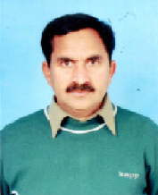
 | Admn Section | Mr. Shams Elahi | Naib Qasid | 051-9057216 | 0347-9147343
 | Admn Section | Mr. Mujahid Ali | Labour | 051-9057216 | 0300-7150011 | mujahidaliansari87@gmail.com | 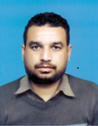
 | P/G Section | Mr. Abdul Jabbar | Assistant | 051-9057217 | 0300-9830904 | qariabduljabbar692@gmails.com
 | P/G Section | Mr. Muhammad Nadeem Saber | LDC | 051-9057217 | 0321-5228556 | nadeemm75@gmail.com | 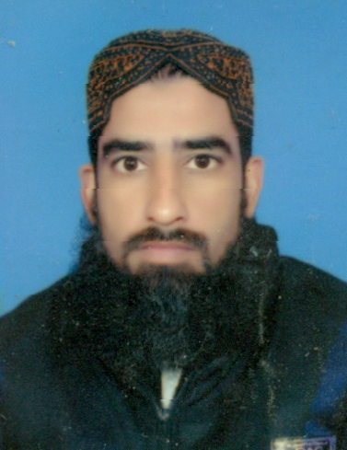
 | P/G Section | Mr. Nasir Mehmood | LDC | 051-9057217 | 0307-5787771 | nasirab777@hotmail.com
 | P/G Section | Ms. Rakhshanda Mehtab | Labour | 051-9057217 | 0331-8149288
 | Monitoring Section | Ms. Qurat-ul-Ain | R. Assistant | 051-9057338 | 0310-8504506 | quratulain.mumtaz@aiou.edu.pk
 | Monitoring Section | Mr. Rizwan Ahmed | LDC | 051-9057338 | 0333-5584094 | rizwan.rajaaiou@gmail.com
 | Tutor Registar Section | Mr. Tariq Mehmood | LDC | 051-9057891 | 0321-5672802
 | Tutor Registar Section | Malik Noman Ikhlaq | LDC | 051-9057891 | 0300-5278795 | maliknoman488@gmail.com
 | Wafiqi Mohtasib Section | Mr.Muhammad Jahangir | Assistant | 051-9057347 | 0300-9830904 | jahangirlaghari@yahoo.com
 | Wafiqi Mohtasib Section | Mr. Munawar Hussain Sajid | UDC | 051-9057347 | 0300-4852523
 | Wafiqi Mohtasib Section | Mr. Ibrar Ahmed | LDC | 051-9057347 | 0346-5296003
 | Wafiqi Mohtasib Section | Mr. Mohsin Raza | Naib Qasid | 051-9057347 | 0342-5012838 | mohsinrazaaiou5@gmail.com
 | Complaint Redressal Unit | Mr. Jawed Akhter | R. Assistant | NIL | 0314-7725650
 | Complaint Redressal Unit | Mr. Aftab Ali | LDC | NIL | 0345-5070033
 | Complaint Redressal Unit | Mr. Tauqeer-ul-Hassan | LDC | NIL | 0331-5546925

