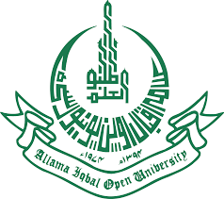 |  |  | Research Scholarship OPPORTUNITIES  Language Description and Documentation Project  (An NRPU Project Funded by HEC) |  | 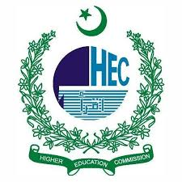
Language Description and Documentation is an NRPU (National Research Program for Universities) project funded by the Higher education Commission (HEC) of Pakistan to describe and document ‘Madaglashti’ (a language spoken in Chitral – Khyber Pakhtunkhwa, Pakistan). Currently we are looking for active and skilled scholars who are enrolled in MPhil (English/Linguistics) Degree program at any public sector university of Pakistan on purely contractual/part time basis.

S. No: | Position and Honorarium | Number of post | Required minimum qualification | Required status
1 | Research Scholar  Rs. 20,000/- fixed per month | 3 | MA (16 years education) English preferably with specialization in Linguistics/  Applied Linguistics | The candidates must be enrolled in MPhil (English/Linguistics) at a public sector university. Excellent communication /interpersonal skills. Strong computer and report writing skills.
Interested candidates are advised to send their CVs along with credentials and covering letter clearly stating the position applied for, latest by February 28, 2022 1600 Hrs to
Dr. Muhammad Kamal Khan, Principal Investigator
Department of English, Block No. 8
Allama Iqbal Open University, H/8-2, Islamabad
Phone: 051-9057766 Email: kamal.khan@aiou.edu.pk
Note:
- The positions are based at Islamabad Campus.
- No TA/DA shall be admissible for interview.
- Incomplete applications/letter/documents will not be entertained.
- Only shortlisted candidates will be called for interview.
Office of Research, Innovation & Commercialization (ORIC)
Allama Iqbal Open University, Islamabad

