ALLAMA IQBAL OPEN UNIVERSITY, ISLAMABAD
(Department of Science Education)
WARNING
- PLAGIARISM OR HIRING OF GHOST WRITER(S) FOR SOLVING THE ASSIGNMENT(S) WILL DEBAR THE STUDENT FROM AWARD OF DEGREE/CERTIFICATE, IF FOUND AT ANY STAGE.
- SUBMITTING ASSIGNMENT(S) BORROWED OR STOLEN FROM OTHERS AS ONE’S OWN WILL BE PENALIZED AS DEFINED IN “AIOU PLAGIARISM POLICY”.

Course: Foundations of Science Education (8627) Semester: Spring, 2026

Level: BEd (1.5 Years)
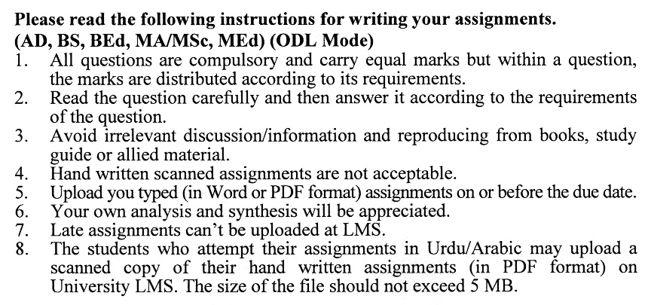

Total Marks: 100 Pass Marks: 50 Assignment No.1
(Unit No.1-5)

Q.1 Examine the connections between the Qur'an, Hadith, and contemporary scientific understanding. Explore this relationship by providing concrete examples that highlight how these texts align with or support similar ideas. Share your perspective clearly and thoughtfully. (20)
Q.2 What is the deductive method of teaching science, and how does it work in the classroom? Have you noticed any ways that Constructive Empiricism shows up in how science is taught or learned? Share your thoughts and examples. (20)
Q.3 Evaluate the interdependence of science and philosophy. Do you agree that these two fields are mutually reliant? If so, provide a well-structured argument supporting this view. If you disagree, explain your reasoning and support your assertions with relevant examples. (20)
Q.4 Reflect on the 'Inductive Method' of teaching and its role in secondary science education. What are the notable advantages and drawbacks you identify in this approach? Discuss your observations in detail, supported by examples that highlight your understanding of its impact on student learning. (20)
Q.5 Analyze the concept of 'Instrumentalism' within the context of science education. Discuss its implications for teaching and learning practices and evaluate how this philosophical approach influences curriculum development and student engagement in scientific inquiry. (20)

Total Marks: 100 Pass Marks: 50
Assignment No.2
(Unit 6-9)

Q.1 What are the main features of Gestalt theory, and why is it important for the learning process? Delve into the implications of Gestalt principles on education, providing insights into how they can shape effective teaching and learning experiences. (20)
Q.2 Define the philosophy of Realism and explore its significance within the context of science education. In your discussion, analyze how Realist principles can influence educational practices and the understanding of scientific concepts among students. (20)
Q.3 Critically examine the social limitations that hinder the effective implementation of science for national and societal development. Analyze how these limitations impact scientific progress and propose potential strategies to address them. (20)
Q.4 Critically analyze the implications of Constructivism in the science laboratory setting. Think about how it might change the way students conduct experiments, interact with each other, and build their understanding of scientific concepts. Share your thoughts and examples! (20)
Q.5 Discuss in detail the future trends of science education in the developed countries. Also, determine the prospects of science education as an emerging field of educational research. (20)

