ALLAMA IQBAL OPEN UNIVERSITY, ISLAMABAD
(Department of Science Education)

WARNING
- PLAGIARISM OR HIRING OF GHOST WRITER(S) FOR SOLVING THE ASSIGNMENT(S) WILL DEBAR THE STUDENT FROM AWARD OF DEGREE/CERTIFICATE, IF FOUND AT ANY STAGE.
- SUBMITTING ASSIGNMENT(S) BORROWED OR STOLEN FROM OTHERS AS ONE’S OWN WILL BE PENALIZED AS DEFINED IN “AIOU PLAGIARISM POLICY”.

Course: Laboratory Organization, Management and Safety Methods (6438)
Level: BEd (2.5/4 year) Semester: Spring, 2026
Credit Hours: 3

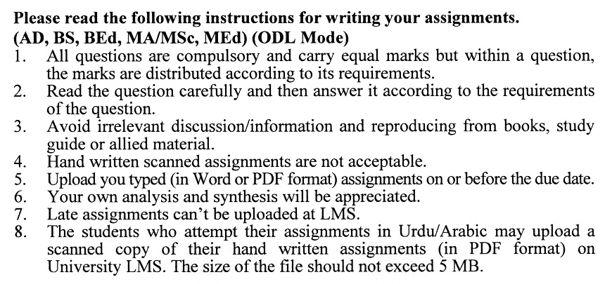

Total Marks: 100 Pass Marks: 50
ASSIGNMENT No. 1
(Units: 1-4)

Note: Attempt all questions. All questions carry equal marks.
Q.1 Analyze the key differences and similarities between traditional and flexible science laboratory models, with reference to their educational effectiveness. Also, elaborate on the professional competencies and abilities required of science teachers for the development and effective management of modern science laboratories. (20)
Q.2 Analyze international standard laboratory practices and assess how they compare with
prevailing laboratory practices in the school system of Pakistan, with reference to quality, safety, and pedagogical effectiveness. (20)
Q.3 Explain cleaning solutions and their importance in chemistry and biology laboratories. Discuss different techniques for pouring and transferring liquids in the laboratory. (20)
Q.4 Critically describe the teaching strategies employed in science laboratories in Pakistan and evaluate their major strengths and limitations. (20)
Q.5 Analyze the process and criteria for effective inspection of science laboratories, highlighting the essential components that require evaluation. Illustrate your discussion
with suitable examples from Pakistan. (20)
Total Marks: 100 Pass Marks: 50
ASSIGNMENT No. 2
(Units: 5-9)

Q.1 Review the situation of practical science in low-income countries. Also, discuss the Barriers to improving laboratory work in developing countries. (20)
Q.2 Critically discuss the Personalized System of Instruction (PSI) as a pedagogical A strategy for conducting laboratory work in science education. (20)
Q.3 Discuss the practical implications of translating laboratory aims and objectives into actionable procedures and outcomes. (20)
Q.4 Elaborate Criterion-Referenced Tests (CRTs)? Discuss how CRTs can be effectively used to assess student learning and skills in science laboratory environments. (20)
Q.5 Analyze and differentiate between the three categories of laboratory teaching strategies, with reference to their instructional effectiveness. Evaluate the contribution of research projects to teaching and learning in laboratory environments. (20)

