ALLAMA IQBAL OPEN UNIVERSITY, ISLAMABAD
(Department of Science Education)

WARNING
- PLAGIARISM OR HIRING OF GHOST WRITER(S) FOR SOLVING THE ASSIGNMENT(S) WILL DEBAR THE STUDENT FROM AWARD OF DEGREE/CERTIFICATE, IF FOUND AT ANY STAGE.
- SUBMITTING ASSIGNMENT(S) BORROWED OR STOLEN FROM OTHERS AS ONE’S OWN WILL BE PENALIZED AS DEFINED IN “AIOU PLAGIARISM POLICY”.

Course: Teaching Strategies in Science Education (6437) Semester: Spring, 2026

Level: BEd (2.5/ 4 YEARS)

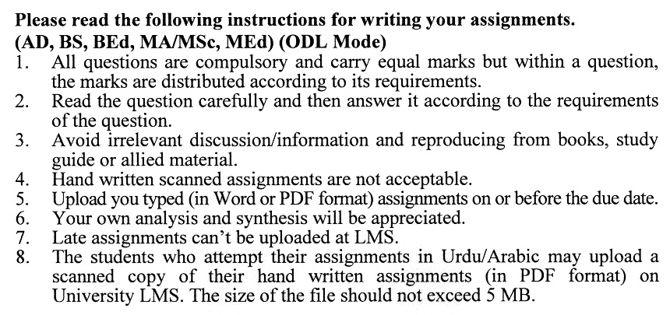

Total Marks: 100 Pass Marks: 50
ASSIGNMENT No. 1
(Unit 1–4)

Q.1 Examine the significance of the Nature of Science in promoting effective science education. Discuss the Nature of Science from the perspective of a science teacher, highlighting its implications for classroom practice. (20)
Q.2 Explain the essential features of effective science teaching. Discuss the role and significance of Integrated Scientific Process Skills in science teaching and learning, with appropriate examples. (20)
Q.3 Discuss how the Demonstration Method can be beneficial for both science teachers and students in addressing and solving complex scientific problems. State the general rules for effective demonstration in the science classroom. (20)
Q.4 Explain the uses of models in effective science teaching. Describe how Modeling Instruction can promote the learning of science. Examine the use of the Cooperative Learning Model in the Pakistani context. (20)
Q.5 Critically explain how instructional planning is carried out through the 5E Instructional Model. Discuss the nature of learner activities across the different phases of the 5E Model, highlighting their pedagogical significance. Also, develop a detailed lesson plan based on the 5E Instructional Approach for a selected topic. (20)

Total Marks: 100 Pass Marks: 50
ASSIGNMENT No. 2
(Unit 5–9)

Q.1 Critically explain the concept of Scientific Inquiry in the context of science education. Differentiate between Discovery and Inquiry teaching strategies, highlighting their distinctive features and educational applications. (20)
Q.2 Evaluate the role of questioning as a strategy for facilitating Discovery Learning. Examine the key considerations and precautions necessary for effective classroom questioning. Assess the principles and pedagogical value of questioning in fostering learners’ discovery and inquiry skills. (20)
Q.3 Critically explain the concept of simulations and identify their various sources in science education. Discuss the advantages and disadvantages of using simulations in the teaching and learning of science. (20)
Q.4 Critically discuss the role of radio and television in science education, highlighting their instructional significance and educational impact. Explain the educational objectives that can be achieved using television as an educational technology tool. (20)
Q.5 Explain the role of computers in developing and applying scientific knowledge. Describe the difficulties in adopting individualized teaching at the school level and provide recommendations to overcome them. (20)

