ALLAMA IQBAL OPEN UNIVERSITY, ISLAMABAD
(Department of Science Education)
WARNING
- PLAGIARISM OR HIRING OF GHOST WRITER(S) FOR SOLVING THE ASSIGNMENT(S) WILL DEBAR THE STUDENT FROM AWARD OF DEGREE/CERTIFICATE, IF FOUND AT ANY STAGE.
- SUBMITTING ASSIGNMENT(S) BORROWED OR STOLEN FROM OTHERS AS ONE’S OWN WILL BE PENALIZED AS DEFINED IN “AIOU PLAGIARISM POLICY”.

Course: Foundations of Science Education (6435) Semester: Spring, 2026
Level: BEd (2.5/4 year)
Credit Hours: 3
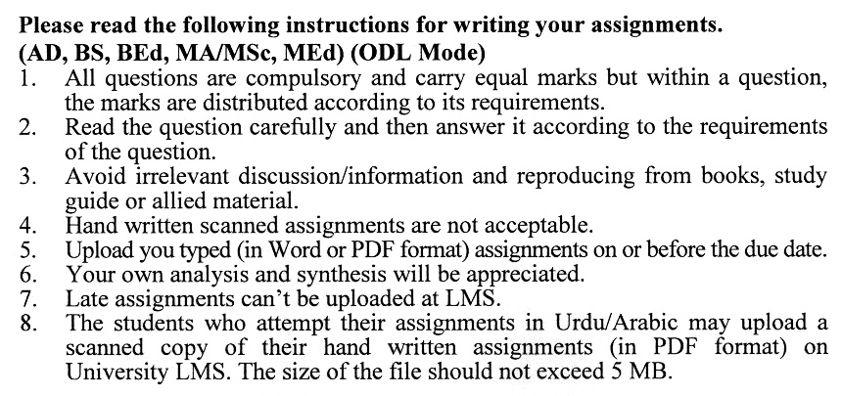
Total Marks: 100 Pass Marks: 50
ASSIGNMENT No. 1
(Units: 1-4)
Note: Attempt all questions. All questions carry equal marks.
Q.1 Examine the interrelationships among the Quran, Hadith, and contemporary scientific understanding. In your analysis, provide relevant examples to illustrate the connections between these texts and modern scientific principles. (20)
Q.2 What is Idealism as a philosophy? Why is it important for teaching science, and how does it affect the way science is taught in schools? Explain it with examples. (20)
Q.3 Critically analyze the historical factors that have impeded scientific progress in the Muslim world. Also propose strategic pathways for revitalizing a culture of scientific inquiry within these contexts. (20)
Q.4 Provide a comprehensive explanation of inductive reasoning and deductive reasoning, supported by examples from science education. Discuss how these reasoning types contribute to the development of scientific thinking in learners. (20)
Q.5 Analyze the concept of 'Instrumentalism' within the context of science education. Discuss its implications for teaching and learning practices and evaluate how this philosophical approach influences curriculum development and student engagement in scientific inquiry. (20)

Total Marks: 100 Pass Marks: 50
ASSIGNMENT No. 2
(Units: 5-9)

Q.1. Analyze Jerome Bruner’s Theory of Education, highlighting its key elements and implications for science instruction. Include specific examples of how Bruner's ideas can be applied in the science classroom. (20)
Q.2 Reflect on the concept of Realism. What does Realism mean to you, and why is it significant in the context of teaching and learning science? Discuss its implications for educators and students for a deeper understanding of scientific inquiry. (20)
Q.3 Analyze the emerging trends likely to shape the future of science education in developed countries. Consider the roles of technological innovation, curriculum reform, and evolving pedagogical approaches in your response. (20)
Q.4 Critically examine the role of science education in driving economic development within emerging economies. How can science education be transformed into a catalyst for equitable economic growth in the next two decades? (20)
Q.5 Evaluate the impending trends in science education in Pakistan by analyzing current reforms, technological integration, and global influences. How can science education evolve into a driver of social equity and economic transformation in Pakistan’s future? (20)

