ALLAMA IQBAL OPEN UNIVERSITY, ISLAMABAD
(Department of Science Education)
[WARNING
- PLAGIARISM OR HIRING OF GHOST WRITER(S) FOR SOLVING THE ASSIGNMENT(S) WILL DEBAR THE STUDENT FROM AWARD OF DEGREE/CERTIFICATE, IF FOUND AT ANY STAGE.
- SUBMITTING ASSIGNMENTS BORROWED OR STOLEN FROM OTHER(S) AS ONE’S OWN WILL BE PENALIZED AS DEFINED IN “AIOU PLAGIARISM POLICY”.

Course: Laboratory Organization, Management and Safety Methods (698)
Level: M. ED Semester: Spring, 2026
Credit Hours: 3
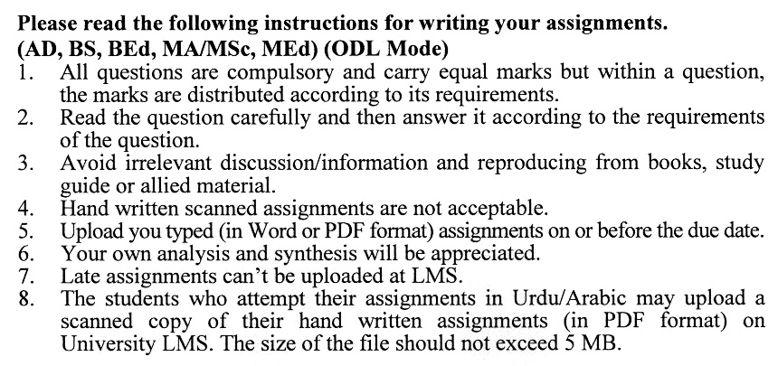

Total Marks: 100 Pass Marks: 40
ASSIGNMENT No. 1
(Units: 1-4)
Q.1 Examine global standard laboratory practices and compare them with those used in Pakistani schools. (20)
Q.2 Critically examine globally recognized standard laboratory practices and evaluate their alignment with, and divergence from, the laboratory practices currently implemented in
Pakistani schools. (20)
Q.3 Analyze the role and importance of cleaning solutions in maintaining accuracy, safety, and reliability in chemistry and biology laboratories. Evaluate different techniques used for the pouring and transfer of liquids, with reference to laboratory safety and efficiency. (20)
Q.4 Analyze the standard laboratory design models implemented in Pakistani schools, focusing on spatial planning, equipment integration, and compliance with educational and safety guidelines.? (20)
Q.5 Discuss the responsibilities of science teachers regarding the proper storage and documentation of materials in a science laboratory. Describe the procedures for inspecting a science laboratory and identify the key aspects that should be evaluated during inspection. (20)

Total Marks: 100 Pass Marks: 40
ASSIGNMENT No. 2
(Units: 5-9)

Q.1. Explain how socio-economic and institutional contexts shape laboratory practices in low-income countries and identify their main educational goals. Also discuss why comparing these goals with those in other settings is important for improving science education? (20)
Q.2 Analyze the Personalized System of Instruction (PSI) as an instructional strategy for laboratory-based science learning, with reference to its theoretical foundations and classroom implementation. (20)
Q.3 Evaluate the contribution of research projects to teaching and learning in laboratory environments. Examine different approaches to sequencing laboratory activities and assess their impact on student learning outcomes. (20)
Q.4 What is the Role of Feedback in Assessment of Laboratory Work? Also Discuss in detail how Criterion-Referenced Tests (CRTs) can be effectively used to assess student learning and skills in science laboratory environments. (20)
Q.5 Discuss different Laboratory Safety Techniques in Detail. Also Discuss Different. Techniques Used against the Radiation, Chemical and Fire Hazards in Laboratory? What are the First Aid Treatment for Heat and Chemical Burns? (20)

