ALLAMA IQBAL OPEN UNIVERSITY, ISLAMABAD
(Department of Science Education)

WARNING
- PLAGIARISM OR HIRING OF GHOST WRITER(S) FOR SOLVING THE ASSIGNMENT(S) WILL DEBAR THE STUDENT FROM AWARD OF DEGREE/CERTIFICATE, IF FOUND AT ANY STAGE.
- SUBMITTING ASSIGNMENT(S) BORROWED OR STOLEN FROM OTHERS AS ONE’S OWN WILL BE PENALIZED AS DEFINED IN “AIOU PLAGIARISM POLICY”.

Course: Teaching Strategies in Science Education (696) Semester: Spring, 2026

Level: MA / MEd

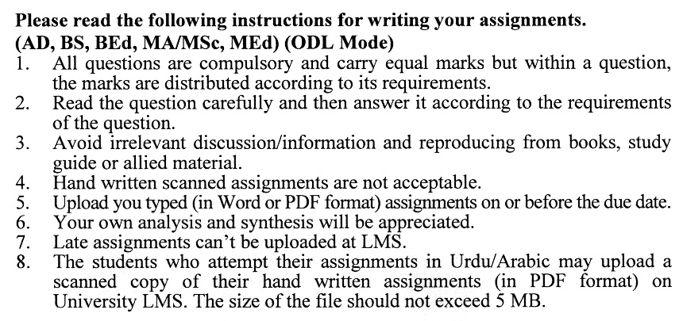

Total Marks: 100 Pass Marks: 40
ASSIGNMENT No. 1
(Unit 1–4)
Q.1 Critically examine the fundamental elements that characterize effective science teaching at the secondary school level. Discuss the role and significance of Integrated Scientific Process Skills in science teaching and learning, with appropriate examples. (20)

Q.2 Analyze the significance of aims, goals, and instructional objectives in enhancing effective science education. Select an appropriate topic from the science curriculum and develop a detailed lesson plan based on the SOLO Taxonomy framework. (20)

Q.3 Critically discuss the various types of standards employed in science education. Examine the role of science education standards in the design of effective and measurable Student Learning Outcomes. (20)

Q.4 Explain the significance of the Learning Cycle in science education. Describe the Cooperative Learning Model for science teaching, including its steps and its role in promoting Modeling Instruction. (20)
Q.5 Analyze the role of discussion as an instructional strategy in science education. Evaluate the essential rules for facilitating productive group discussions and examine the key considerations necessary for managing classroom discussions effectively.? (20)

Total Marks: 100 Pass Marks: 40
ASSIGNMENT No. 2
(Unit 5–9)

Q.1. Analyze the meaning and significance of Scientific Inquiry as an approach to science teaching and learning. Compare and contrast Discovery and Inquiry strategies with reference to their theoretical foundations and classroom implementation. (20)
Q.2 Critically explain the concept of the Discovery Approach in science education. Discuss how questioning techniques can be effectively utilized in Discovery Learning. Describe the precautions that should be observed while using questioning strategies in the classroom. (20)
Q.3 Analyze the role of computer-based and real-world simulations in supporting experiential learning in science education. How effective are these simulations in fostering higher-order cognitive skills, including analysis, synthesis, and evaluation, among learners? (20)
Q.4 Critically discuss the role of radio and television in science education, highlighting their instructional significance and educational impact. (20)
Q.5 Evaluate the contribution of computer technology to the advancement, organization, and application of scientific knowledge in education and research. Examine the factors that hinder the implementation of individualized teaching in schools and suggest practical strategies for overcoming these barriers. (20)

