ALLAMA IQBAL OPEN UNIVERSITY, ISLAMABAD
(Department of Science Education)

WARNING
- PLAGIARISM OR HIRING OF GHOST WRITER(S) FOR SOLVING THE ASSIGNMENT(S) WILL DEBAR THE STUDENT FROM AWARD OF DEGREE/CERTIFICATE, IF FOUND AT ANY STAGE.
- SUBMITTING ASSIGNMENT(S) BORROWED OR STOLEN FROM OTHER(S) AS ONE’S OWN WILL BE PENALIZED AS DEFINED IN “AIOU PLAGIARISM POLICY”.

Course: Foundations of Science Education (695) Semester: Spring, 2026

Level: MA /MEd (Science Education)
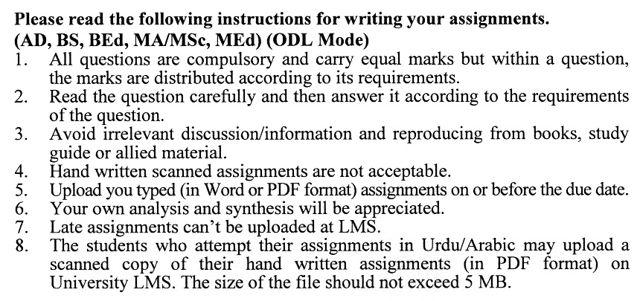

Total Marks: 100 Pass Marks: 40
Assignment No.1
(Unit No.1-5)

Q.1 How do the Quran, Hadith, and modern science converge or diverge in their understanding of the world? Craft an argument supported by pertinent examples that showcase the intricate relationship between these spiritual and empirical sources. (20)

Q.2 Explore the significant influence of key Muslim thinkers on the evolution of different scientific branches. How did their insights and methodologies shape our understanding of science today? Support your discussion with compelling examples. (20)

Q.3 Evaluate the interdependence of science and philosophy. Do you agree that these two fields are mutually reliant? If so, provide a well-structured argument supporting this view. If you disagree, explain your reasoning and support your assertions with relevant examples. (20)

Q.4 Provide a comprehensive analysis of the 'Inductive Method' of teaching, focusing specifically on its application in secondary-level science education. Discuss the advantages and disadvantages you observe in employing this method and support your observations with relevant examples from educational practice. (20)

Q.5 Explore the idea of 'Instrumentalism' as it relates to science education. How does this perspective shape our understanding of the purpose of scientific theories and models in the classroom? Discuss its relevance and impact on both teaching strategies and learners’ perceptions of science. (20)

Total Marks: 100 Pass Marks: 40
Assignment No.2
(Unit 6-9)

Q.1 What does the term Constructivism mean to you, and how can it be applied in the context of teaching and learning science? Explore the various ways in which Constructivism can enhance scientific education and examine its implications for hands-on experimentation in the laboratory. (20)

Q.2 Reflect on the concept of Realism and its relevance to science education. What does Realism means to you, and why is it significant in the context of teaching and learning science? Discuss its implications for educators and students in cultivating deeper understanding of scientific inquiry. (20)

Q.3 Explain in detail the concept and practices of formative classroom assessment as conceptualized within Benjamin S. Bloom’s theoretical framework. (20)

Q.4 How does the principle of falsification challenge or support the development of scientific knowledge? Furthermore, evaluate the central tenets of realism and their implications for shaping a coherent and philosophically grounded approach to science education. (20)

Q.5 Consider the major outcomes of the revolution in science teaching. In your discussion, reflect on how these outcomes have influenced both educators and learners. What lasting effects have you observed, and how do they shape the future of science education? (20)

