Prof. Dr. Farish Ullah Yousafzai 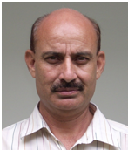
Director (Dean)
Faculty of Social Sciences
Ph# 0533643112, Ext.161
Email: farish_usafzai@yahoo.com, farish.ullah@uog.edu.pk
Farish Ullah Yousafzai completed his post-doctorate fellowship in the area of health communication from WKW School of Communication, Nanyang Technological University, Singapore in 2006-2007. He has done his Ph.D in campaigns’ effects in the area of health communication from University of Karachi in 2002. He has more than 26 years post graduate level teaching experience and at his credit. He was selected as professor in communication sciences and appointed as Director Social Sciences, University of Gujrat in Dec. 2011. His area of interest is health communication effects and several national and regional journals have published his articles. His second area of interest is war and peace journalism. His book “Social Communication Campaigns: A Study of the Effects Process” has been translated into three European languages—French, German, and Russian. He has supervised more than 30 students at M.Phil level.

