Water

Water Conservation Program Implementation at AIOU
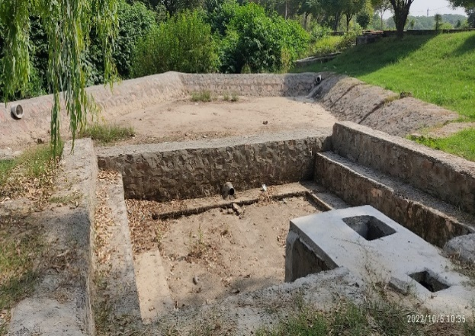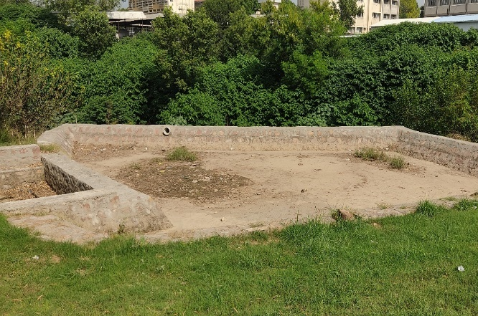
Water Conservation in Ground Water Tanks at AIOU
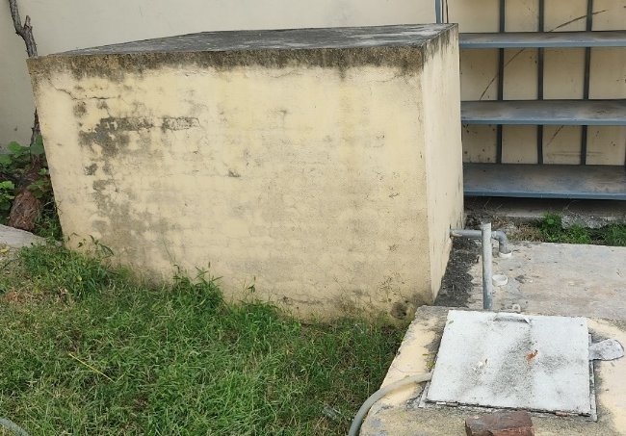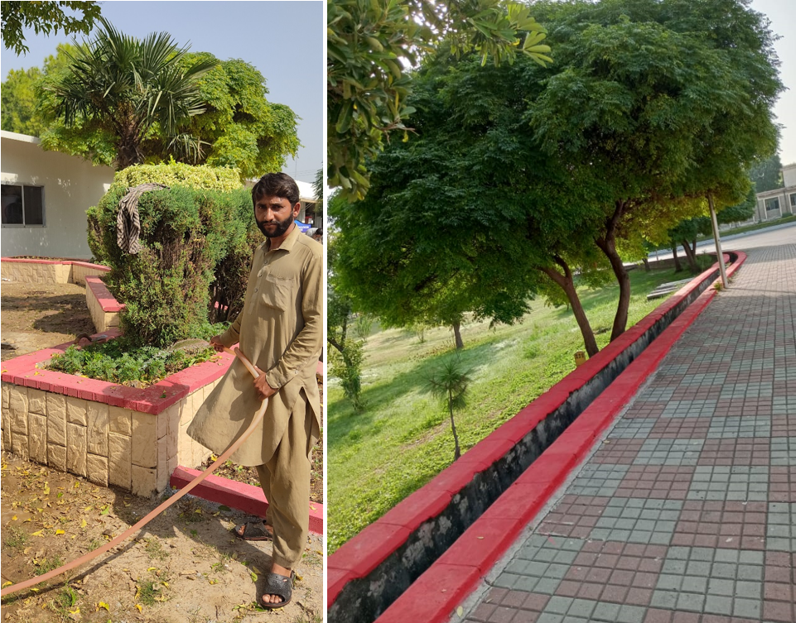
Used Water is saved and re-used
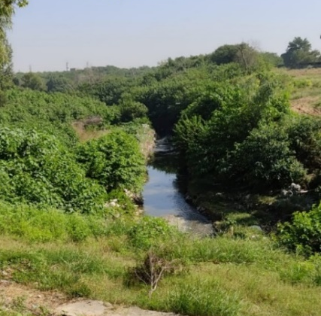
Forest Lake at AIOU for Water Conservation
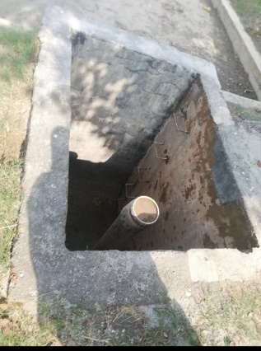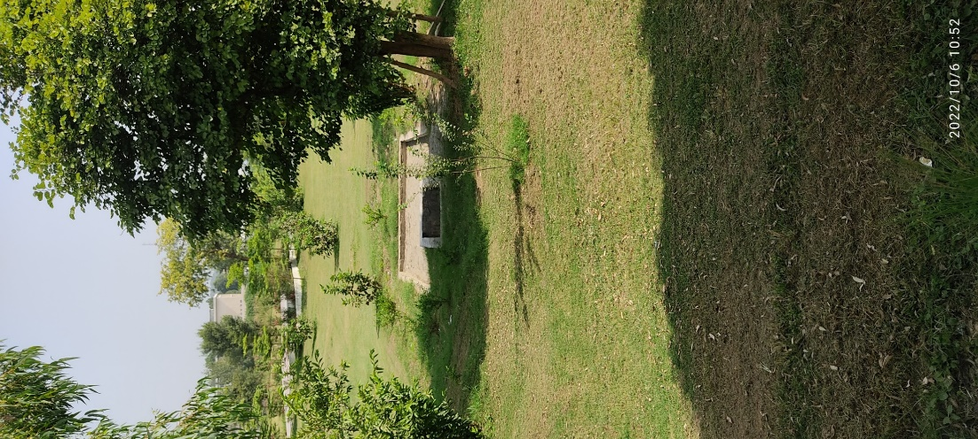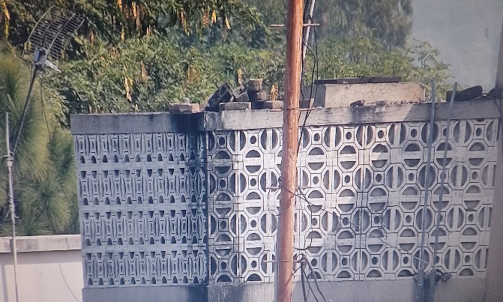
Water Conservation in Rain harvest Wells for water recharge at AIOU. Water tanks have been installed to collect and store rain water
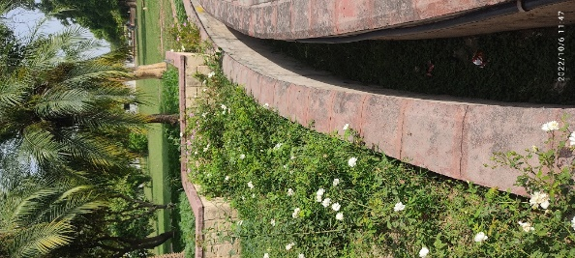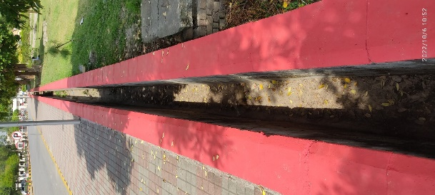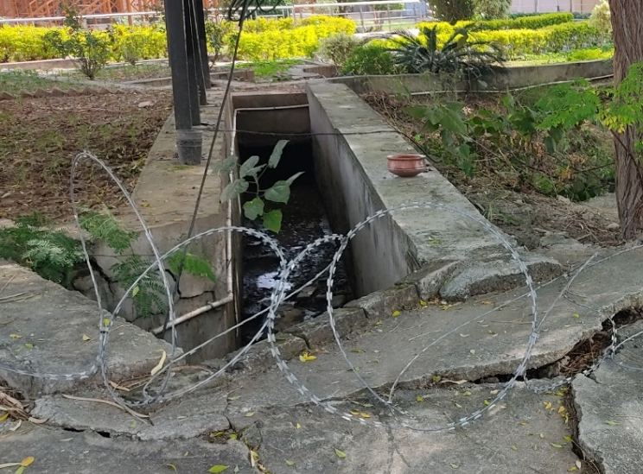
Water canals have been constructed to conserve rainwater and used water
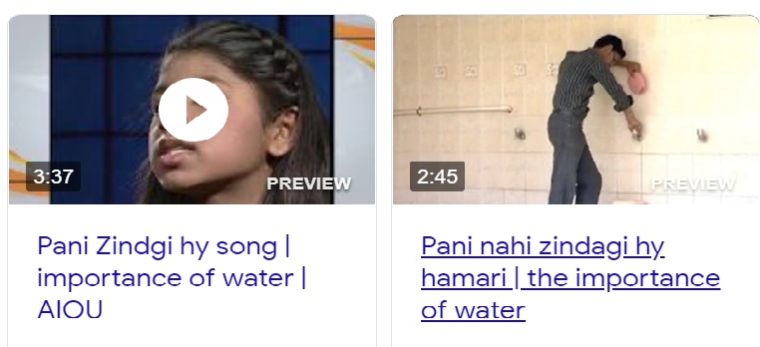
Public awareness program on smart water usage
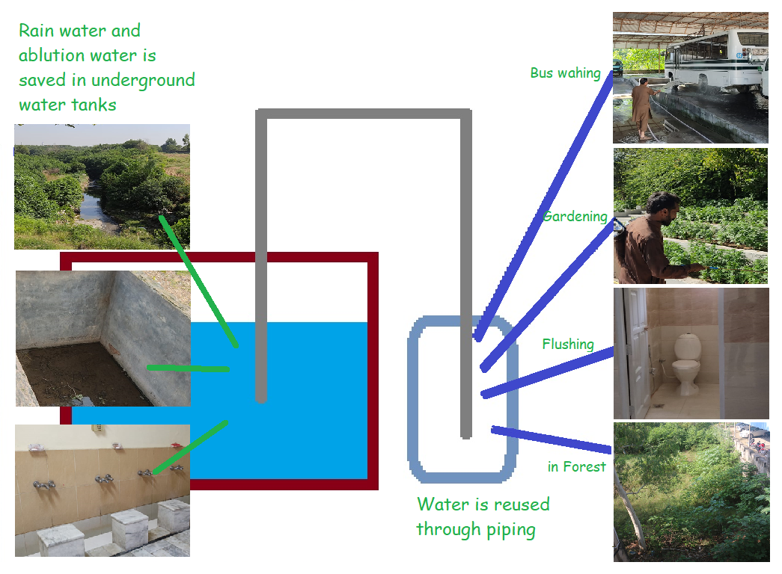
- Water Recycling Program Implemented at AIOU

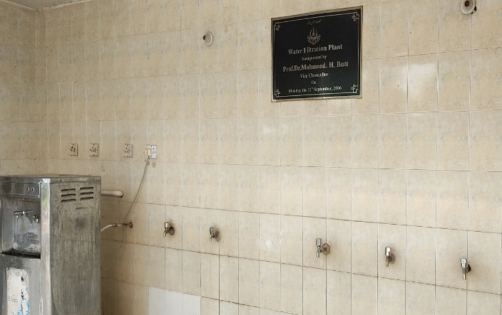
Water filtration Systems are installed. Stored water is filtered and used for drinking

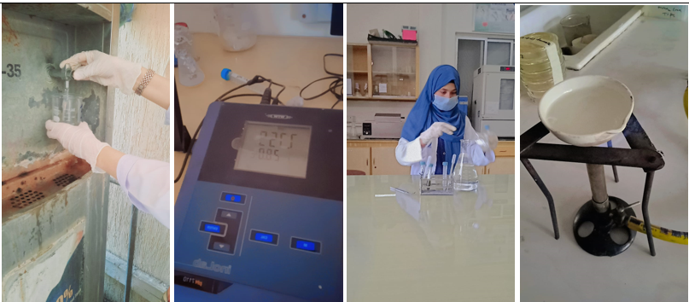
Water quality sampling and monitoring at AIOU, Islamabad-Pakistan

