Waste

3R (Reduce, Reuse and Recycle) Program for University Waste

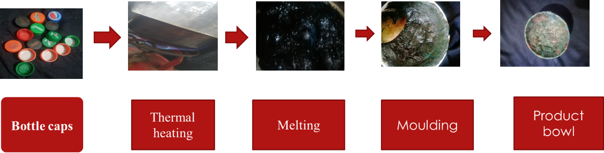

Transformation of plastic bottle caps to decorative bowl (30 pieces of cap = 1 bowl (6.5x3 cm size)
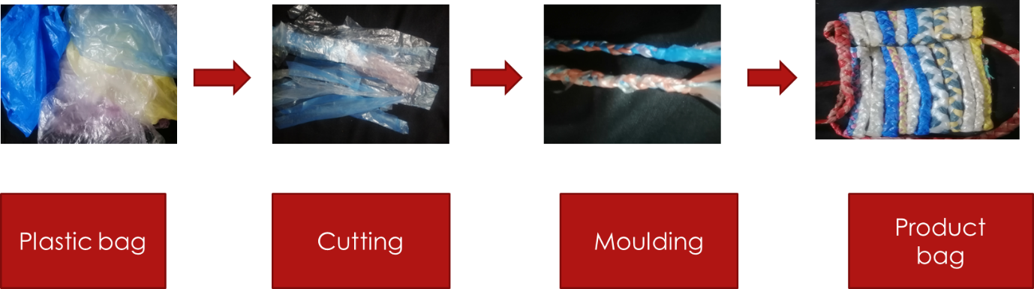

Transformation of plastic bags to small useable bags (recycled bags) (8 Polythene bag = 1 Bag (21x10 cm size)
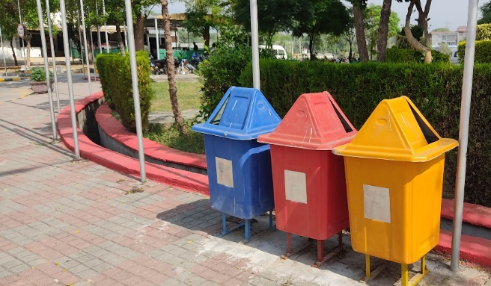
Separate Dustbins for Recyclable Items
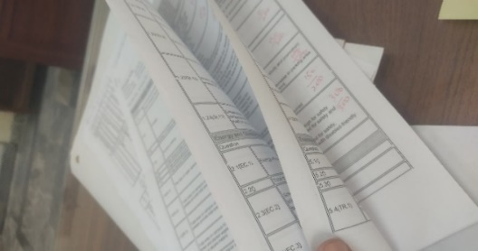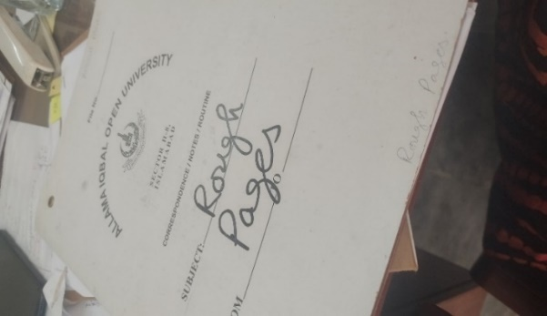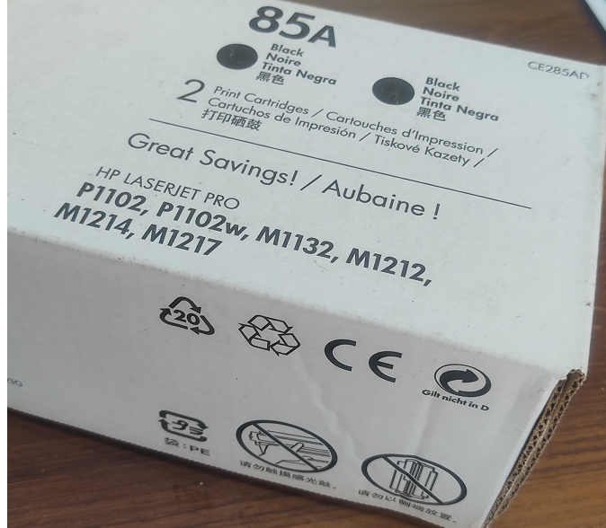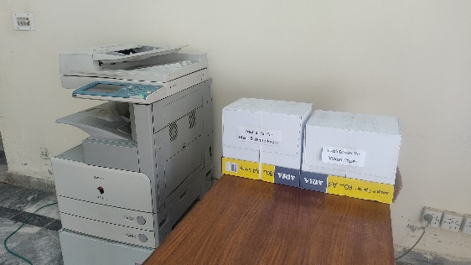
- Both sides of papers are always used. Such papers are re-used for different purposes.. Ink-cartridges are refilled and reused

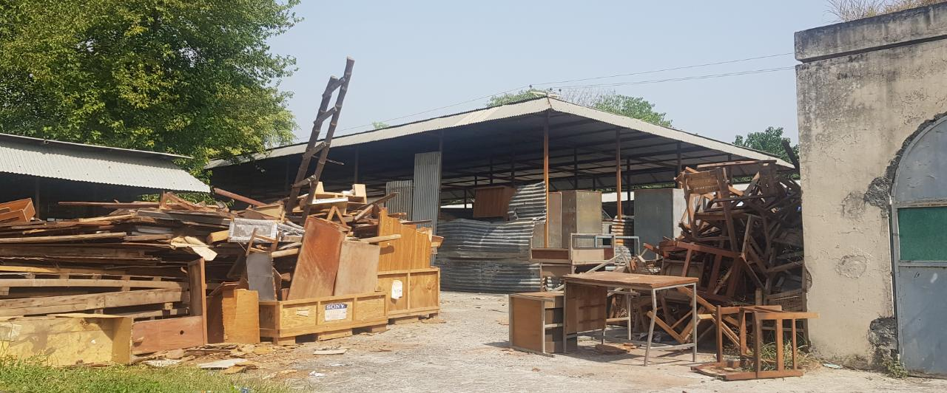
Old furniture is recycled by making new furniture items from them or using them for bio-fuel purposes
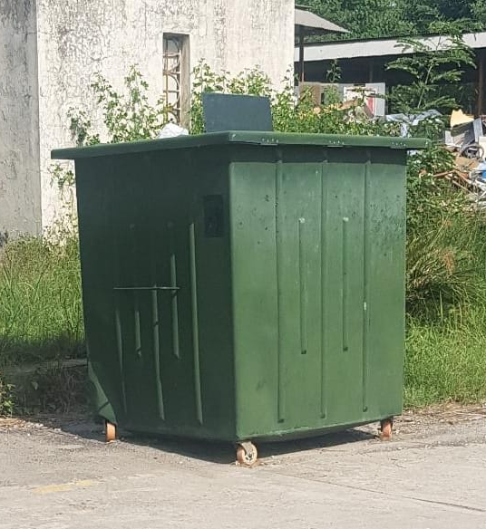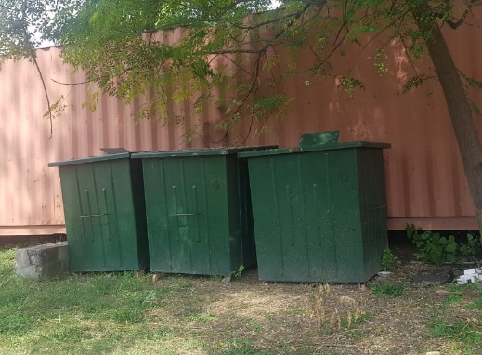
Organic waste is collected in separate bins and is processed at agricultural department for production of high-quality compost and biodiesel
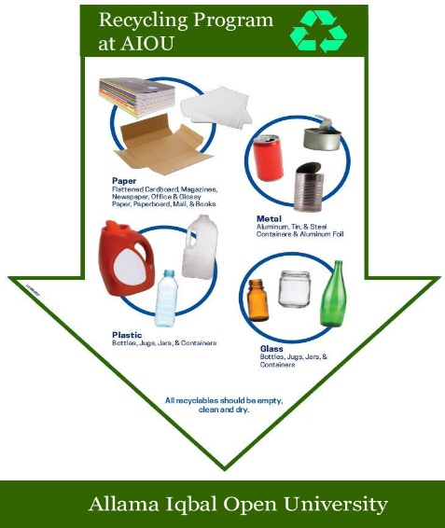
Recycling SOPs are followed for University Waste

[3] Waste (WS)

[3.2] Program to Reduce the Use of Paper and Plastic on Campus
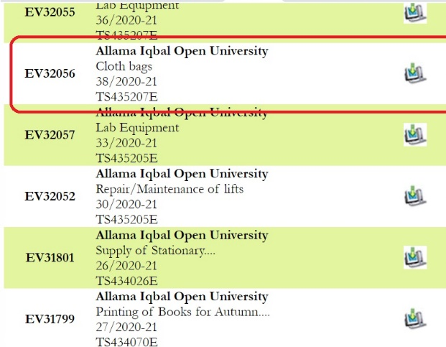
AIOU’s uses Cloth Bags since 2021 to reduce the use of plastic bags for all its activities
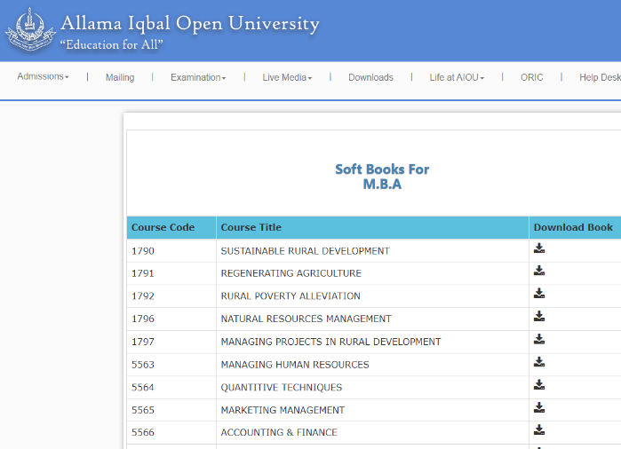
Books available only in soft form for all the programs
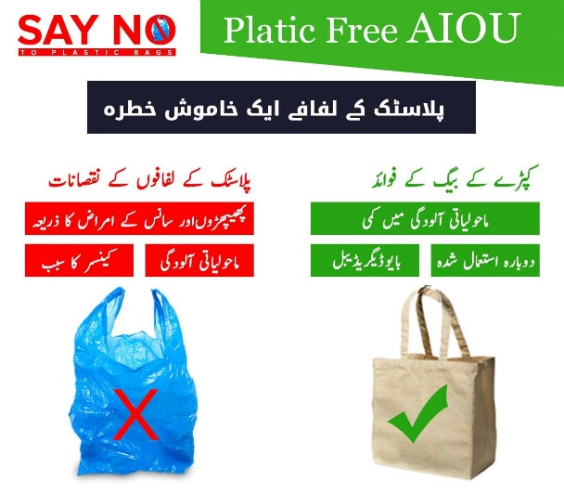
AIOU’s “Say no to Plastic Bags” Campaign which is a permanent program
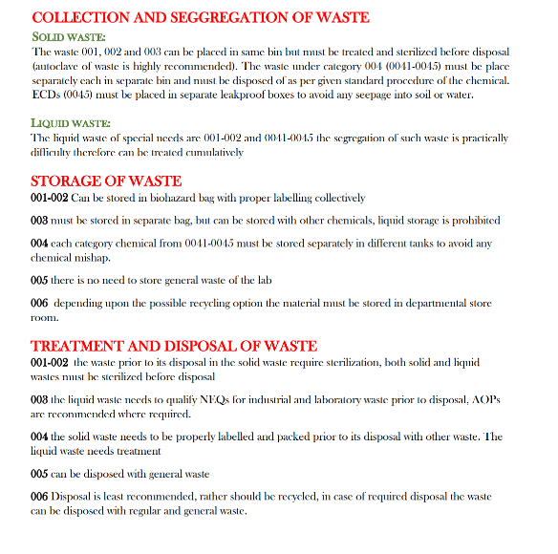
Different departments have SOPs for collection, segregation and disposal/recycling of Organic Waste. 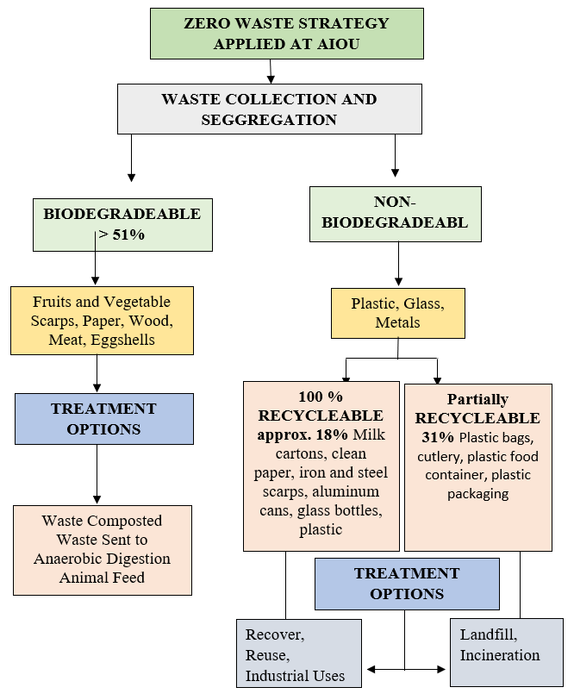
Zero Waste strategy is implemented at AIOU
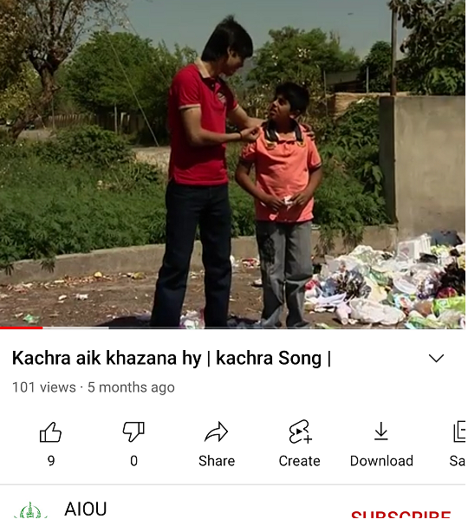
Video programs and songs for motivating students are available. Video link: https://www.youtube.com/watch?v=iRUpFwwL2tY
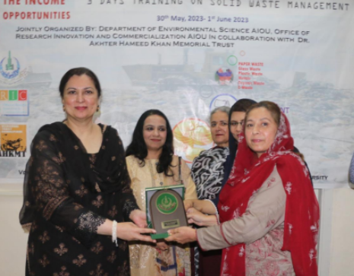
“Waste to Money” awareness program is implemented at AIOU.

Sewage Disposal

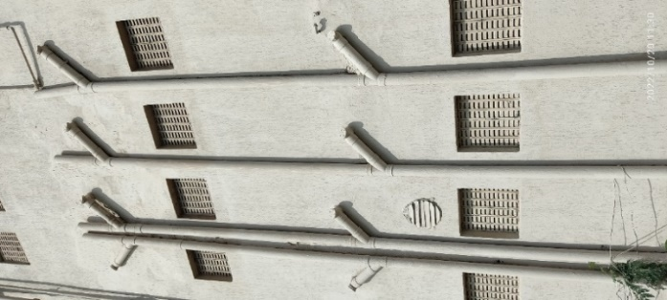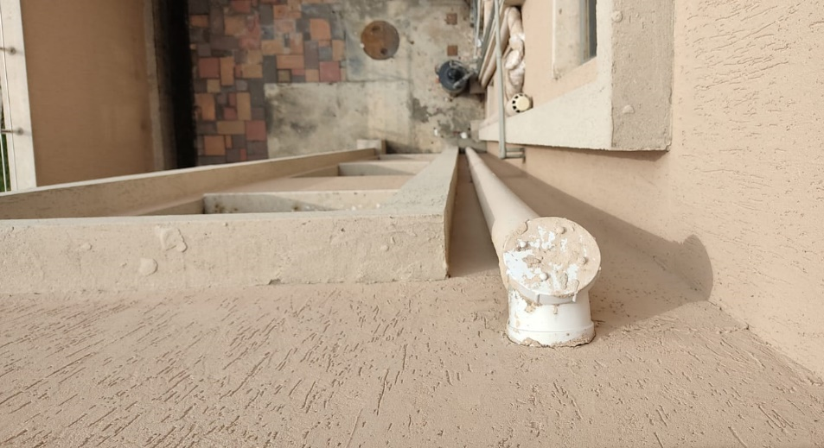
AIOU’s Sewage Collection System

Description:
- The sewage solid and liquid waste is carried away through pipelines spread throughout the university building. These pipes carry this sewage material to a sewage treatment plant to separate solid and liquid through the process of chemicals.

At AIOU, sewage is treated in two phases. In phase I, the solid waste is removed, and the sewage sludge is used for watering Olive and the Botanical Garden.

In Phase II, after removal of solid waste bacterial decomposition is done and the treated water is used for car washing, washing of campus pathways and other cleaning activities.

The bioremediated water is also utilized for irrigation purposes for different plants and flowers grown in parks managed by AIOU.

The AIOU buildings have extensive sewage disposal system consisting of sewage collection ducts and underground septic tanks that are drained into the main Sewage Disposal System.
- The AIOU department has a duty to cleanse and maintain these sewage lines to ensure that the area that they serve is effectively drained. There is also a duty to make provision for the emptying of those sewers, normally through sewage treatment works, or where appropriate, through discharges direct to watercourses.

