Outreach programs and projects in the local community to improve or promote health & wellbeing
AIOU has always delivered outreach programmes and projects in the local community to improve or promote health & wellbeing. These programs are related to hygiene, nutrition, family planning, sports, exercise and other health and well-being related topics. The main target groups are always local communities, disadvantaged people like transgenders and disabled persons and refugees or immigrant communities.
1- One Day Community Outreach Event on “Nutrition for Healthier Living”
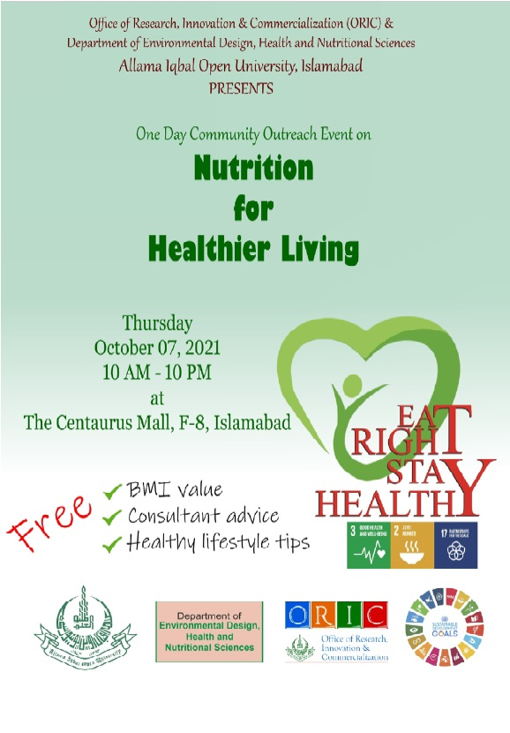
2- Online Interactive Session on “Breast Cancer Awareness and Screening”
3- Awareness at the School/College level about Waste Reduction to improve Health
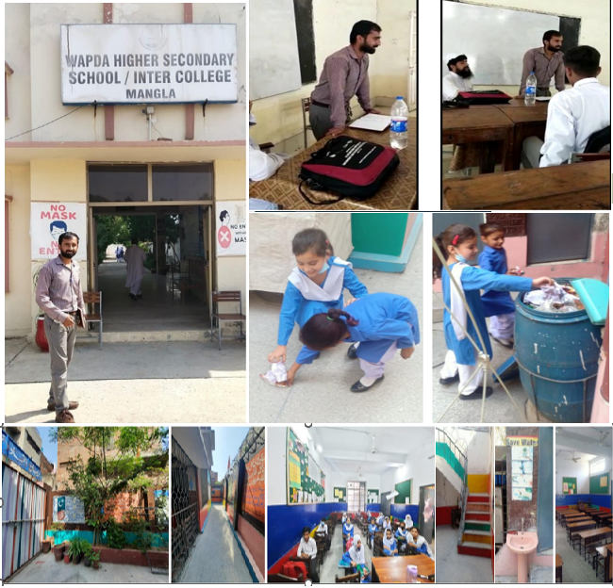
4- Awareness rising at school/college level to promote health & wellbeing and provide them with assistance and advice
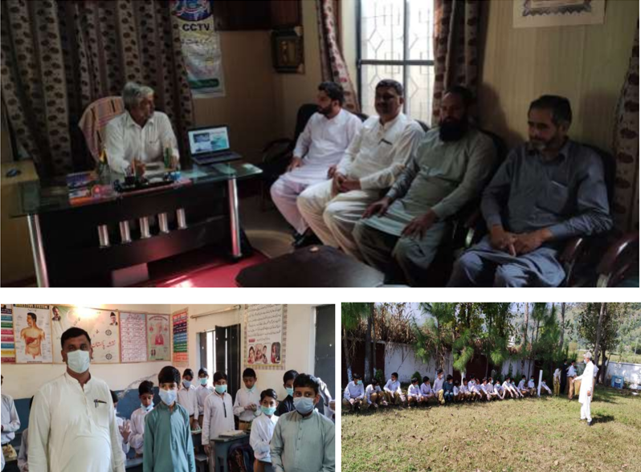
5- Community event at local school on Healthy Lunch
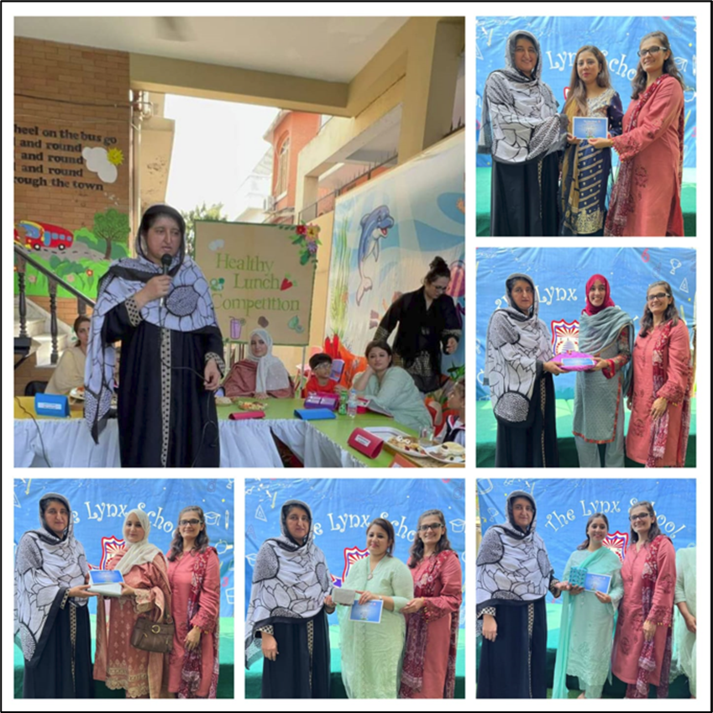
6- Educating transgenders on skills and health:
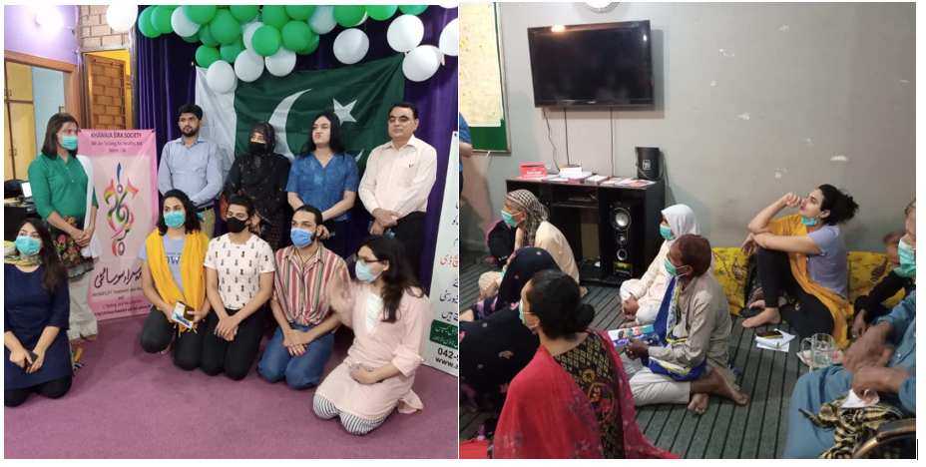
7- AIOU has Afghan refugee program for Afghan refugees who have not been able to get access to basic health facilities.

