Outreach educational activities for the wider community
1- AIOU Will Provide Education to Afghan Refugees in Camps
2- News: AIOU is all set to establish a regional office in Afghanistan
The Allama Iqbal Open University (AIOU) is all set to open up its full-fledged regional office in Afghanistan to promote education in the brotherly country at this much needed time, Vice Chancellor AIOU, Dr. Zia Ul-Qayyum said.
The office would be set up once the university gets permission from the federal government, which is already helping the brotherly country in various fields, the VC told in an exclusive interview here. The initiative of offering helping hand to the brotherly country paced up after the recent visit of Afghan Ministry of Higher Education delegation during which the delegates had requested the varsity to help their country in promoting education, reconstructing educational infrastructure, and training Afghan teachers.
3- One Day Community Outreach Event on “Nutrition for Healthier Living”
4- Education for Transgenders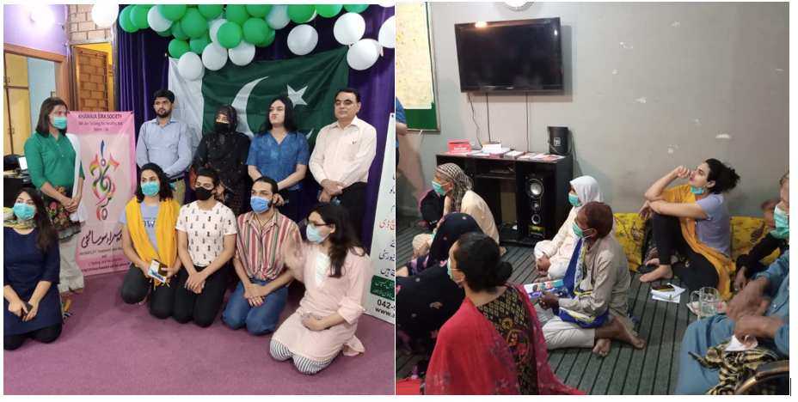
5- “Interactive session on Breast Cancer Awareness” for Community
6- Education for Jail mates
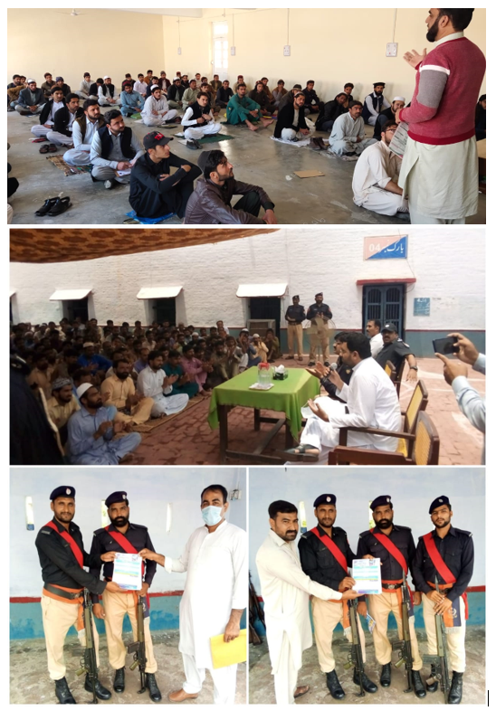
7- ONE-DAY HANDS-ON WORKSHOP ON DATA ANALYSIS AND INTERPRETATION USING SPSS
ORIC-AIOU arranged a Seminar titled “Data Analysis and Interpretation using SPSS” on 18th March, 2021 from 09:30 am to 01:00 pm in the Chinese Computer Lab (Academic Complex). The basic objective for holding this seminar wass to provide the skills to researchers regarding data analysis in order to conserve their time and effort in research work. This also provided students with the knowledge of the statistical tools to be employed and ability to run statistical software packages. This seminar gave an orientiation to MS/M.Phil/Ph.D scholars from various disciplines.
8- Public Awareness Seminars/gatherings on the Importance of Education
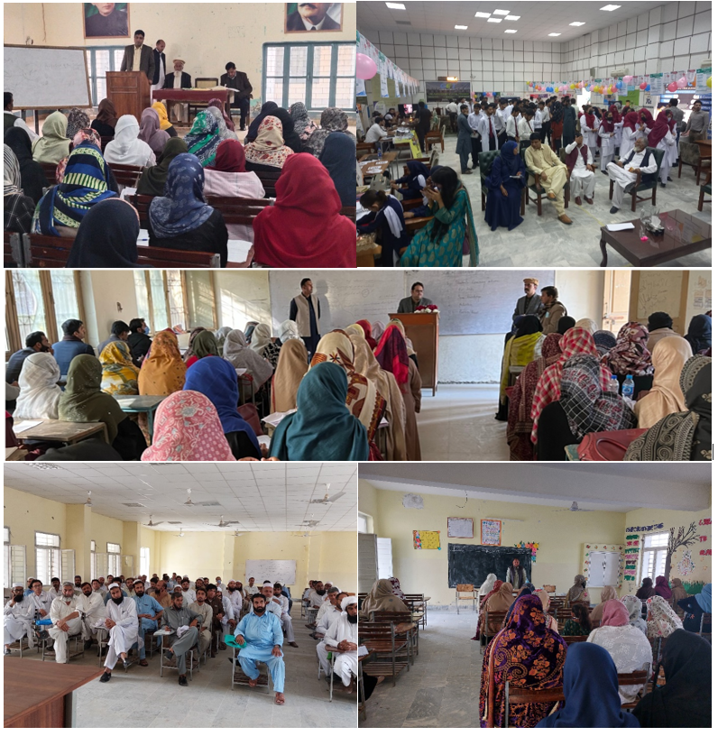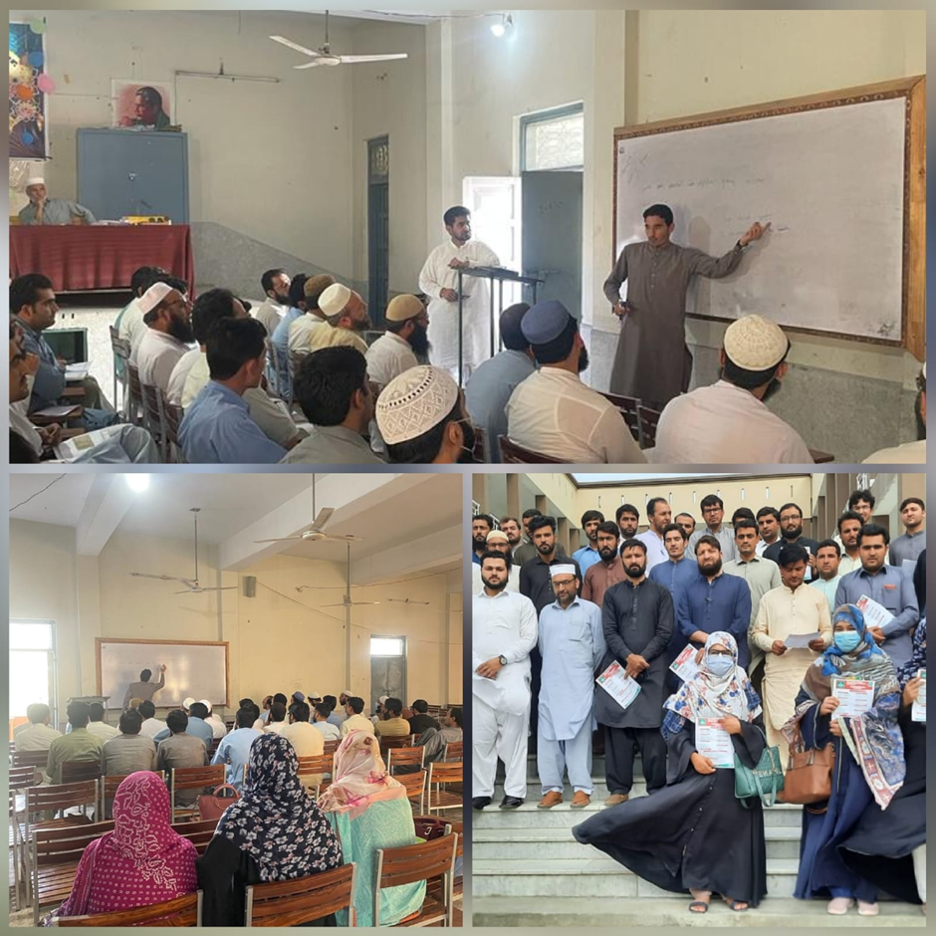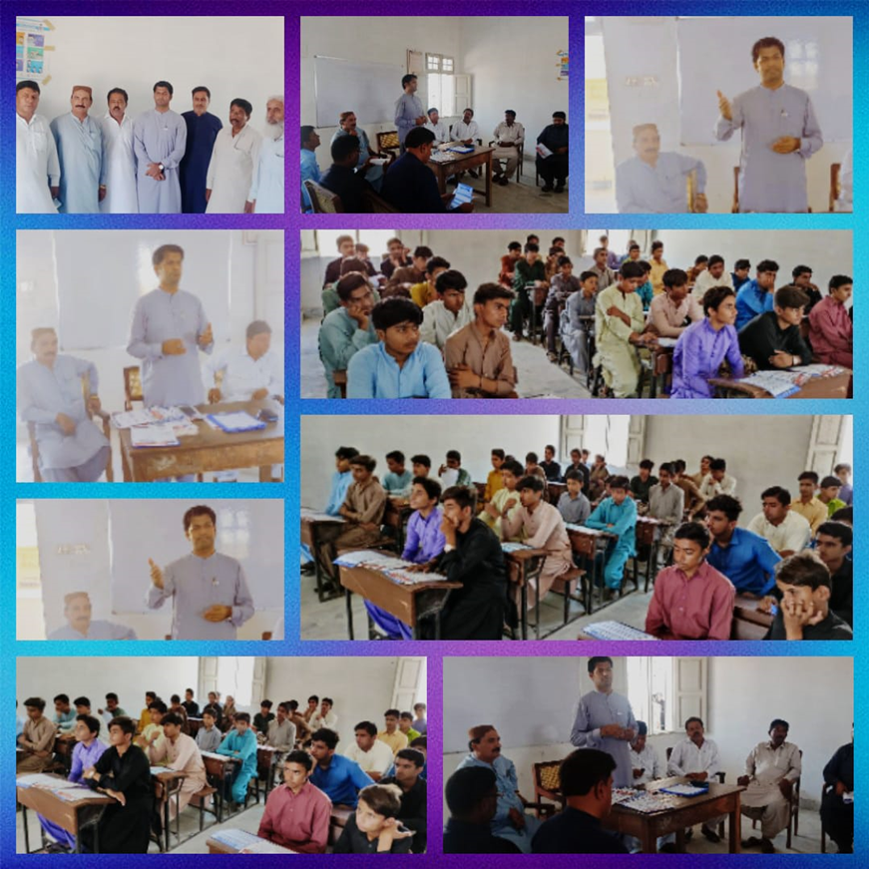
9- One Day Webinar on “Entrepreneurial Ideas in Humanities and Social Sciences”
10- Webinar on “Innovation & Entrepreneurship”
11- One Day Interactive Workshop on “Awareness of Opportunities for International Career Paths”

