Employment Practice Living Wage
Since the AIOU is a public sector university, it complies with the policy already in place by the Finance Division, Government of Pakistan. The policy grants rights to all civil employees a minimum of 25,000/- PKR which is determined as a decent local living wage by the Government of Pakistan. The official notification is provided in the following link:
https://www.finance.gov.pk/circulars/circular_14042022_1.pdf
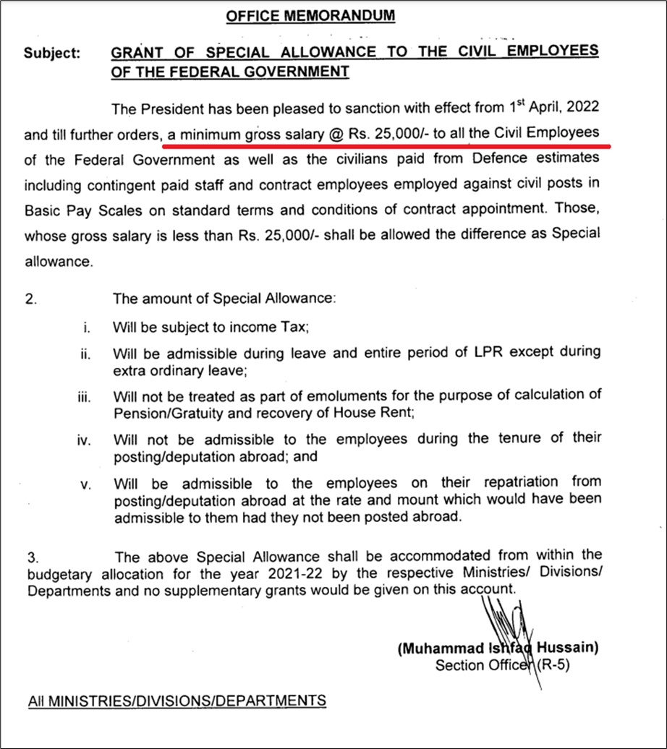
The average salary levels of our faculty and staff, as shown below, are all higher than the aforementioned basic wage standard.
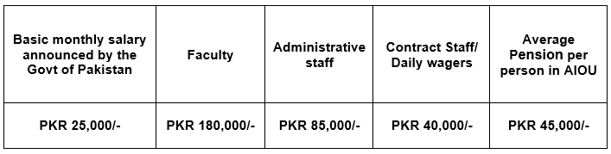
The average salary that AIOU pays to all our faculty and staff are higher than the standard for basic wages approved and announced by the Finance Division of Govt of Pakistan.
The average pension that AIOU pays to all its retired staff is higher than the minimum pension declared, approved and announced by the Finance Division of Govt of Pakistan.
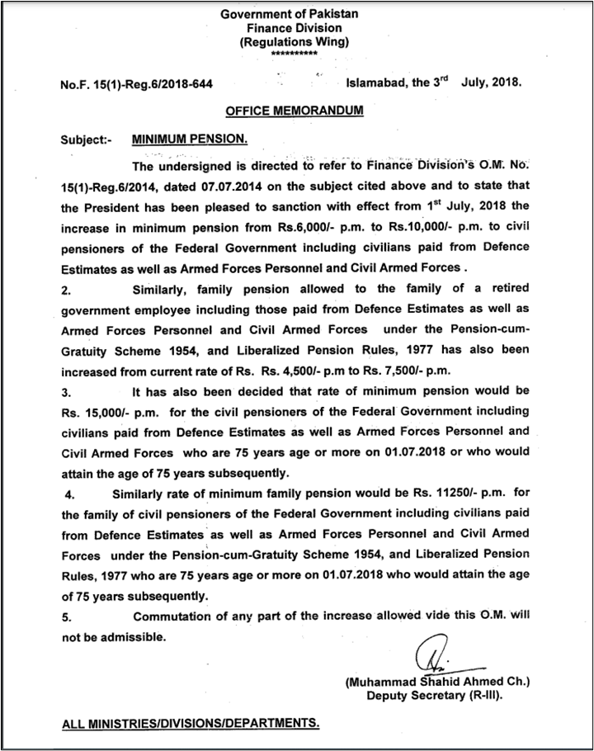
https://www.finance.gov.pk/circulars/circular_03072018_2.pdf
https://www.finance.gov.pk/circulars/circular_08072021_2.pdf
