Employment Policy on Discrimination
1- The AIOU has a clear non-discriminatory policy in its act which mentions that “The University shall be open to all persons of either sex of whatever religion, race, creed, class or colour and no citizen of Pakistan shall be denied the privileges of the University on the ground only, of sex, religion, race, caste, creed, class, color or domicile.” It is mentioned on page 11 of the following link:
https://www.aiou.edu.pk/rti/University%20Act/mobile/index.html
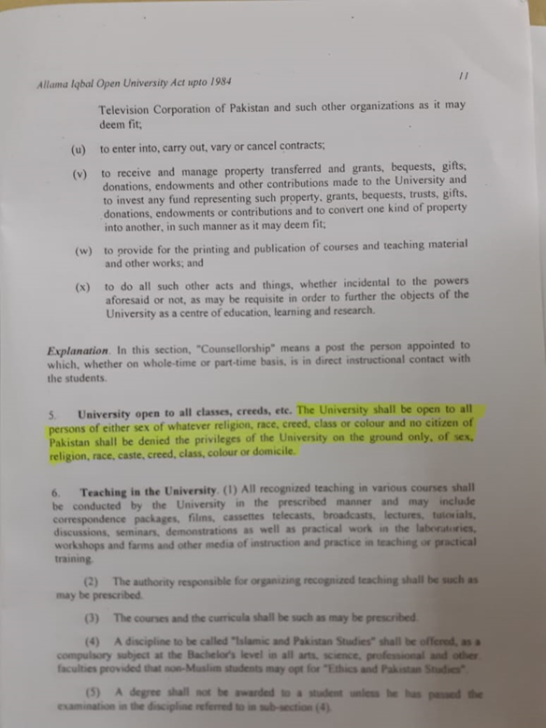
2- Training and other services are open to all irrespective of their sex, religion, race, caste, creed, class, color, or domicile. For example:
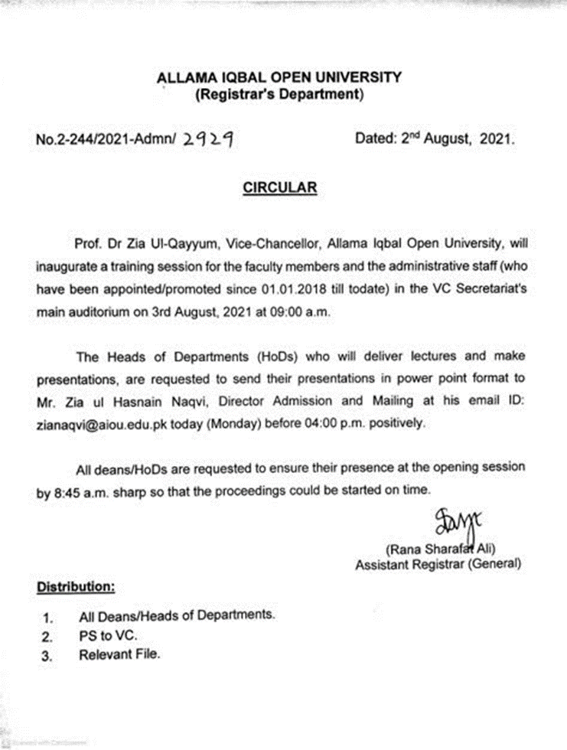
3- AIOU has designated staff to streamline the cases, especially of discriminatory nature:
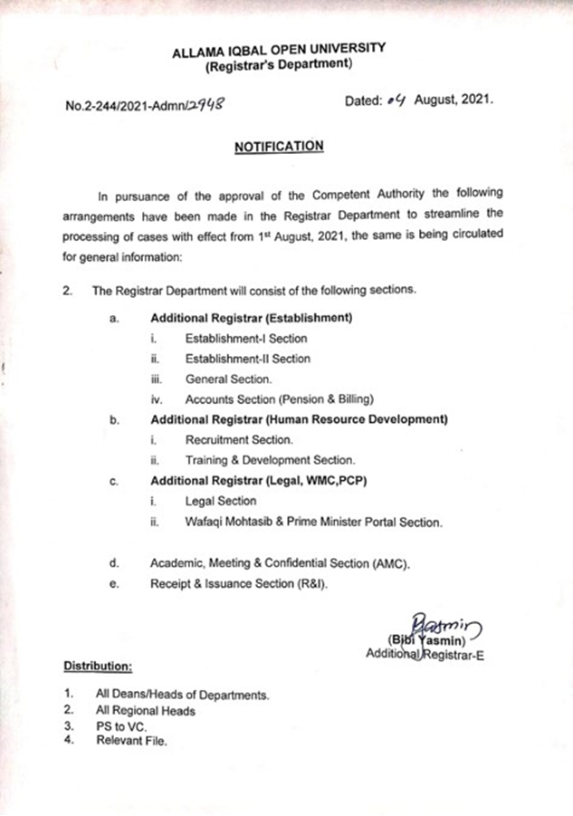
4- Equal rights to minorities:
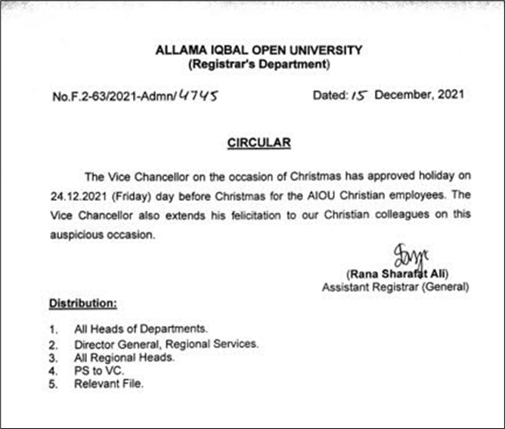
5- Disparity Reduction allowance for all employees
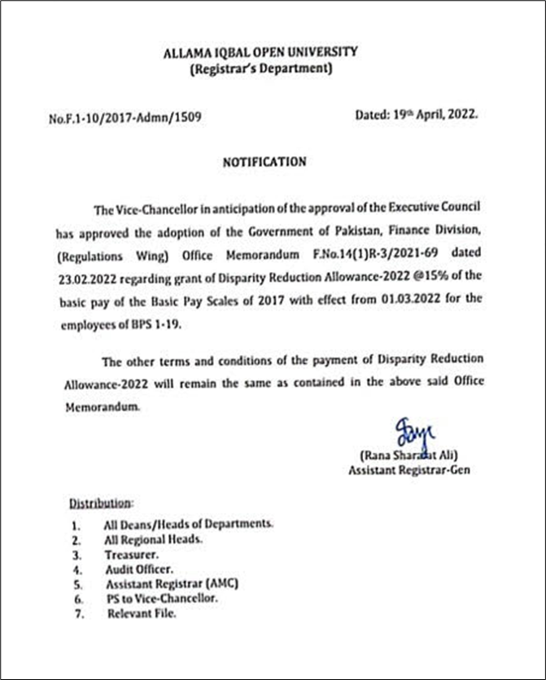
6- Circular for “Measures to ensure respectful, safe, secure, productive and conducive research environment in HEIs“
