Community Anti-poverty Programmes
1 • AIOU’s skills-based training programs on designing, cutting, stitching and entrepreneurship for girls and masonry for boys in Gilgit and Skardu
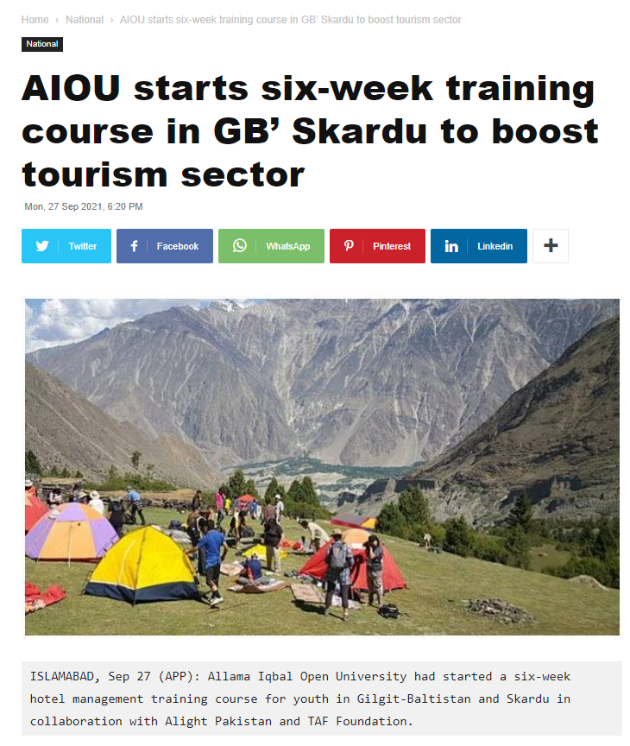
2 • AIOU and BF Technologies have jointly developed and launched short courses for youth to develop their e-commerce skills
3 • Hotel management training courses for youth in Gilgit-Baltistan and Skardu in collaboration with Alight Pakistan and TAF Foundation
https://www.aiounews.com/aiou-short-courses-2022-hospitality-and-customer-care//
4 • Post Graduate Diploma in Entrepreneurship
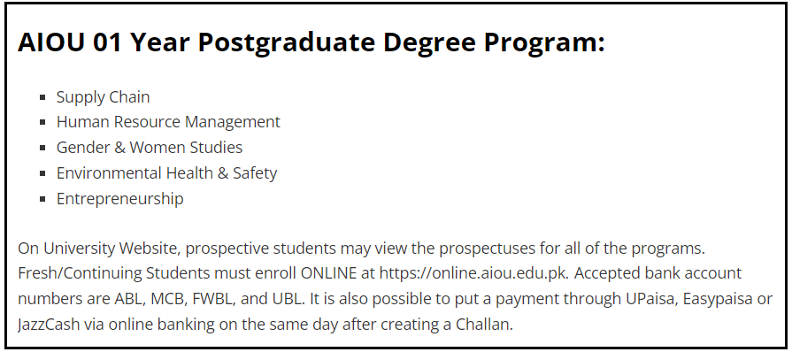
5 • Skill Based Training
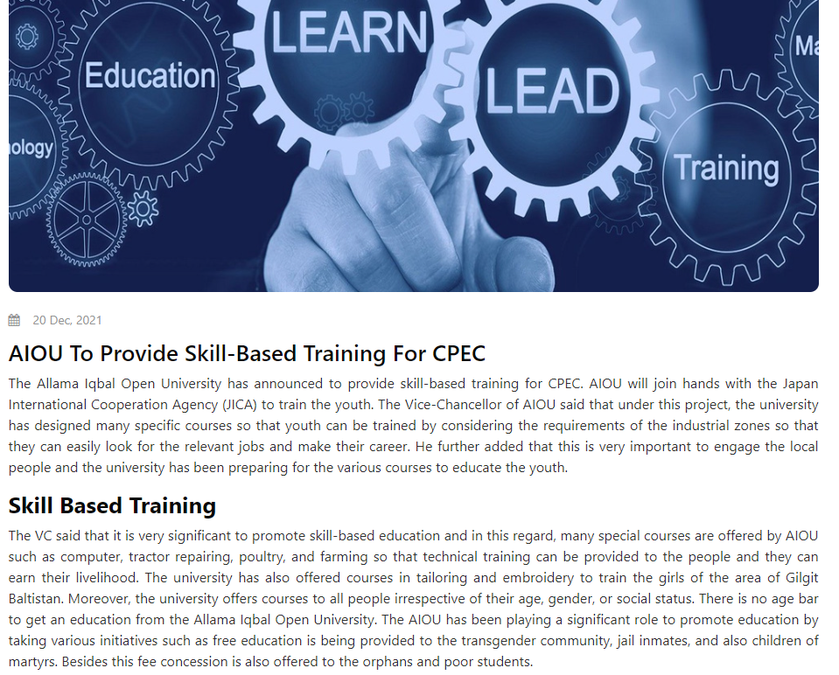
6 • Idea Competition for AIOU students /Alumni to select innovative ideas and their incubation at AIOU Business Incubation Centre
7 • Training of more than 3000 farmers across the country
8 • Training on “Kitchen Gardening” to the local community
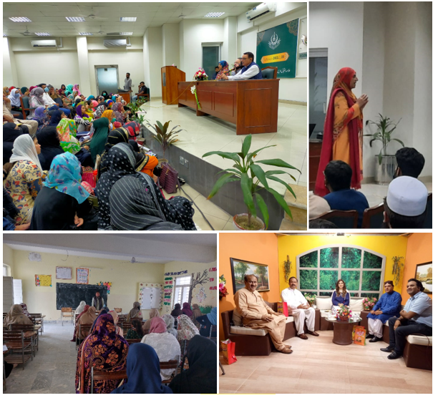
9 • Education/Training of Transgenders
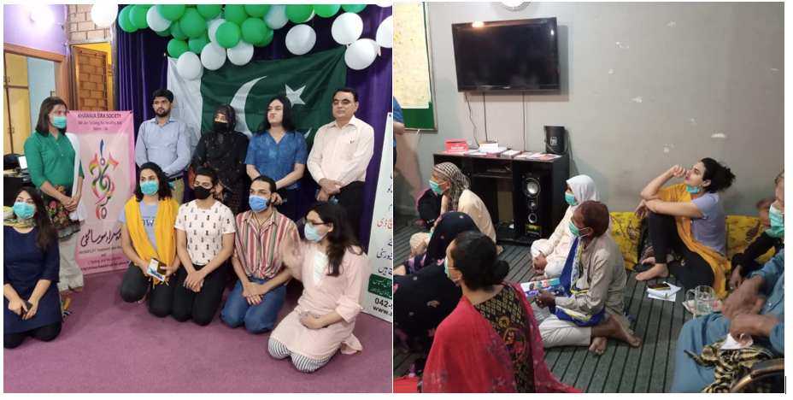
10 • Education/Training for Jail mates
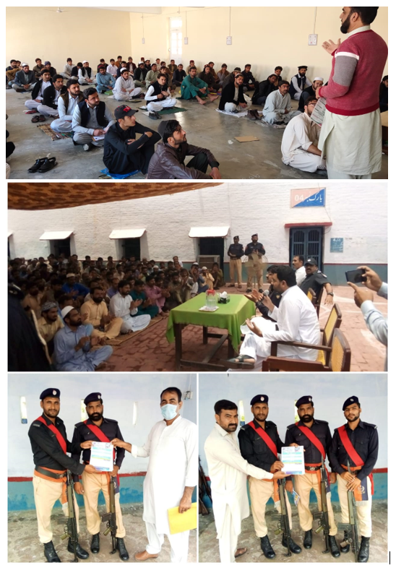
11 • Public Awareness Seminars/gatherings on skill Development & Entrepreneurship
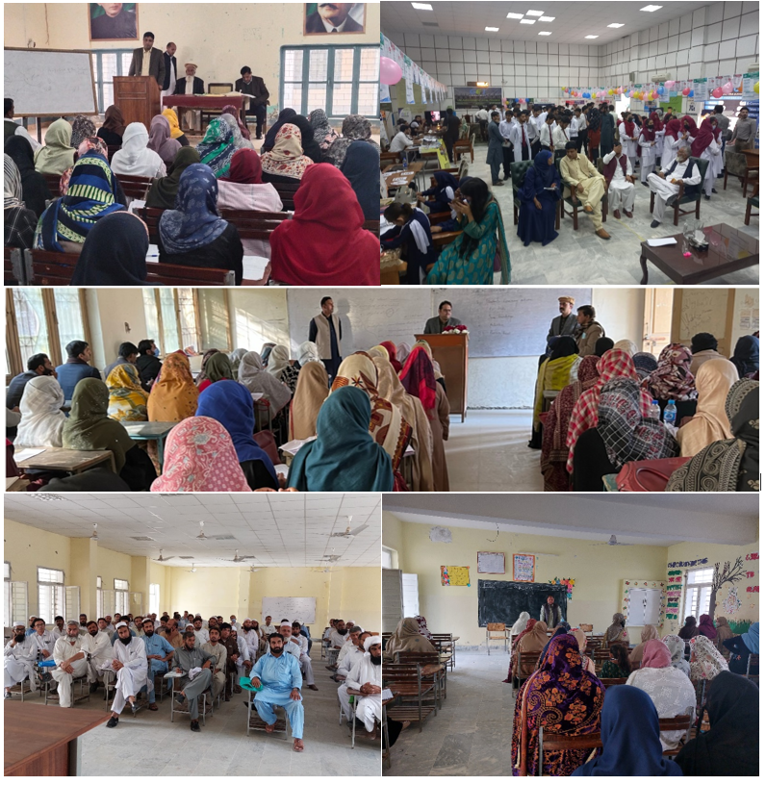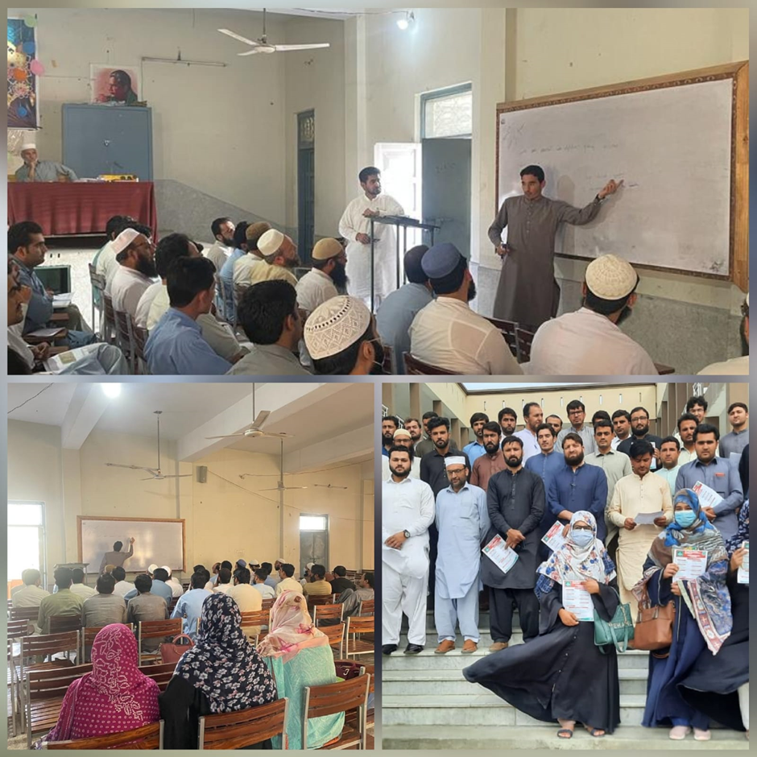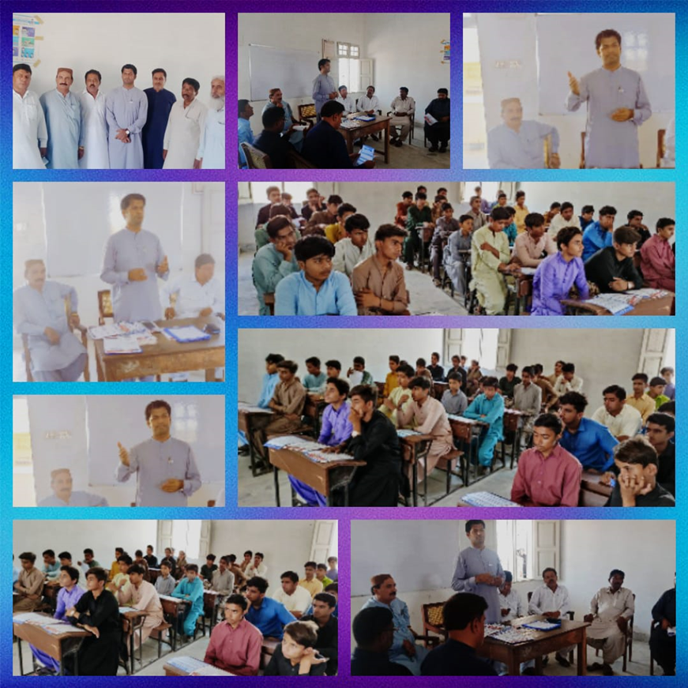
12 • One Day Webinar on “Entrepreneurial Ideas in Humanities and Social Sciences”
13 • Webinar on “Innovation & Entrepreneurship”
14 • One Day Interactive Workshop on “Awareness of Opportunities for International Career Paths”
15 • Skill Training
https://tribune.com.pk/story/2263305/aiou-to-launch-skill-training
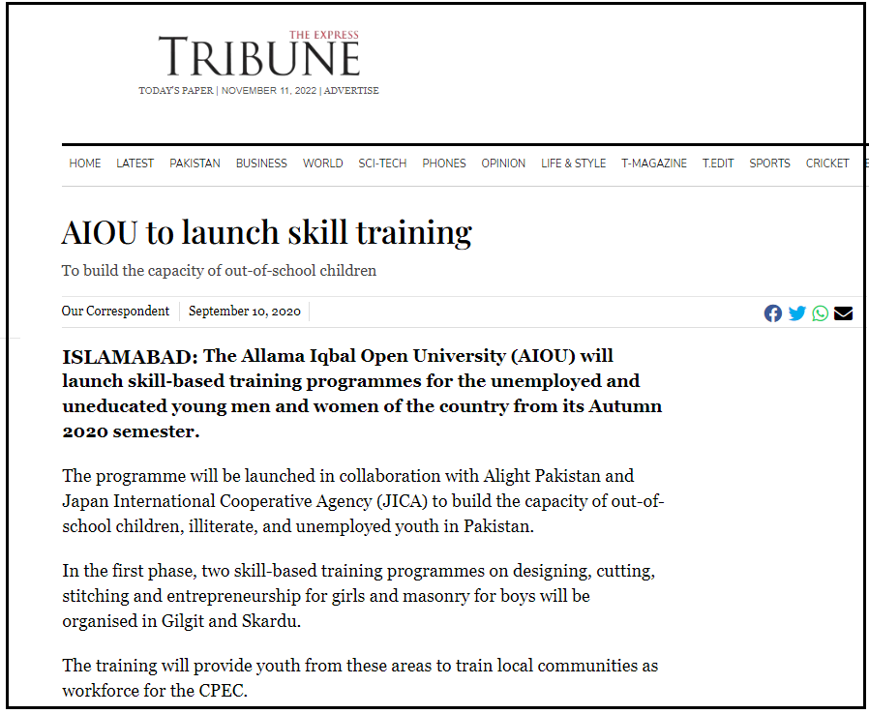
- AIOU Waives Fee For Flood Victims (https://www.urdupoint.com/en/pakistan/aiou-waives-fee-for-flood-victims-1560166.html)
- AIOU Holds RDs Conference For Inclusion Of Out-of-school Children (https://www.urdupoint.com/en/pakistan/aiou-holds-rds-conference-for-inclusion-of-ou-1542190.html)
- Pak army delegation lauds AIOU services for Gwadar https://www.brecorder.com/news/40176767/pak-army-delegation-lauds-aiou-services-for-gwadar
- AIOU Relaunches English Access Microscholarship Program (https://propakistani.pk/2022/04/14/aiou-relaunches-english-access-microscholarship-program/)

