AIOU’s adoption of international best practice on tackling the SDGs
*AIOU is continuously promoting SDGs and developing best practices to tackle the SDGs in all related fields. AIOU review comparative approaches and develop international best practice on tackling the SDGs through international collaboration and research.
Currently, AIOU is part of the following SDG-based initiatives to tackle the SDGs:
1- Times Higher Education releases annual Impact Rankings to assess universities against their pledges to implement SDGs. This is a ranking that universities must apply to and supply their own information, so not every school that has proclaimed support of the SDGs is included. AIOU is part of Impact ranking Data since 2019 and is improving its position each year by adopting all the best practices as advised and recommended.
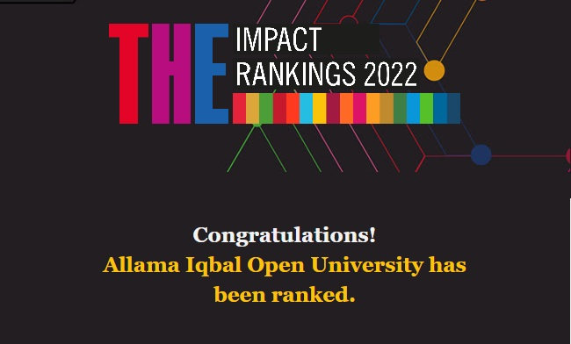
2- UI Green Metric University Sustainability Ranking is a world university ranking to assess and compare the current condition and policies related to Green Campus and Sustainability in Universities all over the world. As per the latest UI Green Metric ranking 2021, AIOU has been ranked 16th among other Pakistani universities, 245th in Asia and 485th among 956 participating Universities of the world. This is a great honor for the University that we have improved the University Ranking as compared to the previous year 2020.
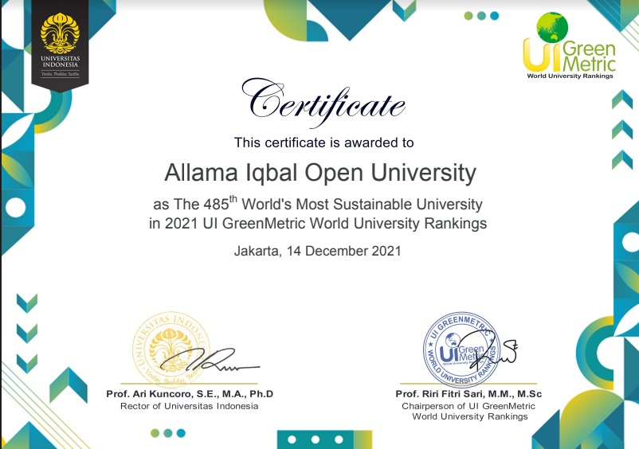
3- The university is also offering programs in collaboration with the Commonwealth of Learning (COL).
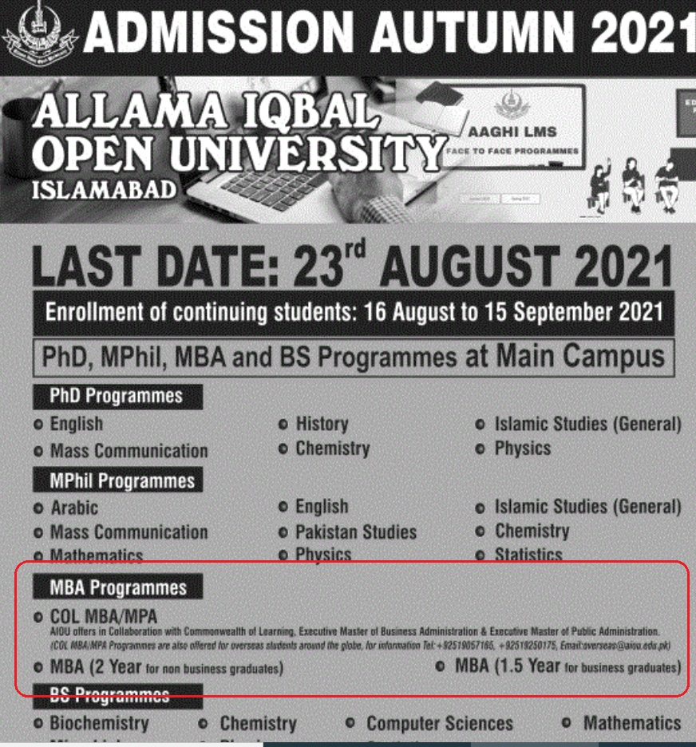
4- AIOU is also hosting international students and faculty for exchange programs that involve the issues addressed by SDG’s from countries such as Turkey, Egypt, Indonesia, Central Asian States, and Belarus. Moreover, it also provides opportunities for AIOU students, faculty, and staff to go on fellowships/exchange programs.
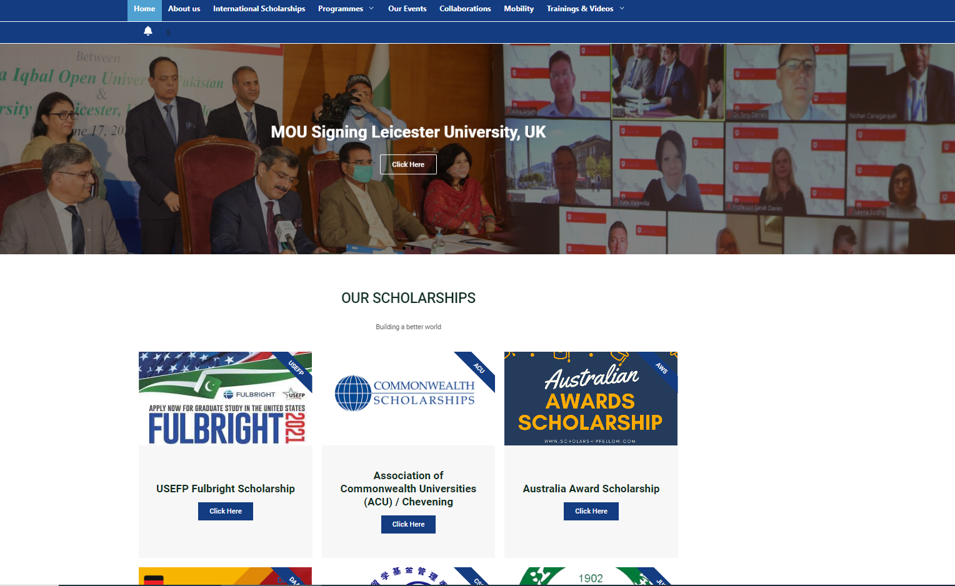
5- Hum Pakistani’ is an initiative launched by Allama Iqbal Open University (AIOU) in collaboration with the Sustainable Development Policy Institute (SDPI) and Pakistan Peace Collective. Under the initiative, trainings are being imparted to the people at the tehsil and district levels to promote the ‘Hum Pakistani’ narrative aimed at addressing the common challenges and purging the society from the menace of extremism and terrorism.
Hum-Pakistani-Programme-1Download
6- Clean green Pakistan is a national campaign and AIOU has also become a part of this national campaign by organizing activities related to “Clean Green Pakistan” in Main campus and across its regions such as; Tree plantation drive etc.
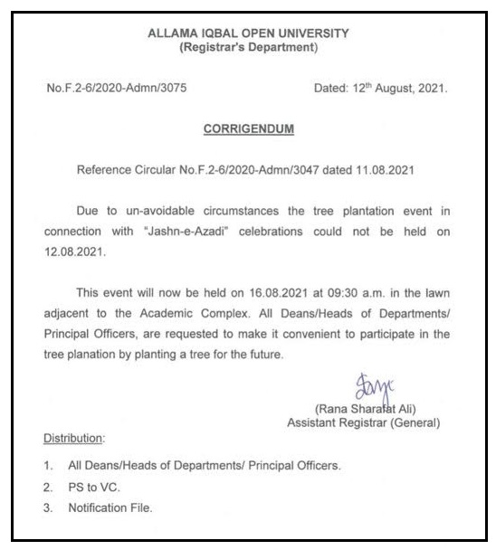
7- AIOU has been a part of Anti-tobacco drive: University campuses to go smoke free. In 2017, Allama Iqbal Open University (AIOU) and Capital Administration of Pakistan signed a Memorandum of Understanding (MoU) to motivate the youth, ‘Say no to Tobacco’. The AIOU campus has already been declared smoking free area.
