AIOU’s Participation in Policy-making at local, regional, national and/or global levels to implement programs and policies to end poverty in all its dimensions
AIOU is part of many forums internationally and nationally and participate in various seminars, conferences and policy dialogues to recommend stakeholders the future policies and programs to end poverty in all its dimensions.
i- AIOU was part of the ‘NUTRITION International“ forum to devise policy guidelines for maternal, newborn and adolescent health and nutrition in Pakistan.
Health-AIOU-SGBA-Report-PakistanDownload
ii- NEXT Gen U training for Pakistani Youth to become independent
NextGenU-CHSD-signed-document-2Download
AIOU Faculty and Staff input in Policy Dialogues:
1. Meeting of ORIC managers held at Rawalpindi Medical University for community work related to SDGs
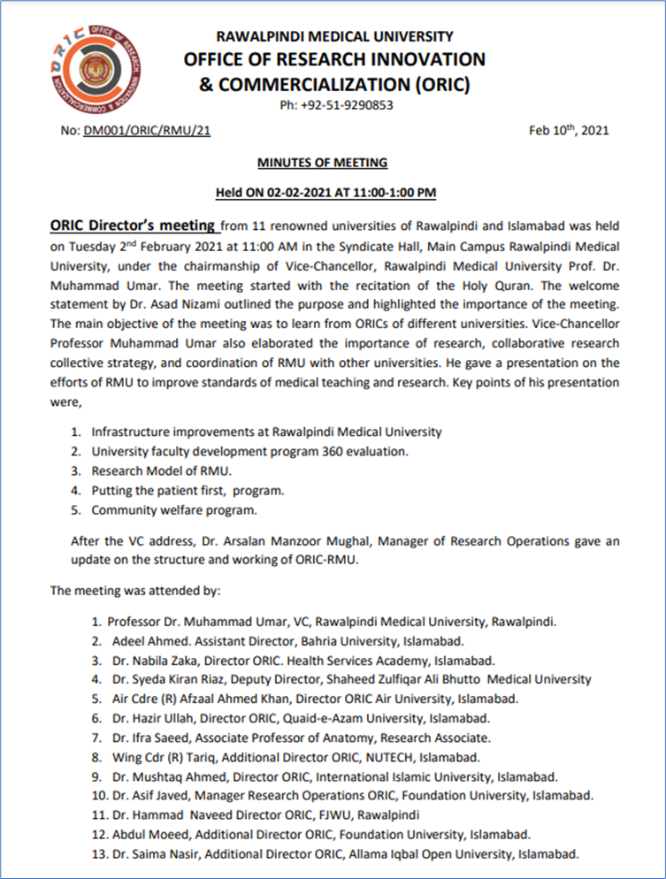
2. Consultancy Services to HEC to develop concrete and detailed operational plans to assist higher education institutes to mobilize resources from non-governmental sources – Resource Enhancement Framework
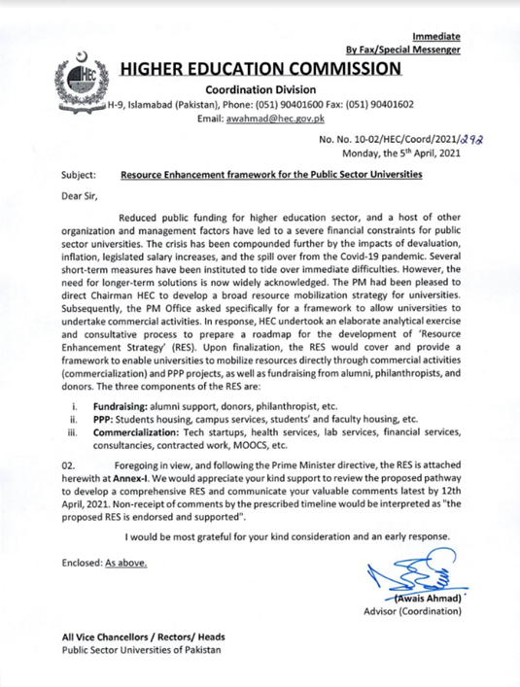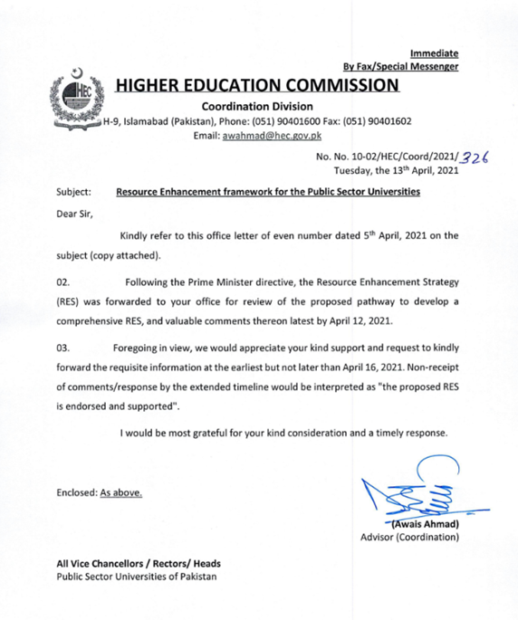
AIOU’s ASEA-UNINET Membership
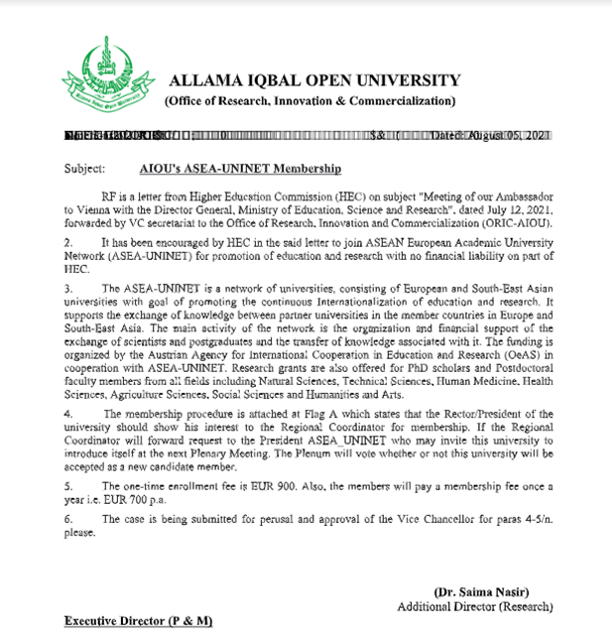
Dr Munazza as reviewer British Council
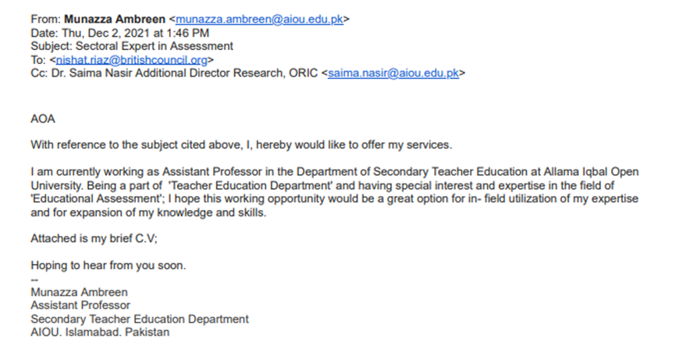
AIOU is a member of the AAOU forum:
AAOUDownload
AIOU is a member of ICDE:
International-Council-for-Open-and-Distance-EducationDownload

