AIOU in SDG Policy Development
Members of the University serve as committee members in various central organs including the Higher Education Commission, Ministry of Federal Education and Professional Training, and Ministry of Science and Technology (MoST), assisting the policy development process by identifying problems and challenges as well as by formulating policies and strategies. Scholars from the University have actively participated in international cooperation projects and events. By combining the characteristics of domestic research with international research, the University is able to enhance its international research perspective and its influence in sustainable development.
AIOU’s initiatives for Policy Development based on SDGs:
1- Hum Pakistani’ is an initiative launched by Allama Iqbal Open University (AIOU) in collaboration with the Sustainable Development Policy Institute (SDPI) and Pakistan Peace Collective. Under the initiative, trainings are being imparted to the people at the tehsil and district levels to promote the ‘Hum Pakistani’ narrative aimed at addressing the common challenges and purging the society from the menace of extremism and terrorism.
Hum-Pakistani-Programme-1Download
2- Clean green Pakistan is a national campaign and AIOU has also become a part of this national campaign by organizing activities related to “Clean Green Pakistan” in Main campus and across its regions such as; Tree plantation drive etc.
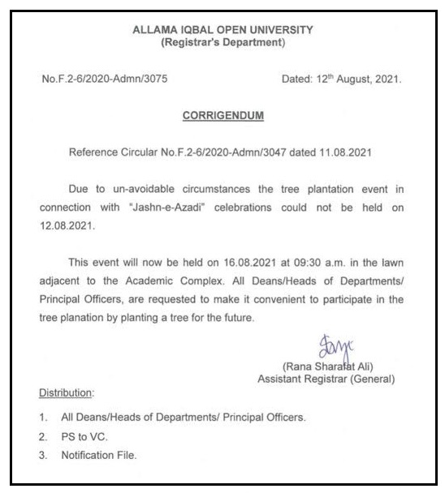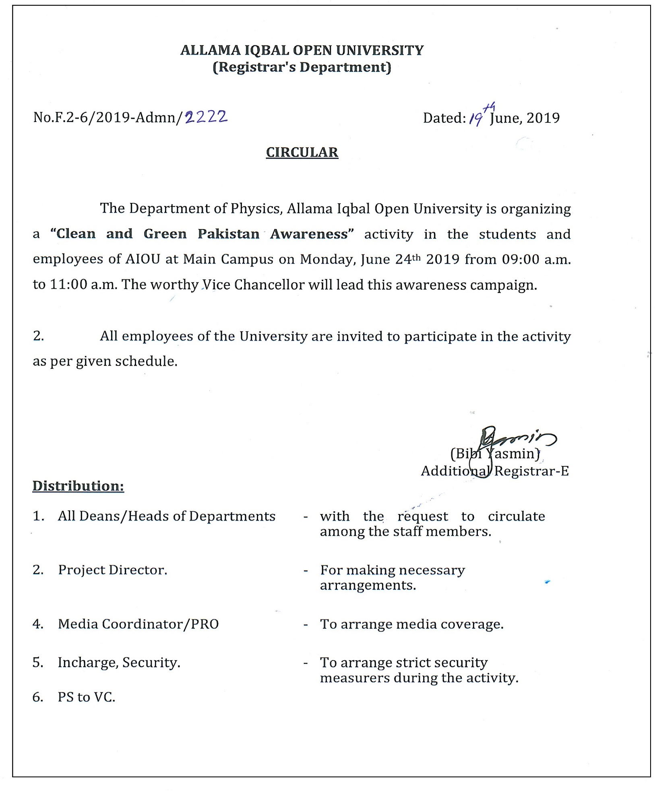
2- AIOU has been a part of Anti-tobacco drive: University campuses to go smoke free. In 2017, Allama Iqbal Open University (AIOU) and Capital Administration of Pakistan signed a Memorandum of Understanding (MoU) to motivate the youth, ‘Say no to Tobacco’. The AIOU campus has already been declared smoking free area.
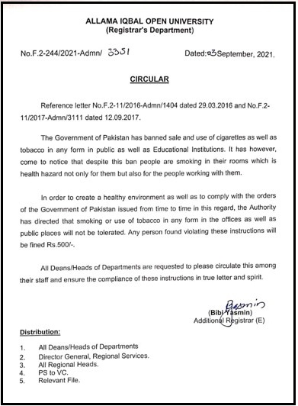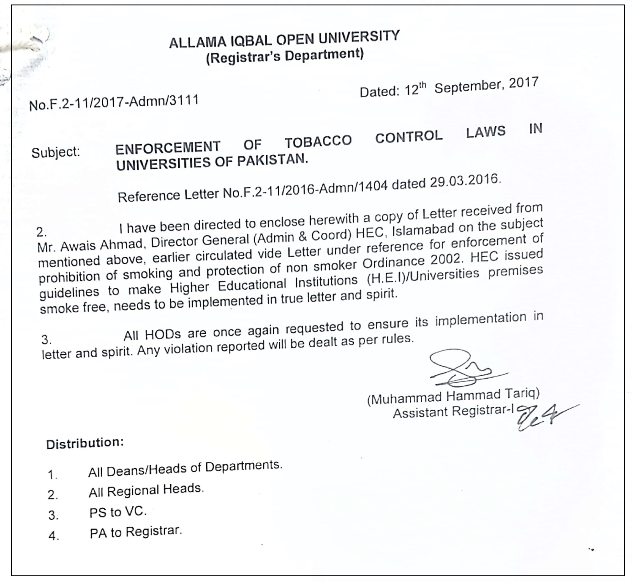

AIOU Faculty and Staff input in Policy Dialogues:
1. Meeting of ORIC managers held at Rawalpindi Medical University for community work related to SDGs
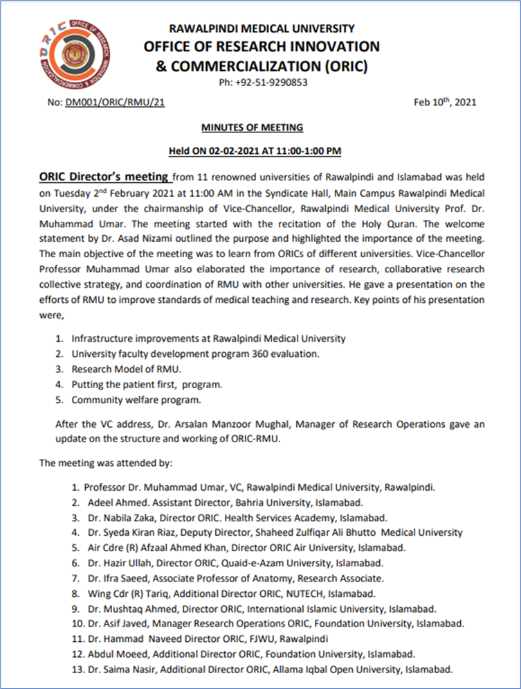
2. Consultancy Services to HEC to develop concrete and detailed operational plans to assist higher education institutes mobilize resources from non-governmental sources – Resource Enhancement Framework
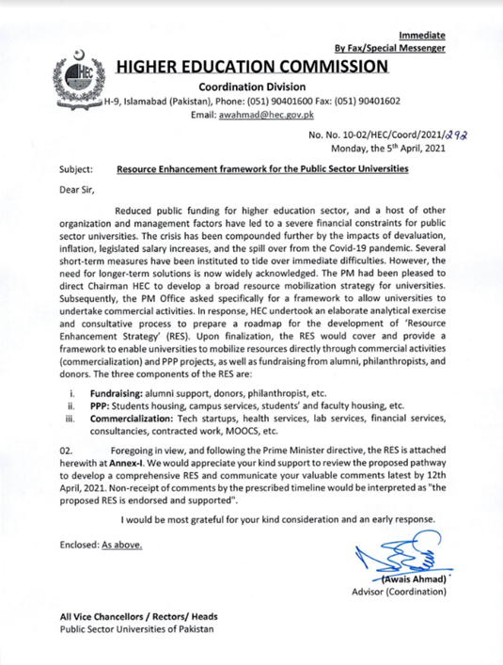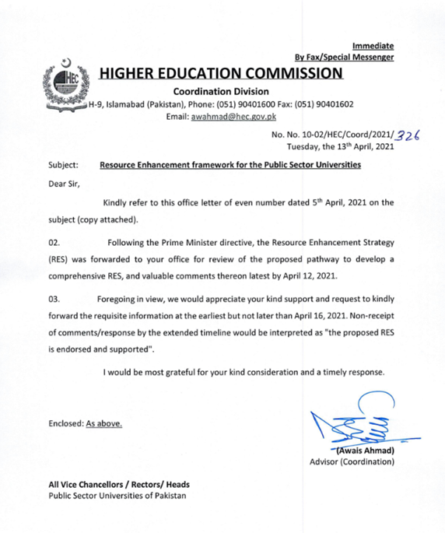
3- Dr Munazza Ambreen (Assistant Professor AIOU) as reviewer British Council
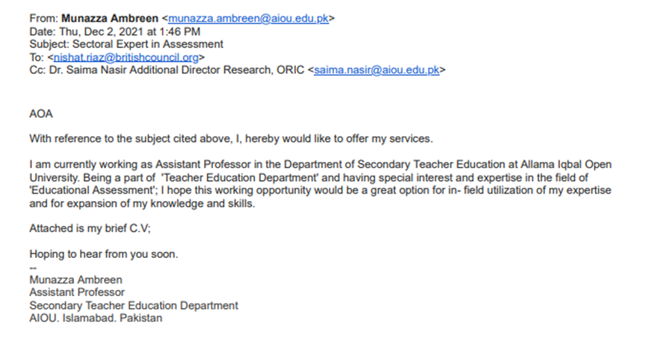

Our faculty and other staff attended these SDGs based events:
1. Higher Education Commission’s Local Challenge Fund workshop
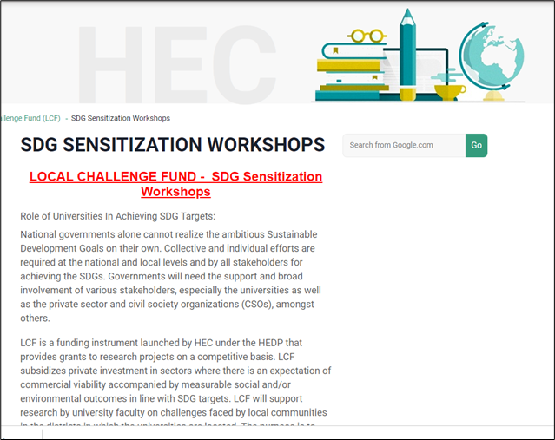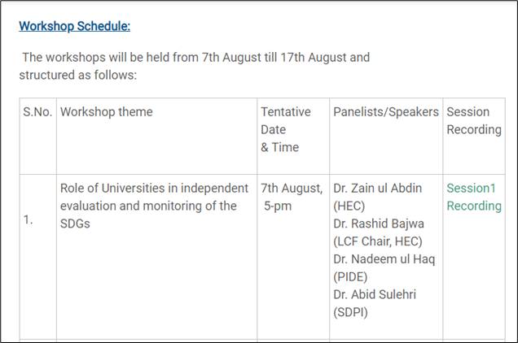

AIOU’s ASEA-UNINET Membership
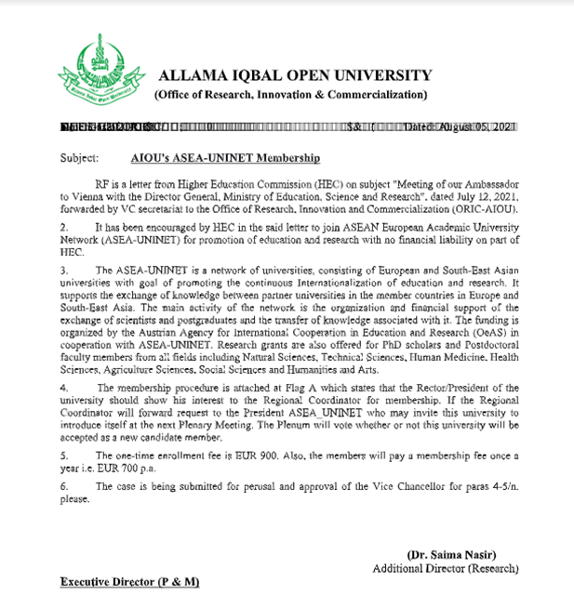

SEARCH SITE
Top of Form
Bottom of Form

FUNDING OPPORTUNITIES FOR AIOU FACULTY
https://www.advance-africa.com/Call-for-Proposals.html
https://www.authoraid.info/en/funding/
https://www.sida.se/en/for-partners/research-partners/research-calls-and-grants
https://www.idrc.ca/en/funding
Covid 19 research funding opportunities
IFS Individual Research Grants
https://www.terravivagrants.info/
https://opecfund.org/what-we-offer/grants/grant-application
https://www.advance-africa.com/Call-for-Proposals-and-Grants-for-Short-Films-in-Pakistan.html
https://www.advance-africa.com/Canada-Fund-for-Local-Initiatives-in-Pakistan.html
https://www.advance-africa.com/German-Embassy-Grants-for-Micro-Projects-in-Pakistan.html
https://www.advance-africa.com/Heritage-Grants-for-Young-People-in-India-and-Pakistan-and-Bangladesh.html
https://www.advance-africa.com/Human-Rights-Monitoring-and-Advocacy-Small-Grants-in-Pakistan.html
https://www.advance-africa.com/Social-Change-Through-Arts-Grants-in-Pakistan-and-India.html
https://www.advance-africa.com/USAID-Grants-for-Placing-Pakistani-Youth-in-Jobs.html
http://www.mladiinfo.eu/2021/03/11/twas-research-grants-program/
https://www.advance-africa.com/Australian-High-Commission-Small-Grants-in-Pakistan.html
https://www.advance-africa.com/Early-Career-Grants-for-Individuals.html
https://www.advance-africa.com/PhD-and-Masters-by-Research-Scholarships.html
https://www.advance-africa.com/Research-Grants-for-PhD-Students-and-Young-Academics.html

