AIOU in Cross-Sectoral Dialogues for SDGs
The AIOU has huge teaching and research capacity, which is conducive for teachers and students to establish a cooperative relationships (such as industry-academy cooperation and internship) with other local, national and international organizations. AIOU has arranged a number of national and international conferences based on SDGs in collaboration with the government and NGOs.
Moreover, based on industry trends, the University has developed courses and programs related to emerging fields such as smart technology, Artificial Intelligence, Virtual Setups, Entrepreneurship, green energy technology, Medicinal products and medical biotechnology to narrow the gap between education and application as well as cultivate talent with both social and professional knowledge.

Initiatives:
1- CAKE-Tech
The project “Collective Action on Knowledge Economy with Technology” (CAKE-Tech) has been established with the conviction that Cyber technologies can function as a tool for targeting the SDGs. UN SDGs are 17 milestones to be achieved by all the signatory nations. Pakistan being part of this global effort is endeavoring to achieve these SDGs.
Two international conferences have been arranged uptill now under CAKE-Tech initiative.
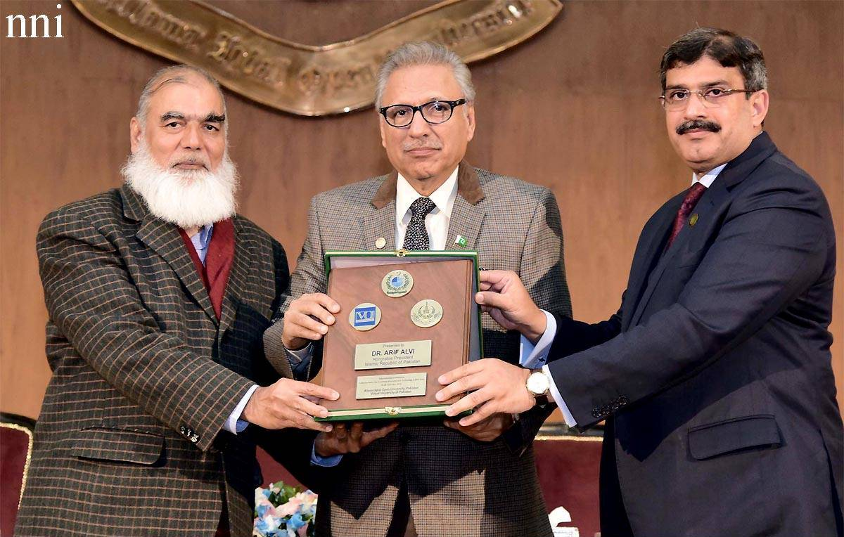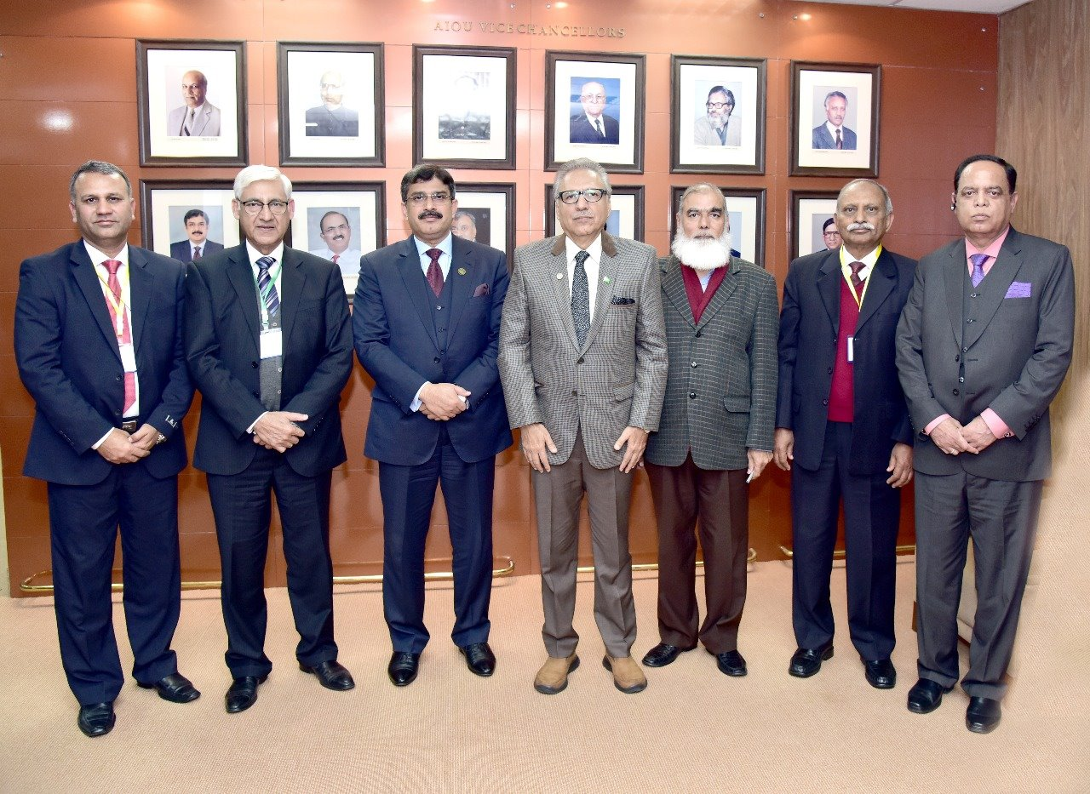
2- AIOU’s ^{1st} International Conference on Climate Resilient Agriculture for Sustainable Development & Food Security (ICCRA-SD & FS-2022)
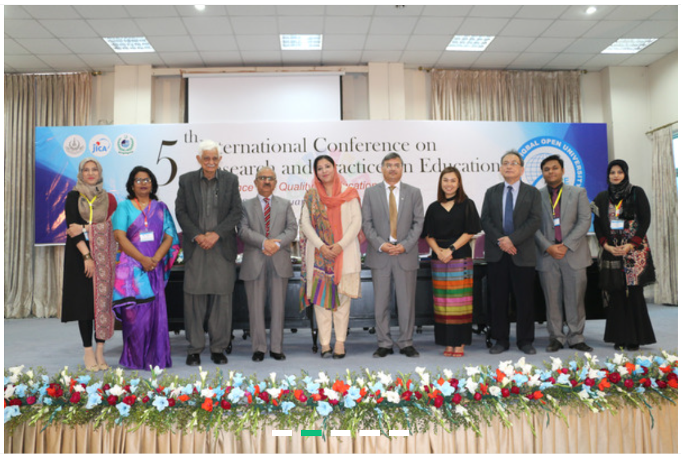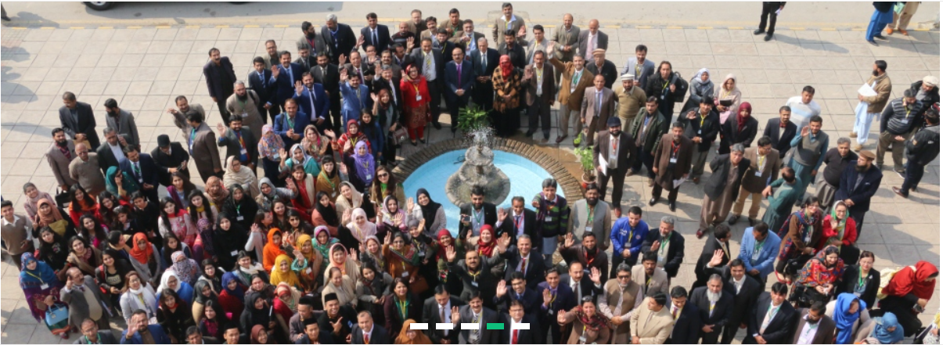
3- E-Commerce seminar
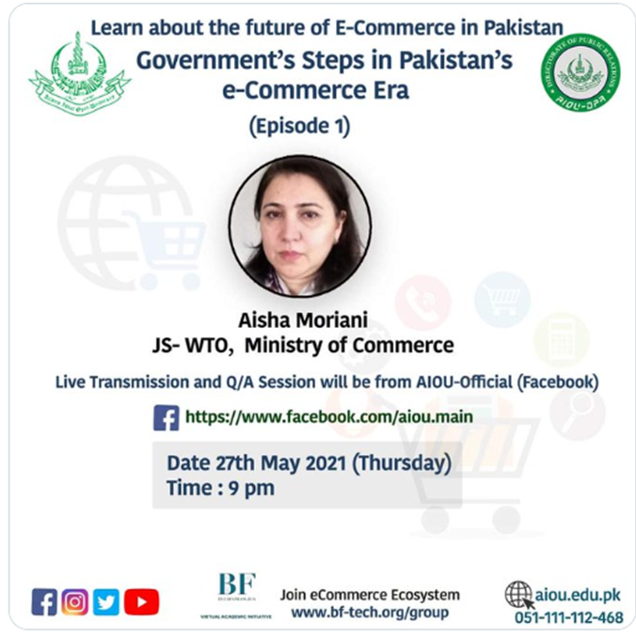
2- AIOU Conference on SDGs
Conference-on-SDGsDownload
3- International Conference on Interfaith Relations:
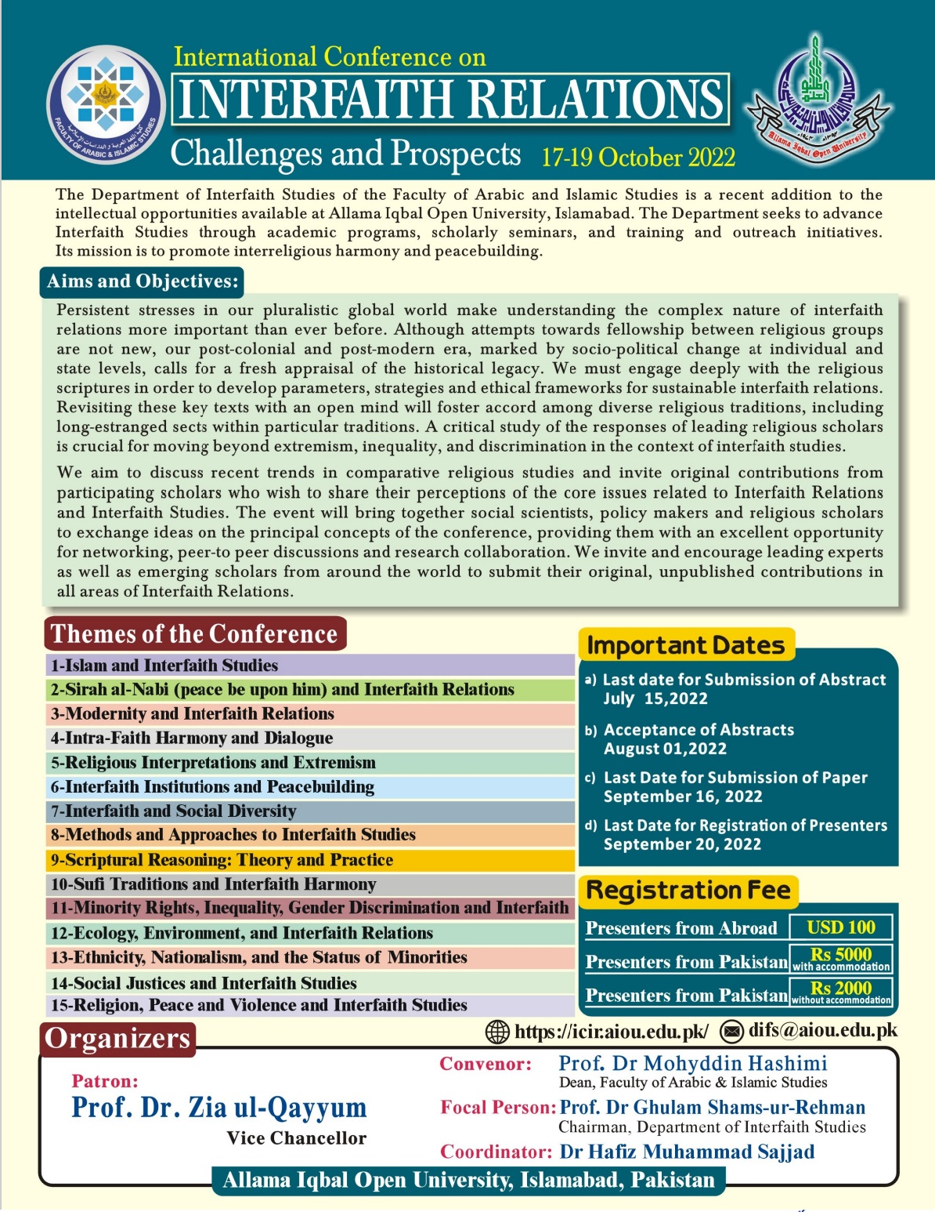
4- International Conference on Interfaith Relations: Challenges and Prospects
Interfaith-Conference-programme-bookDownload

Other Conferences attended by AIOU faculty and staff:
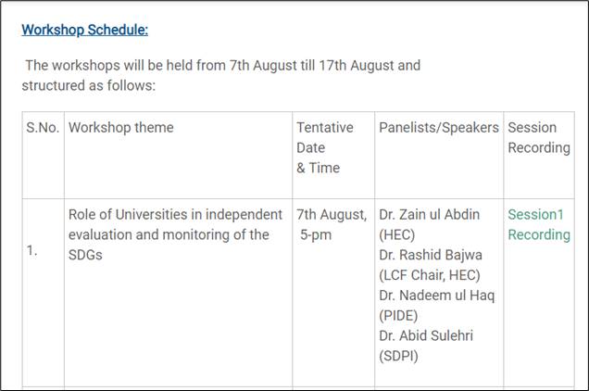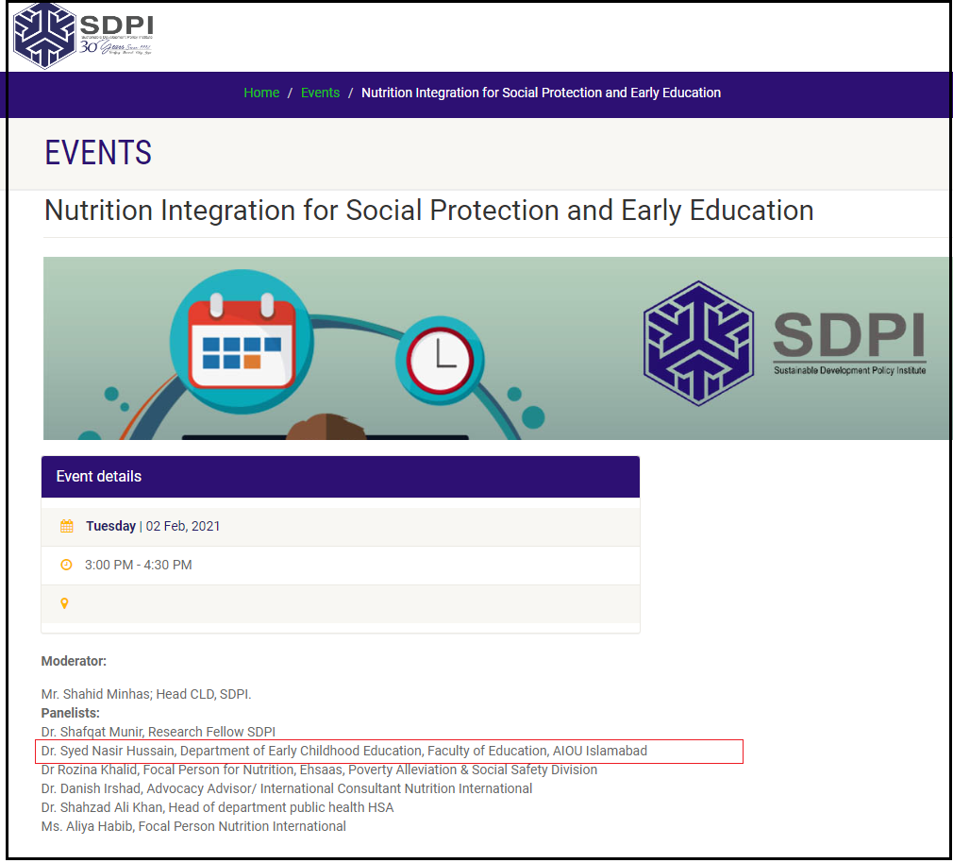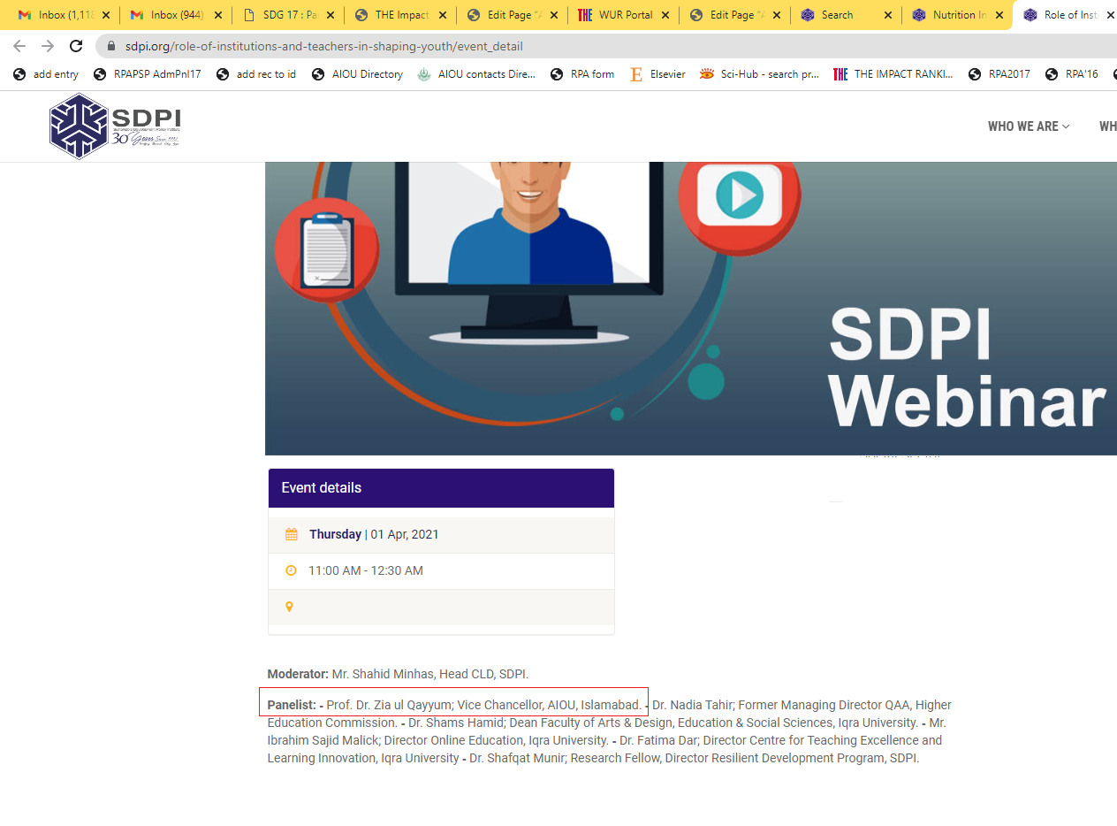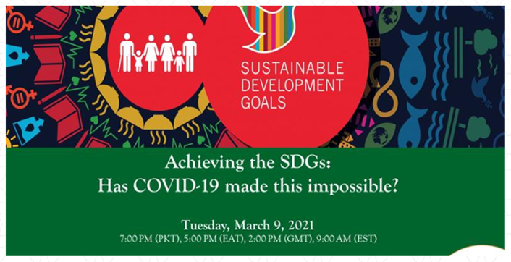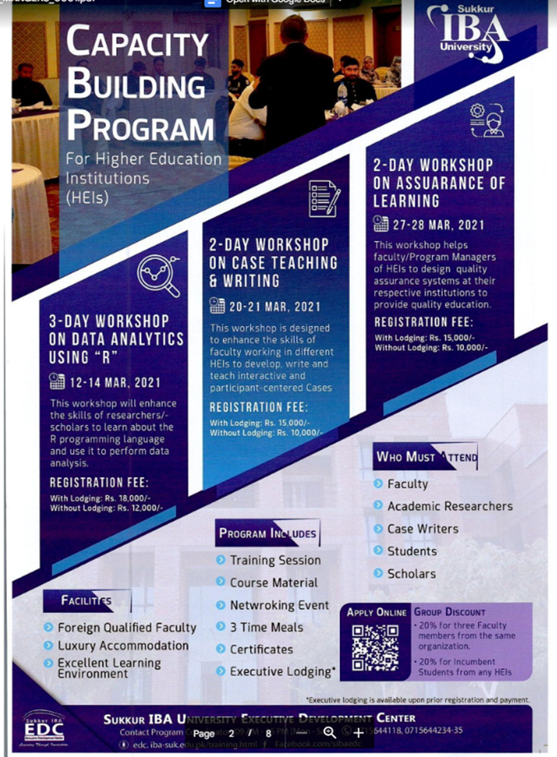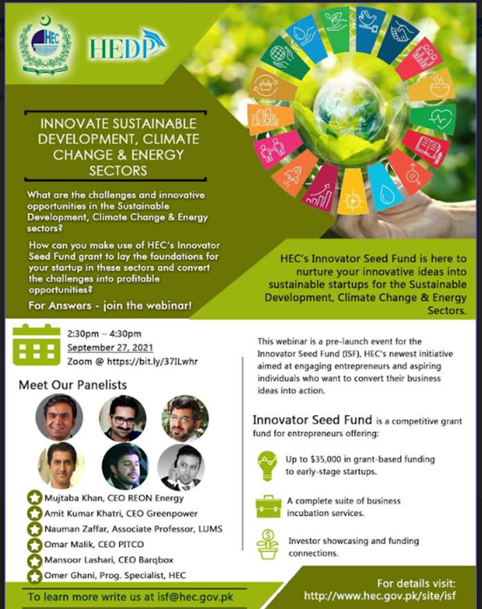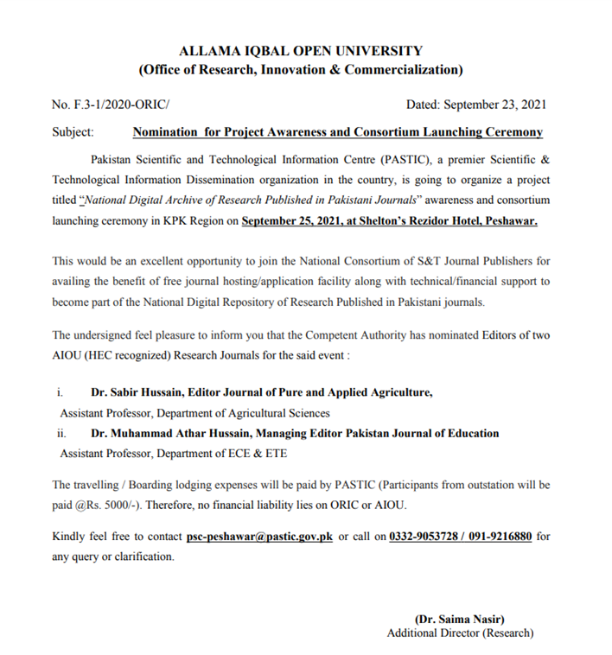
AIOU also Signed a number of MoUs with Universities, institutions, and NGOs
AIOU-COLLABORATIONS-WITH-SHIFADownload
AIOU & NextGenU-CHSD-signed-documentDownload

