Employment Practice Unions
The AIOU recognizes labor and union rights in accordance with the Government of Pakistan irrespective of gender and nationality. The AIOU currently has three unions namely:
- Employees Welfare Association (EWA)
- Academic Staff Association (ASA) and
- Officers Welfare Association (OWA).
All of these associations are working for the welfare and rights of employees duly endorsed by the University administration.
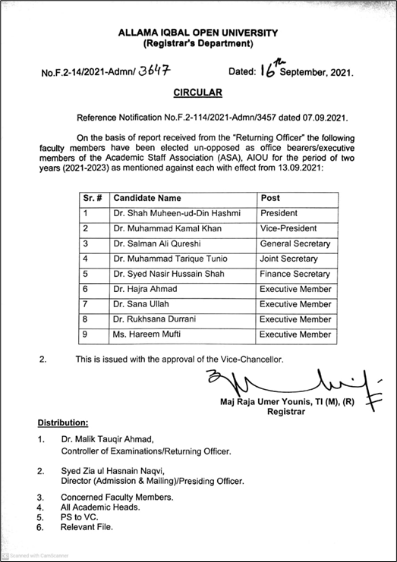ASA newly selected members’ notification
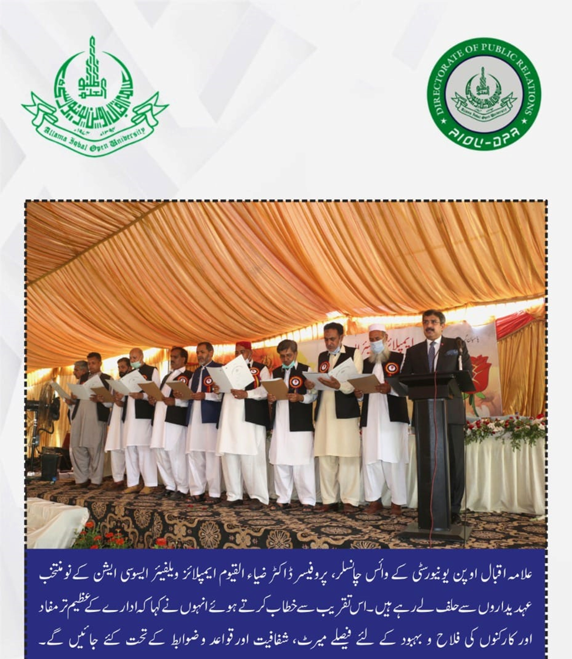EWA newly elected members Oath Taking Ceremony

