AIOU Courses related to sustainability and the SDGs
• AIOU is offering a number of academic courses addressing sustainability and the SDGs. The University offers a range of degrees and individual initiatives that cover vital issues raised by the SDGs.
For course content please visit https://aiou.edu.pk/books
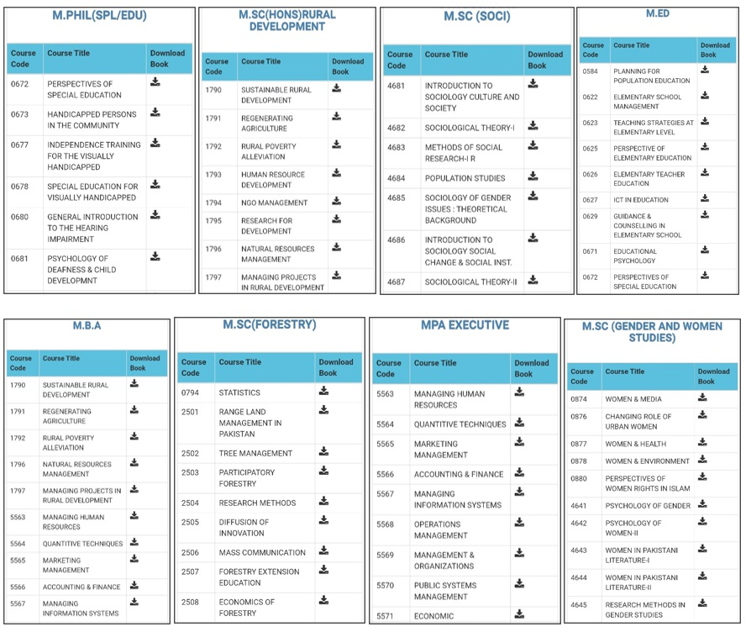Courses/Subjects Related to Sustainability in different programs
Course-Mapping-data-1Download

