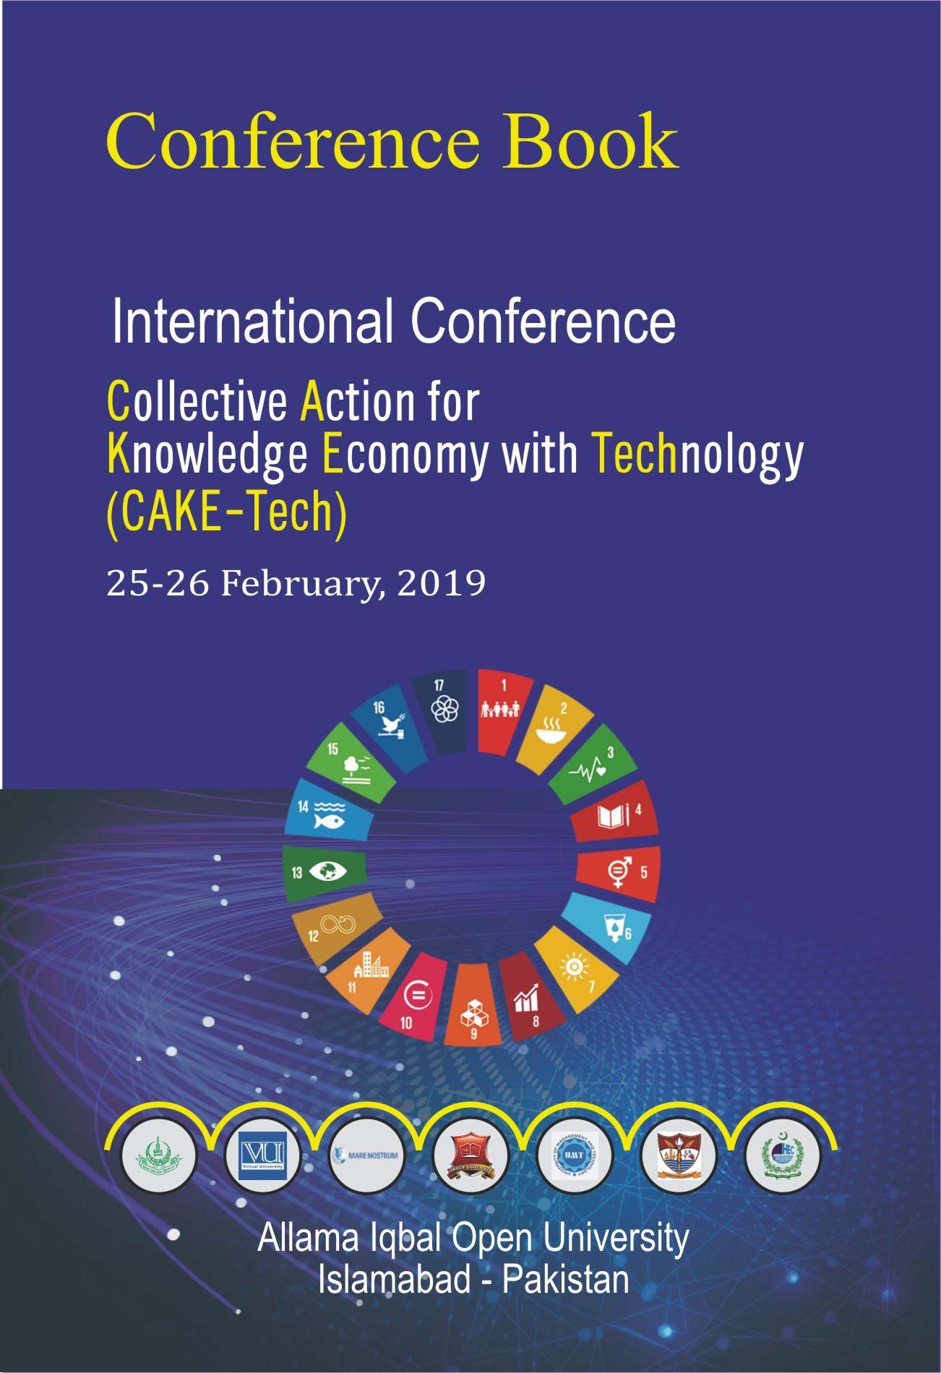

CONFERENCE BOOK

INTERNATIONAL CONFERENCE

COLLECTIVE ACTION FOR
KNOWLEDGE ECONOMY WITHTECHNOLOGY
(CAKE-Tech)

25-26 February 2019

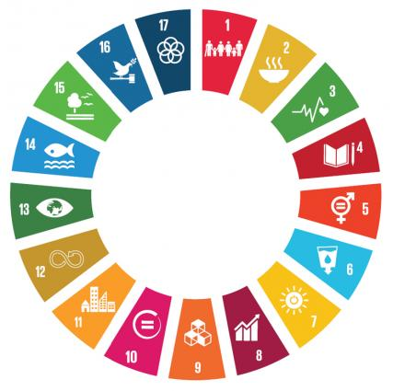

Allama Iqbal Open University
Islamabad, Pakistan
Sr. No. | Contents | Page No.
 | Conference Brief | 2
 | Message of The President of Islamic Republic of Pakistan | 3
 | Message of Federal Minister for Education and Professional Training | 4
 | Message of Vice Chancellor Allama Iqbal Open University | 5
 | Message of Rector Virtual University of Pakistan | 6
 | Message of The Founding Rector Virtual University of Pakistan | 7
 | Message of Conference Coordinator | 8
 | Conference Program (Inaugural Session) | 9
 | PlenarySession-I | 10
 | PlenarySession-II | 11
 | Parallel Workshop-I | 12
 | Parallel Workshop-II | 13
 | Parallel Workshop-III | 14
 | Closing Session | 15
 | Speakers’ Profile | 16
 | Conference Team | 26

CONFERENCE BRIEF

UN Sustainable Development Goals (SDGs) are 17 milestones to be achieved by all the signatory nations. Pakistan being part of this global effort is endeavouring to achieve these SDGs. The project “Collective Action on Knowledge Economy with Technology” (CAKE-Tech) is being established with the conviction that Cyber technologies can function as a tool for targeting the SDGs with a well synchronized holistic approach. Delivery of non-formal learning and skill development materials to change the mind-set and develop realization amongst the populace towards societal development will enable:
1. Application of technologies for empowerment of the masses.
2. Alliance with international and national players for sharing expertise and experience for mutual benefit.
3. Sustainable development and economic growth based on professional involvement of families, communities and societies.
4. The realization of the importance of family income management, family management, timely marriages, breast feeding and birth intervals.
5. Improvement in the quality of food for balanced nutrition, prevent deficiency diseases in mothers and children and supply of clean water.
6. Measures for better sanitation, hygiene and health.
7. Realization of the rights and responsibilities of citizens, justice, fair play and community relationship.
8. Sustainable energy sources especially green energy.
9. Provision of “Quality Education” for collective competence suited to future generations forced to handle new challenges.
10. The definition of a national research agenda through universities involved in guidance and research on CAKE-Tech.

The program is spread over two days starting with the Inaugural Session, followed by a Plenary Session and Workshops on conference themes. The deliberations will create a shared understanding amongst participants about national challenges and identification of appropriate interventions and technologies for addressing the same. The final wrap-up session will summarize the collective thoughts and help lay down the road map leading to accomplishment of SDGs.

MESSAGE OF THE PRESIDENT OF
ISLAMIC REPUBLIC OF PAKISTAN

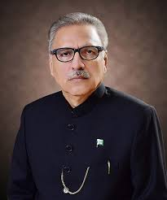

Pakistan is moving forward towards a better and brighter future. This country is blessed with all kinds of natural resources and human capital. We are looking towards the educational institutions to help in managing these resources in the most efficient and effective way. The idea of using mobile technology for the purpose of educating and helping the masses to participate in socio-economic development is very timely and innovative indeed. Mobile and telecom industry in Pakistan has evolved swiftly and today we have one of the largest mobile networks of the world.

Allama Iqbal Open University and Virtual University are two leading institutions in Pakistan which have opened new venues of education through distant learning. These institutions are doing a commendable service to the nation already. Now in collaboration with Qarshi University, University of Veterinary and Animal Sciences, and University of Management and Technology; this initiative, of developing mobile apps and content for achieving the Sustainable Development Goals, is an extra ordinary initiative.

It is evident that this two-day conference is a very well thought through event in which delegates and experts from within Pakistan and three other countries are participating for one cause and that is to help Pakistan develop further and achieve the SDGs through innovative and creative tools and techniques. This is not going to be one event but the beginning of a collaborative action plan. I would be looking forward to the proceedings of this event which will give us a clear picture of how the universities on the one hand can help in improving the quality of life at the household level and on the other hand provide support for socio-economic development of the country.

I am very much hopeful that the senior as well as the young and energetic faculties of the universities of Pakistan will be the real change agents. I especially appreciate the help and support extended by the foreign delegates and for sharing their experiential lessons with us. I wish you all very productive and useful brainstorming sessions through which you may be in a position to identify practical solutions for the current challenges and issues.

Dr. Arif Alvi
President of the Islamic Republic of Pakistan

MESSAGE OF FEDERAL MINISTER FOR
EDUCATION AND PROFESSIONAL TRAINING

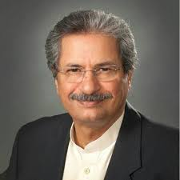

Education is believed to be the only source which can bring about transformational change in the mind-set of the masses in any country across the globe. We in Pakistan are striving to achieve the SDGs with the help of our educational institutions; which not only extend us support but also initiate projects to achieve these goals by making innovative use of prevalent technology that is most popular and massively used by the common man.

In Pakistan 24% of the total population uses mobile phones, while a bigger proportion of adults are active users of other mobile technologies too. The idea of using mobile applications through smart phones to outreach the masses is commendable from the platform of higher education.

I am glad to know that this two days conference on Collective Action of Knowledge Economy with Technology (CAKE-Tech) has been organized as a joint venture of Allama Iqbal Open University, Virtual University, Qarshi University, University of Veterinary and Animal Sciences, and University of Management and Technology. This practice of collaboration among universities is appreciable but most admirable is the act of collaboration between distance education institutions and formal institutions. This mutual feeling of trust among different modes of institutions must be nurtured as it is the need of the day to actualize the SDGs within the target timeframe. Such culture in our research institutions will prove to be beneficial for initiatives like CAKE-Tech and others in future which need to draw strength from multipronged approaches for successful implementation.

I am very optimistic about the potential of our young educators which nourishes under the guidance of their seniors in these educational institutions. I believe that initiatives like CAKE-Tech can only be possible in the hands of such dynamic groups which will be participating in this conference. I am thankful to the foreign delegates who have joined us in this conference to share their diverse knowledge and expertise.

I extend my gratitude to all involved in organizing and generating an intellectual debate on these burning contemporary issues and mitigating the current challenges faced by the society. I shall be waiting eagerly for the productive outcomes of this conference.

Mr. Shafqat Mahmood
Federal Minister for Education and Professional Training

MESSAGE OF VICE CHANCELLOR
ALLAMA IQBAL OPEN UNIVERSITY
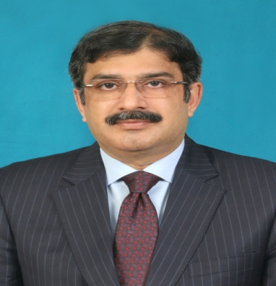

It is a matter of pleasure and pride for me that we are hosting the first conference of Collective Action for Knowledge Economy with Technology (CAKE-Tech) at Allama Iqbal Open University, Islamabad. It is the largest university of Asia in distance education, which primarily focuses on the educational needs of masses by providing quality education at their doorsteps all over the country and by blurring spatial and temporal boundaries. The university takes some special initiatives for the underprivileged and marginalized segments of the society not only for their economic empowerment but also for poverty alleviation. We are committed to provide state of the art facilities to our students by opening up new portals of academic and professional excellence.

The CAKE-Tech initiative based on SDGs is closely related to the vision and mission of AIOU. This collaboration among AIOU, Virtual University, Qarshi University, University of Veterinary and Animal Sciences and University of Management and Technology; is a joint effort for achieving the SDGs through educational and technological intervention. We are all together in the efforts of socio-economic uplift of the common man. In the two days conference we are going to deliberate upon the possibilities of efficient and effective use of mobile technology.

I welcome all the international and national delegates, who are coming to share their expertise and success stories regarding poverty alleviation and educating masses through smart use of technology. All participants from the partner universities who are attending this conference are encouraged to contribute in the plenary sessions and parallel workshops.

In this joint venture we are looking forward to draft a roadmap for the actualization of CAKE-Tech initiative, which is expected to alter the fabric of technology utilization in a purposeful manner. We are striving for a future where every citizen of Pakistan shall be able to access and learn through multiple media content available at a single click.

I hope your two days stay at AIOU will be productive and pleasant. The dynamic organizing team will ensure that all your needs are catered for.

Prof. Dr. Zia Ul-Qayyum
Vice-Chancellor, AIOU

MESSAGE OFRECTOR
VIRTUAL UNIVERSITY OF PAKISTAN

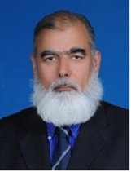

Virtual University of Pakistan is pleased to be a partner of unique community development initiative – “Collective Action on Knowledge Economy with Technology” (CAKE-Tech). No better time than now to start such an initiative - while a great Community Organizer and Philanthropist HE Imran Khan – the Prime Minister of Islamic Republic of Pakistan in the saddle. The participation of the honourable President HE Dr. Arif Alvi Esq. is the reflection on how much the current government values the community development initiatives. Our partners, Universities and International Development Institutions and the leaders of CAKE-Tech initiative, our two exalted Vice Chancellors Dr. Muhammad Nawaz and Dr. Naveed Malik deserve our sincere commendation and our sincere thanks for dedicating their post-retirement energies for this great cause. Mobilizing communities is the need of time and by motivating people to take their destinies in their own hands and providing them with the tools, techniques and training is destined to change our collective future. The focus of the conference and very carefully selected thematic areas i.e. education, energy, health, nutrition, poverty alleviation and the like, provide an enormous space for community development work and collaborating partners and development institutions both private and public to play their role in societal development. May I assure the collaborating partners that Virtual University of Pakistan with its network of around 200 campuses in over 100 cities of Pakistan along with its unique and unparalleled capacity to design, develop, disseminate and deliver education and training with the use of modern ICT technologies to virtually unlimited number of people is there to support you - YOU CAN COUNT on VUP. May ALLAH Bless You!

Professor Dr. Muhammad Abbas Choudhary
Rector, Virtual University of Pakistan

MESSAGE OFTHE FOUNDINGRECTOR
VIRTUAL UNIVERSITY OF PAKISTAN

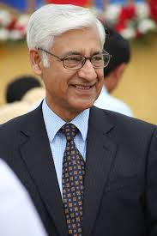

Pakistan faces multiple challenges in its path towards becoming a developed nation. A burgeoning population, a low literacy level, an underserved education sector, all combine to compound the problem. Organic, conventional approaches such as establishing new universities, expanding the reach of school networks etc. are all faced with problems of scarce resources, an exponential increase in the population and the time necessarily required to train the desired manpower.

A holistic approach to the problem, based on the efficacious use of information and communications technology seems to offer a way forward. By using inexpensive devices, pre-loaded with educational software and content for all age groups, and supplemented with focused supportive content that targets regional/local problems, it is possible to take a fast-track towards becoming a self-sustaining knowledge economy. By targeting the household as a unit, all age groups could be addressed simultaneously and by establishing an online network of experts that could offer solutions to specific problems, the effort could be force-multiplied.

However, before undertaking any such exercise, it is critically important to internalize the success stories from around the globe, especially the enormous strides in poverty reduction that China has made in our part of the world. This two-day conference is meant to provide a platform for knowledge exchange so that an effective solution to our challenges could be worked out.

Professor Dr. Naveed A Malik
Founding Rector, Virtual University of Pakistan

MESSAGE OF CONFERENCE COORDINATOR

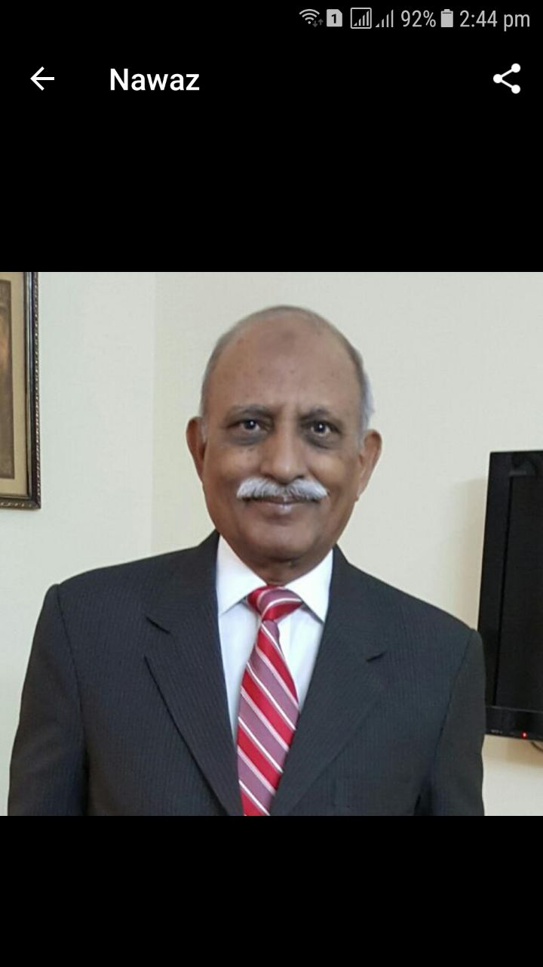

The world is moving toward a connected society where individual relationships and public life are being re-organised, at an unprecedented pace with far-reaching impact. In most connected societies, public services are increasingly delivered and administered online in the form of
‘e-government’, ‘e-service’, ‘e-health’, and ‘e-learning’. The connected services can empower individuals by offering wider access to socio-economic opportunities. People without digital skills or internet access risk further social and economic exclusion. The technology-enabled links between people, devices, and organizations is giving rise to the Fourth Industrial Revolution. Products and services are being further boosted by technology breakthroughs stemming from the internet of things (IoT), robotics, and artificial intelligence (AI) among other sources.

The International Conference on Collective Action for Knowledge Economy with Technology (CAKE-Tech) is a plan to connect individuals through device for organizing daily life; with ample available resources to improve their social status. Several efforts have been made by various organizations including NGOs which are trying to address societal challenges faced by our country. The CAKE-Tech is a mission for socioeconomic uplift and achievement of most SDGs with the use of Cyber technologies. Mobile phone is already in use by nearly one fourth of the population. This device with android apps holding contents for non-formal, formal education and skill development for all age groups will be the tool used for transformation of the mindset and transfer of methodologies for a better future.

This conference will provide an opportunity for cross professional interaction and exchange of experiences which is required for sustainable growth and economic development. Better economy with simultaneous mobile learning and essential knowledge are the areas with special focus on Poverty Alleviation, Nutrition, Health, Clean Water, Energy and mutual collaboration for discussion. It is anticipated that the outcomes of this conference will identify the elemental components for implementation of the CAKE-Tech initiative in the form of a well conceptualized and executed project.

Dr. Muhammad Nawaz
Meritorious Professor Emeritus
Izaz-e-Fazeelat, Pride of Performance
Advisor, Qarshi University Lahore
Conference Program

Day1: Monday25thFebruary2019

InauguralSession

8.30am—11.20am

Venue: MainAuditorium,AIOU

8.30 – 9.30 | Registration
9.30 – 9.45 | Gueststo be Seated
10.00 – 10.05 | Recitationofthe HolyQuran
10.05 – 10.15 | Welcome Address  Professor Dr.Zia Ul-Qayyum,  ViceChancellor, AllamaIqbal Open University, Pakistan.
10.15 – 10.30 | CollectiveAction for KnowledgeEconomywithTechnology(CAKE–Tech)  forSDGs.  Dr. Naveed A. Malik,FoundingRector,VirtualUniversityofPakistan.
10.30 – 10.45 | MobilisingCross-National and Professional Resources for CAKE-Tech  Outreach in Remote Areas.  Mr. Otto Evjenth, ChairmanMareNostrum, Norway.
10.45 – 11.15 | Address bythe Chief Guest

Refreshment
11.15am— 11.45 am
PlenarySession-I
12.00Noon—1.15pm

Venue: MainAuditorium,AIOU

Chairman: Professor Dr. Muhammad Abbas Choudhary
Rector, Virtual UniversityofPakistan.

Facilitator: Dr.Zahid Majeed, AllamaIqbal Open University, Islamabad.

12.00 –12.15 | ICTBased Simulator forDiversified Quantitative OperationalModels for  Development Processes.  Dr. Muhammad AzeemQureshi, Oslo Business School,  Oslo MetropolitanUniversity,Norway.
12.15 –12.30 | EliminatingPovertyby Bridgingthe KnowledgeDivide.  Professor Ronghuai Huang, Dean, SmartLearningInstitute,  Beijing NormalUniversity/Director UNESCOINRULED, China.
12.30 –12.45 | NecessityandImplications of New Generation Education.  Professor WangPing, Director,  Instituteof NewGeneration Education, China.
12.45 –1.00 | LogisticsOrganisation for Success of SDGsEnvisioned in CAKE-Tech.  Mr. Otto Evjenth, Chairman, MareNostrum, Norway.
1.00 – 1.15 | ClosingRemarks, Discussion and Recommendations  Professor Dr. Muhammad Abbas Choudhary,  Rector, Virtual UniversityofPakistan.

LunchandPrayerBreak
1.15 pm— 1.45 pm

PlenarySession-II

2.00pm—3.30pm

Venue: MainAuditorium,AIOU

Chair: ProfessorDr. Munawar Mirza, Advisor, Virtual UniversityofPakistan.
Facilitator: Professor Dr. SaminaAwan, Dean FacultyofSocial Sciences&Humanities, AIOU, Islamabad.

2.00 –2.15 | Family Education to Promote Community Development Practices and  Thinking.  Professor Wang Ping, Director-General Central Institute for Vocational & Technical Education, China.
2.15 –2.30 | Cost Effective Nutrition for Physical and Intellectual Performance of Children, Expectant Mothers and Geriatrics.  Professor Einar Lied, Mare Nostrum, Norway.
2.30 – 2.45 | Methodology for Essential Analysis and Opportunities for Capacity  Building.  Professor Yingjie Wang, China Academy of Sciences, Beijing, China.
2.45 – 3.00 | The Objectives and Targets of the Project “Collective Action for  Knowledge Economy with Technology” (CAKE-Tech). Professor Muhammad Nawaz, Advisor Qarshi University, Lahore.
3.00 – 3.15 | Cyber-learning and Intelligent Technology for Education and Teacher  Training.  Professor Ronghuai Huang, National Engineering Laboratory for Cyber Learning and Intelligent Technology (CIT), Smart Learning Institute (SLI) UNESCO/INRULED, China.
3.15 –3.30 | ClosingRemarks, Discussion and Recommendations  ProfessorDr. MunawarMirza,Advisor, Virtual Universityof Pakistan.

Tea Break
3.30 pm—4.00 pm

Conference Dinner
6:30 pm
Lawn Main Auditorium

Day2: Tuesday26thFebruary2019

ParallelWorkshop-I
9.30am—11.30pm

Venue: Room-104,First Floor, AcademicComplex, AIOU

QualityEducation,Skillsand Enterprise in theDigitalAge

Chair: Professor Dr. Masoom Yasinzai
Rector,InternationalIslamicUniversity,Islamabad.

Facilitator: Dr. TanzilaNabeel,AssociateProfessor,AIOU,Islamabad.

9.30 – 9.50 | New Generation Educationand Continued Education in Marginalized  Population.  Professor WangPing, Director-General CentralInstitute forVocational& Technical Education, China.
9.50 – 10.10 | Approaches forQualityEducation and Skill Development through Mobile  Learning.  Dr. NaveedA Malik,FoundingRector,Virtual Universityof Pakistan.
10.10 – 10.30 | QualityEducation: Skillsand Enterprise in theDigital Age.  Dr. BilalZafar,UniversityofCentral Punjab,Lahore.
10.30 – 10.50 | FunctionalLiteracyas Catalyst for other SDGs: Revival UsingMobile  Phones.  ProfessorDr. MunawarMirza,Virtual Universityof Pakistan.
10.50 – 11.10 | Developing LiteracyandWorkplaceSkills in anIlliterate Workforce.  Professor Dr.Nasir Mahmood,  DeanFacultyof Education, AIOU, Islamabad.
11.10 – 11.30 | ClosingRemarks, Discussion and Recommendations  ProfessorDr. Masoom Yasinzai,  Rector,InternationalIslamicUniversity, Islamabad.

ParallelWorkshop-II
9.30am—11.30pm

Venue: Room-105,First Floor, AcademicComplex, AIOU

PovertyAlleviation

Chair: Professor Ronghuai Huang, Dean, SmartLearningInstitute,
BeijingNormal University, DirectorUNESCOINRULED, China.

Facilitator: Professor Dr. Mohsin Javed, Director QualityEnhancement,
Virtual University ofPakistan.

9.30 – 9.50 | Role ofModernInformation and Technology; RepositoryContents  Support toBridgethe KnowledgeDivide for SustainableGrowth in Rural  Economy.  Professor Ronghuai Huang, Dean, SmartLearningInstitute,  BeijingNormalUniversity, Director UNESCOINRULED, China.
9.50 – 10.10 | System Dynamics-AnIntegrated Approach forCoordinatingNon-Formal  Education ofthe Communities forSDGs Success.  Dr. Muhammad AzeemQureshi, Oslo Business School,  Oslo Metropolitan University, Norway.
10.10 – 10.30 | SMART Management of EducationalResources forSustainable Growth  ofEconomy.  Dr. MuhammadAbbas Choudhary, Rector,VirtualUniversityof Pakistan.
10.30 – 10.50 | Dissemination of EffectiveTechnologiesand Skills for Food Securityin  Rural Economies.  Professor Dr. MasroorEllahi Babar, Dean, VirtualUniversityof Pakistan.
10.50 – 11.10 | Nanotechnologyfor SustainableDevelopment.  Dr. Ali Talha Khalil, Qarshi University,Lahore.
10.10 – 11.25 | Poverty Alleviation through Recognising Prior Learning of Skilled Workforce on CPEC Route  Mr. Izhar Hunzai, Rural Development and CEPEC Expert.
11.25 – 11.35 | ClosingRemarks, Discussion and Recommendations  ProfessorRonghuai Huang, Dean, SmartLearningInstitute,  BeijingNormal University, Director UNESCOINRULED, China.

ParallelWorkshop-III
9.30am—11.30pm

Venue: Room-106,First Floor, AcademicComplex, AIOU

Health forAll, Nutrition, Cleanwater, Sanitation, Hygiene &Energy

Chair: Professor EinarLied,MareNostrum, Norway.

Facilitator: Dr. HajraAhmed, Chairperson, DepartmentofEnvironmentalDesign,
Health and Nutritional Sciences,AIOU, Islamabad.

9.30 – 9.50 | Role of Nutrition in Health and Optimal Learning and Supplemented  Nutrients for Addressing the Nutritional Deficiencies.  Professor Einar Lied, Mare Nostrum, Norway.
9.50 – 10.10 | Aqua Culture as Tool in Tackling Optimal Nutrition, Health and Income  Generation.  Professor Muhammad Noor Khan, University of Veterinary& Animal  Sciences, Lahore.
10.10 – 10.30 | SDG 6: Safe and Clean Drinking Water: Pivotal Role in Collective  Action for Knowledge Economy with Technology (CAKE-Tech).  Brig (Rtd) Muhammad Aslam Khan  Chairman, Gomal Damaan Area Water Partnership, Pakistan.
10.30 – 10.50 | Role of Digital Technology Enabling Nutrition, Clean Water and Health.  Dr. Zara Khan, University of Veterinary & Animal Sciences, Lahore.
10.50 – 11.10 | Affordable Green and Renewable Energy Options in Rural Economy.  Mr. Asim G. Kiyani, Mare Nostrum, Norway.
11.10 – 11.30 | Closing Remarks, Discussion and Recommendations  Professor Einar Lied, Mare Nostrum, Norway.

Tea Break
11:35 am — 11:50

ConsolidatingSession

Venue:Room-106, FirstFloor
AcademicComplex, AIOU

12:00 – 1.00 | Discussionand Recommendations byParticipants of Workshop-I-II-III

Lunchand PrayerBreak
1.00 pm —1.45 pm

Gueststo be Seated for ClosingCeremony
2.00 pmat Main Auditorium, AIOU

Closing Session
2.00 pm — 4.00 pm

Venue: MainAuditorium, AIOU

2.00–2.30 | SecurityClearance andGueststo be Seated
3.00 – 3.05 | Recitationofthe HolyQuran  Dr. Shah Moeen-ud-DinHashimi
3.05 – 3.15 | Welcome Address  ProfessorDr.ZiaUl-Qayyum,  ViceChancellor, AllamaIqbal University, Pakistan.
3.15 – 3.30 | Impression oftheDelegates
3.30 – 3.40 | SummaryandRecommendations forthe “CollectiveAction for  KnowledgeEconomywith Technology” (CAKE-Tech).  ProfessorDr. Muhammad Nawaz, Advisor, Qarshi University,Lahore.
3.40 – 4.00 | Speech bythe Chief Guest

SPEAKERS’ PROFILE

OttoEvjenth
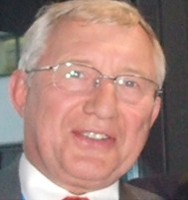

Otto Evjenth is currently the chairman of the Board of Directors of Mare Nostrum a company established to build and manage networks for enhancement of change processes.
He was Formerly the Executive Director of the “Global Media Centre for Development”, an entity established by the “Asia-Pacific Institute for Broadcasting Development” in Malaysia and “Worldview Global Media” in Geneva Switzerland where he was the CEO.
Otto had a business career consisting of managerial assignments for re-engineering of Norwegian and US off-shore technology companies during the period 1970-1980.
He was a Vice President responsible for structural and technological adaptations within Bergens Tidende, a Scandinavian media group with interests in newspapers, local broadcasting, data transmission and book publishing.
He was involved with the introduction of multi-channel television, broadcasting and satellite operations with Telenor and a Director Business Development Telenor Plus, the unit of Telenor introducing new technologies and services. He chaired the permanent committee for business development of the EuropeanCable and Communication Association for three years. Healso headed up the project team which developed satellite services for the Chinese and Pakistani global Diaspora in collaboration with CCTV and PTV. Both services were launched from Oslo and were parts of national strategies for the deployment of information and communication services for strengthening of the connections between the countries and their populations abroad.
Otto has for 15 years resided in Asia (Sri Lanka, China and Malaysia) where he has been working to deploy media technologies and media content for enhanced interventions for social change and development.

Professor Einar Lied

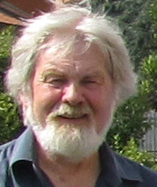

Professor Einar Lied is CSO of Mare Norstum AS, Bergen/Norway.Professor Lied is former principal senior scientist in nutrition and protein metabolism at the Norwegian National Institute of Nutrition and Seafood Research, and professor emeritus in nutrition from the University of Bergen, Faculty of Science and Faculty of Medicine, firstly at the Center of International Health, and then at the Institute of Medicine. He has been guest scientist at research institutions both in the UK and in Sweden working with nutritional regulation of lean body mass, in particular muscle protein synthesis including interaction between gastrointestinal function and development of lean body mass.

Professor Lieds´s main fields of research are amino acid, peptide, protein, and nucleotide nutrition, and their interactions, particularly the role of protein and peptides of marine origin on gastrointestinal function, endocrinology and blood sugar regulation, and the link to muscle protein anabolism and catabolism using both animal and human clinical models. He has been working for several years with protein-energy malnutrition issues in infants and children in the Western Africa during which he built a protein nutrition laboratory at the University of Ghana. In a number of clinical field studies with children in different parts of Ghana he and his colleagues at the Department of Nutrition and Food Science, University of Ghana showed that supplementing cereal-based staple foods with small amounts of white fish powder effectively corrected both protein-energy malnutrition (kwashiorkor/marasmus) and early stage goiter in children and adolescents. He and his colleagues also demonstrated that inclusion of small amounts of marine nucleotides to staple foods strongly stimulated the secretion of gammaglobulins, and thereby stimulated the immune system and defense against infections.

Professor Lied is currently managing projects and doing research studying the effects of marine proteins and peptides supplementation on blood glucose management and muscle growth and maintenance, particularly in people subject to overweight and diabetes type 2, and in elderly subject to sarcopenia; i.e. age dependent loss of muscle mass.

Professor Lied and Mare Norstum AS has specialized in innovation of formulated foods based on food-derived functional peptides and nucleotides of marine origin, and had developed several products for functional nutrition and clinic in particular related to recovery, but also gastrointestinal functioning and distress.
Muhammad Azeem Qureshi

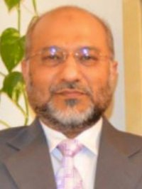

Muhammad Azeem Qureshi is an Associate Professor at Oslo Business School of Oslo Metropolitan University, Norway. Dr Azeem earned PhD in System Dynamics from University of Bergen, Norway – a top System Dynamics center in the world. His professional career spans over almost three decades.

System dynamics is a computer simulation modeling approach to understand dynamic problems arising in complex social, managerial, economic, or ecological systems for policy analysis and design. Dr. Azeem develops and uses system dynamics based management simulators to impart lifelong learning. His research focuses on socio-economic issues, corporate finance and sustainability. He has extensive scientific publications.

Ronghuai Huang

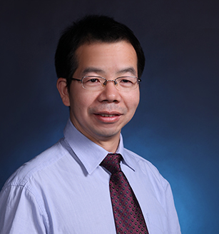

Ronghuai Huang is a Professor in Faculty of Education of Beijing Normal University (BNU). He has been engaged in the research on smart learning environment, educational technology as well as knowledge engineering. He received ‘Chang Jiang Scholar’ award in 2016, which is the highest academic award presented to an individual in higher education by the Ministry of Education of China.He serves as Co-Dean of Smart Learning Institute, Director of UNESCO International Rural Educational and Training Centre, and Director of China National Engineering Lab for CyberLearning Intelligent Technology.He is very active in academic organizations both at home and abroad. He is also Committeeman of the Science Subject Expert Committee of the National Textbook Committee, Vice-chairman of China Education Technology Association,Deputy Director of Teaching Guidance Committee of Educational Technology at Institutions of Higher Education (MOE), and Expert of MOE AI Innovation Panel. During 2013 to 2018, he servesas General Chairfor International Conference on Advanced Learning Technology (ICALT). He is also the President of International Association of Smart Learning Environments (IASLE), and Editor-in-Chief of Springer’s Journal of Smart Learning Environment and Journal of Computers in Education.Till now, he has accomplished and is working on over 100 projects, and his ideas have been widely spread, with about400 academic papers and over 40 books published at home and aboard.

Wang Ping

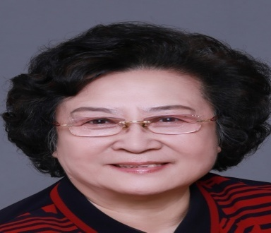

Wang Pingis the President of Beijing Oriental University for women and senior citizens. She was director of the women's magazine of the all-china women's federation in 1978. In 1988, she participated in the preparation for the establishment of the China women's development foundation and served as the secretary-general and vice chairman successively. In 2006, she participated in the preparation for the establishment of Beijing Oriental Women University for the aged and served as the vice President. In 2008, China next generation education foundation was established. In 2010, she served as vice chairman and secretary general of China next generation education foundation. In 2015, she served as chairman and secretary general of China foundation for next generation education. From 2016 till now, she has been the chairman of China next generation education foundation.

Natalie Qin Ming
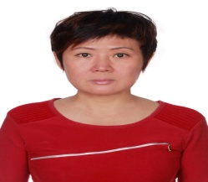

Natalie Qin Mingis the Regional Manager for Worldview Global Media East Asia Ltd,Executive Director for China Green Channel International (CGCI) and Vice General Manager for Victor Geological Exploration Inc. China Partner for IQ Media. She organized a major conference about “Distance Education”. It was a five days event and the Educational Minister (Wei Yu) of China has attended along with other Government officials from Norway. In 2000, also worked with Mr. Otto Evjenth, helped CCTV lunched channel 4, and channel 9, syndicated in Norway by Telenor. In 2003, worked as Chief Representative for Conax, (CA Company of Telenor) set up Beijing office. After that, she worked for Otto, as regional manager for project of China Women federation for “letter teacher, and YA TV project, in Nov.22-23, 2008, originated with Otto “Opportunity and Challenge for Educational Broadcasting” For China Education Television, China University Alumni Association and Worldview Global Media SA., in 2010 to 2011, as executive director for Canadian company of China Green Channel International(CGCI), importing international Children, nature, High tech. green environmental programmers Broadcasting at CETV Channel 3.

Wang Yingjie

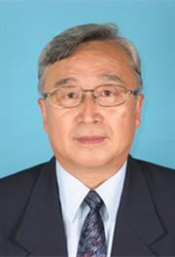

Wang Yingjie is a professor of education at the School of Education, Beijing Normal University, China. Born in China in 1945, he was educated at the Beijing Foreign Studies University and Beijing Normal University. Since 1973, he had held various posts at Beijing Normal University. He was Dean of the International and Comparative Education Research Institute from 1992 to 1995. He then served the university as Vice-President between 1995 and 1999.

He was also Vice-Chairman of the Academic Committee of the university between 1996 and 2005. He took a two year leave between 1993 and 1995 from Beijing Normal University to serve the University of Macao as Dean of the Faculty of Education.

Prof. Wang holds the first Ph.D. degree in comparative education granted in China's mainland after 1949. He has focused his research work on the comparison of Chinese and American higher education. He is considered one of the authorities on the American education system in China.

Professor Dr Munawar Mirza

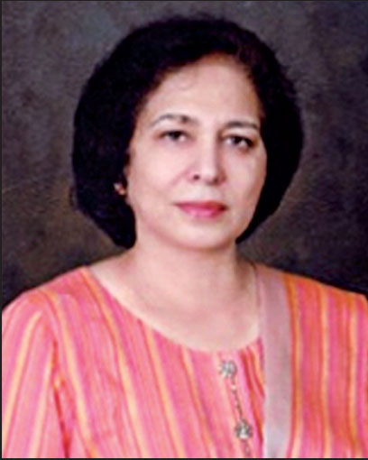

Prof. Dr Munawar Mirza is a distinguished educationist having the field of higher education, is former Vice Chancellor of University of Education. She is a well-recognized figure in the field of higher education, teacher education, academic assessment and quality assurance. Her early work was related to adult literacy and non-formal education. She introduced Non-Formal Education as an area of specialization in M.A. Education at IER. She is member of the International Network of Teacher Education Institutions on Sustainable Development, contributed in the Global Action Program on SD. Her excellence and contribution in the field of higher education and research have brought her recognition at the national/international levels. She has been honored as National Distinguished Professor by the Higher Education Commission, Pakistan.Some of her national awards include Presidential Award Ezaz-e- Fazeelat, Fatima Jinnah Medal, Best University Teacher Award and many awards by civil society organizations.At the international level she was decorated with the most prestigious UNESCO award, theComenius Medal.The University of Glasgow, ranking 74th in the world, conferred upon her the D.Lit. (Hon.) Degree in recognition of her services in the field of teacher education and women development.

Professor Dr. Naveed A Malik

Prof. Dr. Naveed A Malik is the founding Rector of the Virtual University of Pakistan.He obtained his Master’s degree in Physics from the University of the Punjab,Pakistan and later the Doctor of Science Degree from M.I.T. in the field of Electrical Engineering and Computer Science specializing in Digital Signal Processing. As a staff member at the University of the Punjab, Dr. Malik established the Spark Source Mass Spectroscopy laboratory and later became the founding Chairman of the Department of Computer Science. He was the principal architect and developer of the Punjab University’s computerized examination system and was also responsible for the design and implementation of the University’s fibre-optic campus-area network.
Under his leadership, the virtual University of Pakistan has become a well-regarded modern distance learning institution with a student body exceeding 100,000 students. He has lectured extensively, been an active systems and software development consultant and has published several papers on various technical subjects. He is a life member of the Pakistan institute of Physics, a founding signatory of MIT-LINC and the Pakistan Project Manager for
MIT-BLOSSOMS. He was awarded the Pakistani civil award of Sitara-e-Imtiaz in 2008 for his services to education.

Asim G Kiyani
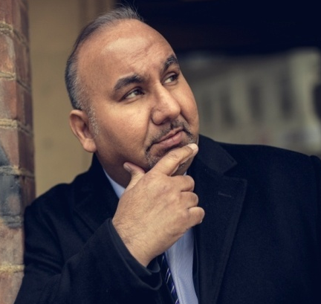

Asim Kiyani is a Norwegian of Pakistani origin. He has been living in Norway since 1974. He speaks several languages rather decently (Norwegian and the Nordic languages), English, German and Turkish.

He is a specialist in international sales & marketing, with heavy emphasis on internationalization strategy and management. Though his education is commercial, he has been working on selling high-tech and IT solutions globally. His prime areas of expertise are: Satcom, Telecom, Maritime, IT for Offshore and IT for energy sector (Smart Grid, Smart Metering, IoT, IIoT, Smart City, Machine Learning, Artificial Intelligence and Analytics. He is Member of Board Pak-Norway Trade Chamber,Strategic Advisor and Member of Board and NostrumStrategic Advisor, Green Power Consultancy.

CONFERENCE TEAM

Conference Convener
Prof. Dr. Zia Ul-Qayyum, Vice Chancellor

Conference Coordinator
Prof. Dr. Nasir Mahmood, Dean, F/o Education

Conference Focal Person
Dr. Muhammad Zaigham Qadeer, Registrar

Conference Management
Dr. Zahid Majeed, Director International Collaboration & Exchange Office
Prof. Dr. Muhammad Nawaz, Advisor, Qarshi University

Conference Management Committees

Conference Program Execution Committee
- Dr. Nasir Mahmood, Dean, F/O Education
- Prof. Dr. Samina Awan, Dean, F/O Social Sciences & Humanities
- Prof. Dr. Shah Mohyuddin Hashmi, Dean, F/O Arabic and Islamic Studies
- Prof. Dr. Syed Zafar Ilyas, Dean, F/O Sciences
- Dr. Zahid Majeed, Assistant Professor Special Education
- Dr. Afshan Huma, Assistant Professor EPPSL
- Dr. Sidra Rizwan, Lecturer Secondary Teacher Education
- Dr Malik Tariq Mahmood, PS to VC
Food and Entertainment Committee
- Dr. Majid Mahmood Bahgram, Associate Professor, MBA
- Dr. Salman Qureshi, Assistant Professor, COL-MBA
- Dr. Fazal Ur Rahman, Chairman, ECE&ETED.
- Dr. Samiullah, Assistant Professor, Science Education
Transport and Accommodation Committee
- Dr. Muhammad Tanveer Afzal, Assistant Professor, Secondary Teacher Education
- Mr. Hamid Ali Nadeem, Lecturer, EPPSL
- Mr. Arshad Mahmood Qamar, Lecturer, Science Education
Design, Publication and Printing Committee
- Dr. Afshan Huma, Assistant Professor EPPSL
- Dr. Sidra Rizwan, Lecturer Secondary Teacher Education
- Dr. Munazza Ambreen, Assistant Professor, STED
- Dr. Hina Noor, Lecturer, Special Education
- Ms. Mubshara Tufail, Lectuer, ECT&ETED
- Mr. Ijaz Ahmad, Director, IET
- Mr. Muhammad Riaz Khan, Senior Printer, PPU
- Ms. Tahira Bibi, Lecturer, EPPSL
- Mr. Javed Akhtar, Media Advisor
- Mr. Arshad Saggar, IET
- Mr. Sohail Anjum, Deputy Registrar, PPU
- Mr. Anwar Ul Haq, Supervisor, PPU
- Mr. Muhammad Hameed, PPU
- Mr. Mushtaq Hussain, PPU
Stage Decoration/Arrangements Committee
- Dr. Kishwar Sultana, Associate Professor History Department
- Dr. Hajra Ahmed, Associate Professor, Environ. Design, Health & Nutritional Science
- Mr. Muhammad Tariq Javaid, Director Student Affairs
Conference Material Development Committee
- Dr. Zahid Majeed, Assistant Professor Special Education
- Mr. Hamid Ali Nadeem, Lecturer, EPPSL
- Mr. Arshad Mahmood Qamar, Lecturer, Science Education
Venue Arrangement Committee
- Mr. Ijaz Ahmed, Director, IET
- Mr. Ajmal Farooq, Director, ICT
- Mr. Sharifullah, Project Director
- Ms. Nabila Khurshid, ORIC.
ICT Arrangements
- Mr. Ajmal Farooq, Director
- Ch. Rizwan Roshan
- Mr. Kashif Rasheed Bhinder
- Mr. Abdul Ghaffar Mughal
- Mr. Habib ur Rehman Hashmi
- Mr. Muhamamd Junaid Aslam
- Mr. Muhammad Mahboob Ur Rahman Usmani
IET Arrangements
- Mr. Ijaz Ahmad, Director
- Mr. Muhammad Jawad
- Mrs. Nasira Aqeel
- Mr. Faisal Azeem
- Mr. Tazkir Ahmed
- Syed Aftab Ali
- Mr. Muhammad Awais Khan
- Mr. Muhammad Younas
- Mr. Iqtidar Ahmed Asad
- Mr. Arshad Saggar

INTERNATIONAL CONFERENCE
COLLECTIVE ACTION FOR KNOWLEDGE ECONOMY WITH TECHNOLOGY
(CAKE-TECH)

NOTES
_______________________________________________________________
_______________________________________________________________
_______________________________________________________________
_______________________________________________________________
_______________________________________________________________
_______________________________________________________________
_______________________________________________________________
_______________________________________________________________
_______________________________________________________________
_______________________________________________________________
_______________________________________________________________
_______________________________________________________________
_______________________________________________________________
_______________________________________________________________
_______________________________________________________________
_______________________________________________________________
_______________________________________________________________
_______________________________________________________________
_______________________________________________________________
_______________________________________________________________
_______________________________________________________________
_______________________________________________________________
_______________________________________________________________
_______________________________________________________________
_______________________________________________________________
INTERNATIONAL CONFERENCE
COLLECTIVE ACTION FOR KNOWLEDGE ECONOMY WITH TECHNOLOGY
(CAKE-TECH)

NOTES
_______________________________________________________________
_______________________________________________________________
_______________________________________________________________
_______________________________________________________________
_______________________________________________________________
_______________________________________________________________
_______________________________________________________________
_______________________________________________________________
_______________________________________________________________
_______________________________________________________________
_______________________________________________________________
_______________________________________________________________
_______________________________________________________________
_______________________________________________________________
_______________________________________________________________
_______________________________________________________________
_______________________________________________________________
_______________________________________________________________
_______________________________________________________________
_______________________________________________________________
_______________________________________________________________
_______________________________________________________________
_______________________________________________________________
_______________________________________________________________
_______________________________________________________________
INTERNATIONAL CONFERENCE
COLLECTIVE ACTION FOR KNOWLEDGE ECONOMY WITH TECHNOLOGY
(CAKE-TECH)

NOTES
_______________________________________________________________
_______________________________________________________________
_______________________________________________________________
_______________________________________________________________
_______________________________________________________________
_______________________________________________________________
_______________________________________________________________
_______________________________________________________________
_______________________________________________________________
_______________________________________________________________
_______________________________________________________________
_______________________________________________________________
_______________________________________________________________
_______________________________________________________________
_______________________________________________________________
_______________________________________________________________
_______________________________________________________________
_______________________________________________________________
_______________________________________________________________
_______________________________________________________________
_______________________________________________________________
_______________________________________________________________
_______________________________________________________________
_______________________________________________________________
_______________________________________________________________
INTERNATIONAL CONFERENCE
COLLECTIVE ACTION FOR KNOWLEDGE ECONOMY WITH TECHNOLOGY
(CAKE-TECH)

NOTES
_______________________________________________________________
_______________________________________________________________
_______________________________________________________________
_______________________________________________________________
_______________________________________________________________
_______________________________________________________________
_______________________________________________________________
_______________________________________________________________
_______________________________________________________________
_______________________________________________________________
_______________________________________________________________
_______________________________________________________________
_______________________________________________________________
_______________________________________________________________
_______________________________________________________________
_______________________________________________________________
_______________________________________________________________
_______________________________________________________________
_______________________________________________________________
_______________________________________________________________
_______________________________________________________________
_______________________________________________________________
_______________________________________________________________
_______________________________________________________________
_______________________________________________________________
INTERNATIONAL CONFERENCE
COLLECTIVE ACTION FOR KNOWLEDGE ECONOMY WITH TECHNOLOGY
(CAKE-TECH)

NOTES
_______________________________________________________________
_______________________________________________________________
_______________________________________________________________
_______________________________________________________________
_______________________________________________________________
_______________________________________________________________
_______________________________________________________________
_______________________________________________________________
_______________________________________________________________
_______________________________________________________________
_______________________________________________________________
_______________________________________________________________
_______________________________________________________________
_______________________________________________________________
_______________________________________________________________
_______________________________________________________________
_______________________________________________________________
_______________________________________________________________
_______________________________________________________________
_______________________________________________________________
_______________________________________________________________
_______________________________________________________________
_______________________________________________________________
_______________________________________________________________
_______________________________________________________________
INTERNATIONAL CONFERENCE
COLLECTIVE ACTION FOR KNOWLEDGE ECONOMY WITH TECHNOLOGY
(CAKE-TECH)

NOTES
_______________________________________________________________
_______________________________________________________________
_______________________________________________________________
_______________________________________________________________
_______________________________________________________________
_______________________________________________________________
_______________________________________________________________
_______________________________________________________________
_______________________________________________________________
_______________________________________________________________
_______________________________________________________________
_______________________________________________________________
_______________________________________________________________
_______________________________________________________________
_______________________________________________________________
_______________________________________________________________
_______________________________________________________________
_______________________________________________________________
_______________________________________________________________
_______________________________________________________________
_______________________________________________________________
_______________________________________________________________
_______________________________________________________________
_______________________________________________________________
_______________________________________________________________
INTERNATIONAL CONFERENCE
COLLECTIVE ACTION FOR KNOWLEDGE ECONOMY WITH TECHNOLOGY
(CAKE-TECH)

NOTES
_______________________________________________________________
_______________________________________________________________
_______________________________________________________________
_______________________________________________________________
_______________________________________________________________
_______________________________________________________________
_______________________________________________________________
_______________________________________________________________
_______________________________________________________________
_______________________________________________________________
_______________________________________________________________
_______________________________________________________________
_______________________________________________________________
_______________________________________________________________
_______________________________________________________________
_______________________________________________________________
_______________________________________________________________
_______________________________________________________________
_______________________________________________________________
_______________________________________________________________
_______________________________________________________________
_______________________________________________________________
_______________________________________________________________
_______________________________________________________________
_______________________________________________________________

