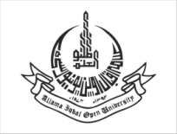
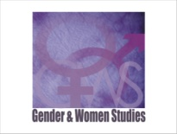
ALLAMA IQBAL OPEN UNIVERSITY
DEPARTMENT OF GENDER & WOMEN STUDIES
First National Gender Studies Conference, 2017
“Gender & Feminist Research: Potential, Practices and predicaments”

The department of Gender & Women Studies, Allama Iqbal Open University Islamabad welcomes researchers to a national conference on Gender & Feminist Research Methods taking place in March 2017 at AlOU Islamabad Campus.
Tentative Date: 14th to 16th March 2017
Venue: Academic Complex, AIOU, Main Campus H-8. Islamabad
Organizer: Department of Gender & Women Studies AIOU

The Rationale of the Conference:
This conference is devoted to providing a platform to academics, researchers, practitioners and students from the discipline of Gender & Women studies and Social Sciences for exchange of experiences, ideas and innovations in doing empirical Gender or Feminist research. This conference is envisaged to provide an opportunity to the researchers to analyze the feminist research methods being employed in an indigenous perspective, by focusing on the Qualitative Research tools and techniques and to learn about the challenges and success of theses research practices.
Call for Papers:
The call for papers is open now!
Themes:
Papers from disciplines other than Gender and Women Studies such as Social Sciences, Humanities and Arts are also welcome but preference will be given to the papers grounded in qualitative methods having a research impact on gender and women issues from a sociological, psychological, cultural, anthropological and economic perspective.

We would like to consider and emphasize on research papers based on feminist and qualitative research methods and theoretical frameworks.

Important Dates:
Abstract submission deadline: 20th December, 2016 (Registration fee is Rs. 1000/-)
Full text paper submission deadline: 20th January, 2017
Acceptance of Abstract Notification: 30th January, 2017

For more information:

Please visit website ………….. or email: mehreenqaisar@aiou.edu.pk
Organizer:
Gender & Women Studies Department
Chairperson of the conference committee: Dr. Riffat Haque
Conference Coordinators:
1:Ms. Maria Mustafa 2: Ms. Mehreen Qaisar
Lecturer Lecturer
Gender & Women Studies Department Gender & Women Studies Department
Email: maria_mustafa@aiou.edu.pk Email: mehreenqaisar@aiou.edu.pk

