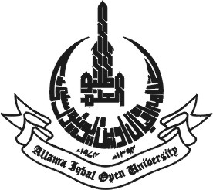
ALLAMA IQBAL OPEN UNIVERSITY
Department ___________________

CHECK LIST/CERTIFICATE FOR CHAIRMAN COURSE TEAM

- Title of the Course:_______________________________________________________
- Level: _________________________ Credit:_____________________________
- No. of Units ___________________ No of Pages:________________________
- No of Illustration:________________________________________________________
- No of Radio/T.V/Non Broadcast Programs suggested by the Course Team:___________
- Name of the Course Development Coordinator:_________________________________
- Course outline recommended by the Committee of Courses in meeting No.______held on__________
- Recommended by Faculty Board in Meeting No. _______________ held on___________
- Approved by the Academic Council in Meeting No. ____________ held on___________
- Proposed date of launching__________________________________________________

Certified that the course mentioned above have been discussed/checked in Course Team meeting in respect of :-

- Course contents in the light of the recommendation made by the Committee of Courses
- Content of each unit.
- Student Learning activities
- Self Assessment Questions
- Number of Radio/T.V/Non broadcast programmes
- Language of the course according to the level
- Illustration in connection with text
- Glossary
- Bibliography
- Scripts of Radio/T.V/Non broadcast programs
- Assignments
- Student’s allied material
- Tutor’s material

All the above mentioned have been checked and forwarded for necessary action, please.

(Chairman Course Team)
Dated_______________
Chairman/Chairperson

The above course along with checklist is forwarded for approval and further process, please.

(Chairman/Chairperson)
Dean Faculty of

Head of Directorate of AP&CP

